EVENT MANAGEMENT SYSTEM
Requirements Specification Document

Software Modeling Project
Version 1.0 | March 2026
Epoka University | Group of 8 Members
1. Introduction
The Event Management System (EMS) is a web-based platform designed to centralize and automate the complete lifecycle of an event, from initial planning and resource allocation to attendee registration, on-site management, and post-event reporting. The system serves seven distinct types of users, each with a defined role and level of access, ensuring that every aspect of event management is handled efficiently and securely.
This document covers the full requirements specification including the system description, user levels, functional requirements, non-functional requirements, use case summary, and diagram references.

2. Product / Service Description

2.1 Product Context
The EMS is a standalone web platform that interfaces with external payment gateways such as Stripe and PayPal, calendar applications such as Google Calendar and Microsoft Outlook, and automated email/SMS notification services. It does not depend on any existing internal legacy system but exposes secure REST APIs for third-party integrations.

2.2 Aim of the System
The primary goal of the Event Management System is to eliminate the inefficiencies of manual event coordination by providing a unified digital platform for all stakeholders. The system aims to:
- Reduce Manual Effort Automate repetitive tasks such as ticket generation, email confirmations, and staff scheduling.
- Improve Data Accuracy Maintain a single source of truth for attendee lists, schedules, venue availability, and financial records.
- Enhance Communication Provide a seamless interface for organizers to interact with attendees, vendors, and staff in real time.
- Ensure Security and Compliance Protect user data and payment information in full compliance with GDPR standards.
- Support Scalability Handle events of any size, from small workshops to large-scale concerts and international conferences.

2.3 User Characteristics & Actors
The system defines seven actors, each with a distinct role and set of permissions:

# | Actor | Description
1 | System Administrator | Manages system settings, user accounts, and security configurations. Has full override access across the entire platform and is responsible for system integrity.
2 | Event Organizer | Creates and manages events, books venues, assigns staff, tracks registrations, manages budgets, and generates reports. The primary power user of the system.
3 | Attendee | Browses available events, registers, purchases tickets, receives automated notifications, and submits post-event feedback.
4 | Cashier | Handles all payment transactions, issues digital and physical tickets, processes refunds, and generates daily financial summaries.
5 | Venue Manager | Manages venue availability, sets capacity limits, allocates physical resources and equipment, and coordinates with organizers on venue logistics.
6 | Security Guard | Scans and verifies QR code tickets at entry points, controls access to restricted areas, and monitors real-time attendance counts for safety compliance.
7 | Service Provider | External vendors such as caterers and decorators who log in to view their assigned tasks, deadlines, and event-day schedules through a dedicated vendor portal.
8 | WhareHouse  Manager | Tracks equipment inventory, manages storage logistics for event materials, and oversees inbound/outbound shipments
9 | Finance Officer | Oversees high-level financial health, approves large-scale budgets, manages investor relations, and audits overall profitability.
10 | Human Resources | Manages staff recruitment, payroll, labor compliance, and coordinates training for event-day personnel.

2.4 Assumptions
- All users have access to a device with a stable internet connection.
- Attendees have a valid email address for registration and automated notifications.
- The system is deployed on a cloud infrastructure capable of automatic horizontal scaling.
- Payment gateways (Stripe and PayPal) are operational and accessible at all times.
- Security Guards are equipped with a mobile device capable of scanning QR codes.

2.5 Constraints and Dependencies
- The ticketing module depends on the payment gateway integration being completed and tested first.
- GDPR compliance must be enforced from the initial release and cannot be deferred.
- The notification module depends on a third-party email and SMS service provider being configured.
- QR code verification requires the registration and ticketing module to be fully operational.
- The reporting module depends on live data from the attendance, payment, and feedback modules.

3. Requirements 3.1 Priority Definitions
All requirements are prioritized using the following scheme:
Priority | Definition
1 Must Have | Required for the system to function. Mandated by policy, law, or core business need.
2 Should Have | Needed for improved processing and user experience. Delivers significant benefit.
3 Nice to Have | Optional enhancement. May include new or extended functionality.

3.2 General Functional Requirements
The following describes the high-level functional modules that the system must support:
User Authentication and Access Control
All actors must register and log in using a secure username and password. The system enforces strict role-based access control, meaning each actor can only access the modules and data relevant to their assigned role.
Event Creation and Management
Organizers must be able to create, edit, publish, and cancel events. Each event must include a title, description, date, time, location, capacity limit, ticket price, and a full schedule of sessions or sub-events.
Registration and Ticketing
Attendees must be able to browse available events, register, and purchase tickets online. The system must support multiple ticket tiers (VIP, Early Bird, General Admission), promotional discount codes, and waitlist management. Upon successful payment, the system automatically generates a unique digital ticket with a QR code.
Payment Processing
The system must integrate with a secure payment gateway to handle ticket purchases, generate automated tax receipts in PDF format, and process full or partial refunds according to the event refund policy.
QR Code Entry Verification
Security staff must use a mobile interface to scan QR codes at entry points, verify ticket validity in under one second, and monitor real-time attendance counts to ensure venue safety compliance.
Venue and Resource Management
The Venue Manager must be able to update venue availability, set capacity limits, and track equipment and resource allocation across events. Organizers book venues based on availability data provided by Venue Managers.
Staff and Task Management
Organizers must be able to assign tasks and roles to staff members and service providers with deadlines and status tracking. Each assigned user can view and update their responsibilities through a personal dashboard.
Notification System
The system must send automated email or SMS notifications for registration confirmations, payment receipts, event reminders 24 hours in advance, schedule changes, and cancellations.
Feedback and Reporting
After an event concludes, attendees must be prompted to submit feedback through an automated survey. Organizers and administrators must be able to generate detailed reports on attendance, revenue, feedback scores, and resource usage, and export them in CSV or PDF format.
3.3 List of Functional Requirements
All requirements follow the format: Actor + Verb + Object. Requirements are listed below.

Req | Requirement (Actor + Verb + Object) | Priority | Actor
FR_01 | Attendee shall register an account using a valid email address and password and shall receive an automated email confirmation after completing registration. | 1 | Attendee
FR_02 | Attendee shall log in to the system using their registered credentials | 1 | Attendee
FR_03 | Attendee shall browse the full list of available events on the platform | 1 | Attendee
FR_04 | Attendee shall search and filter for events by name, date, location, or category | 2 | Attendee
FR_05 | Attendee shall view the complete details of any selected event | 1 | Attendee
FR_06 | Attendee shall purchase a ticket for an event using a secure payment method and receive a digital ticket containing a unique QR code upon successful payment | 1 | Attendee
FR_07 | Attendee shall cancel a ticket and submit a refund request through the platform | 2 | Attendee
FR_08 | Attendee shall submit post-event feedback through an automated survey | 2 | Attendee
FR_09 | Attendee shall manage their personal profile, preferences, and saved payment methods | 3 | Attendee
FR_10 | Attendee shall join a waitlist when an event has reached its maximum capacity | 2 | Attendee
FR_11 | Event Organizer shall create a new event with title, date, time, location, and description | 1 | Event Organizer
FR_12 | Event Organizer shall edit the details of an existing published event | 1 | Event Organizer
FR_13 | Event Organizer shall cancel an event and trigger automated notifications to all registered attendees | 1 | Event Organizer
FR_14 | Event Organizer shall set ticket price, ticket type tiers, and maximum venue capacity | 1 | Event Organizer
FR_15 | Event Organizer shall assign tasks and roles to staff members and service providers | 1 | Event Organizer
FR_16 | Event Organizer shall view and export the full list of registered attendees | 2 | Event Organizer
FR_17 | Event Organizer shall generate a detailed report on attendance, revenue, and feedback | 2 | Event Organizer
FR_18 | Event Organizer shall manage the schedule of sessions and sub-events within a larger event | 1 | Event Organizer
FR_19 | Event Organizer shall book a venue for an event based on availability shown by the Venue Manager | 1 | Event Organizer
FR_20 | Event Organizer shall monitor the real-time budget and expenses of an event | 2 | Event Organizer
FR_21 | Event Organizer shall create and manage promotional discount codes for ticket sales | 3 | Event Organizer
FR_22 | Cashier shall process ticket payments on behalf of walk-in attendees at the venue | 1 | Cashier
FR_23 | Cashier shall issue and print physical tickets for attendees at the point of sale | 1 | Cashier
FR_24 | Cashier shall process full or partial refund requests in accordance with the event refund policy | 2 | Cashier
FR_25 | Cashier shall generate a daily financial summary report of all transactions | 2 | Cashier
FR_26 | Venue Manager shall update the availability status of a venue for specific dates | 1 | Venue Manager
FR_27 | Venue Manager shall set and enforce the maximum attendee capacity for each venue | 1 | Venue Manager
FR_28 | Venue Manager shall allocate equipment and physical resources to assigned events | 2 | Venue Manager
FR_29 | Venue Manager shall view the full schedule of events assigned to their venue | 2 | Venue Manager
FR_30 | Security Guard shall scan the QR code on an attendee ticket using a mobile device at entry and validate or reject entry based on the QR code scan result | 1 | Security Guard
FR_31 | Security Guard shall control and restrict access to designated restricted areas of the event | 2 | Security Guard
FR_32 | Security Guard shall monitor real-time entry and exit counts to ensure venue safety compliance | 2 | Security Guard
FR_33 | Service Provider shall log in and view their assigned tasks and event-day schedules and update the completion status of each assigned task in real time | 1 | Service Provider
FR_34 | Service Provider shall view event-specific requirements and logistical details via the vendor portal | 2 | Service Provider
FR_35 | System Administrator shall create, edit, and deactivate user accounts across all roles | 1 | System Administrator
FR_36 | System Administrator shall configure system-wide settings and security parameters | 1 | System Administrator
FR_37 | System Administrator shall generate and export system-wide reports in CSV or PDF format | 3 | System Administrator
FR_38 | System Administrator shall override or reset any user data in the event of an error or dispute | 1 | System Administrator
FR_39 | System Administrator shall review and manage system error logs and audit trails | 2 | System Administrator

3.4 Non-Functional Requirements
Non-functional requirements are listed below, organized by type.

Req# | Type | Requirement | Priority
NF_01 | Usability | The system shall be fully accessible and functional on desktop, tablet, and mobile devices | 1
NF_02 | Usability | A new user shall be able to complete registration without any technical assistance or training | 1
NF_03 | Usability | All pages shall follow a consistent, intuitive design pattern with clear navigation menus | 2
NF_04 | Usability | The system shall display clear and descriptive error messages when a user performs an invalid action | 2
NF_05 | Usability | The system shall support multiple languages to accommodate international attendees and organizers | 3
NF_06 | Performance | The system shall load event catalog pages in under 2 seconds under normal operating load | 1
NF_07 | Performance | The system shall complete all payment transactions in under 5 seconds to prevent user abandonment | 1
NF_08 | Performance | QR code ticket verification shall return a valid or invalid result in under 1 second | 1
NF_09 | Performance | The system shall support a minimum of 10,000 concurrent users without any performance degradation | 1
NF_10 | Scalability | The system architecture shall scale automatically during high-traffic periods such as major ticket launches | 1
NF_11 | Scalability | The system shall support horizontal scaling across multiple cloud servers to handle peak demand | 2
NF_12 | Scalability | The database shall handle large volumes of simultaneous read and write operations without data loss | 1
NF_13 | Availability | The system shall maintain a guaranteed uptime of 99.9% throughout the year | 1
NF_14 | Availability | The system shall perform automated full backups of all data every 24 hours | 1
NF_15 | Availability | The system shall use failover server configurations to prevent service interruption during hardware failure | 1
NF_16 | Availability | All scheduled maintenance windows shall be communicated to users at least 24 hours in advance | 2
NF_17 | Security | All user passwords shall be hashed using bcrypt or an equivalent industry-standard algorithm | 1
NF_18 | Security | All payment data and personally identifiable information shall be encrypted in transit using TLS 1.2 or higher | 1
NF_19 | Security | All personally identifiable information shall be encrypted at rest in full compliance with GDPR regulations | 1
NF_20 | Security | The system shall enforce strict role-based access control, preventing unauthorized access to any module | 1
NF_21 | Security | The system shall log all login attempts and automatically flag suspicious or repeated failed access attempts | 2
NF_22 | Interoperability | The system shall expose a secure REST API to allow users to export event schedules to Google Calendar | 2
NF_23 | Interoperability | The system shall support calendar synchronization with Microsoft Outlook via a secure API | 2
NF_24 | Interoperability | The system shall integrate with Stripe and PayPal as primary secure payment gateways | 1
NF_25 | Maintainability | The system shall log all application errors and exceptions with timestamps for debugging and auditing | 2
NF_26 | Maintainability | The codebase shall follow standard naming conventions and be accompanied by full technical documentation | 2

4. User Scenarios/Use Cases and Diagrams

4.1 Use Case Table and Activity/Swimlane Diagrams

FR_1 – Attendee shall register an account using a valid email address and password and shall receive an automated email confirmation after completing registration
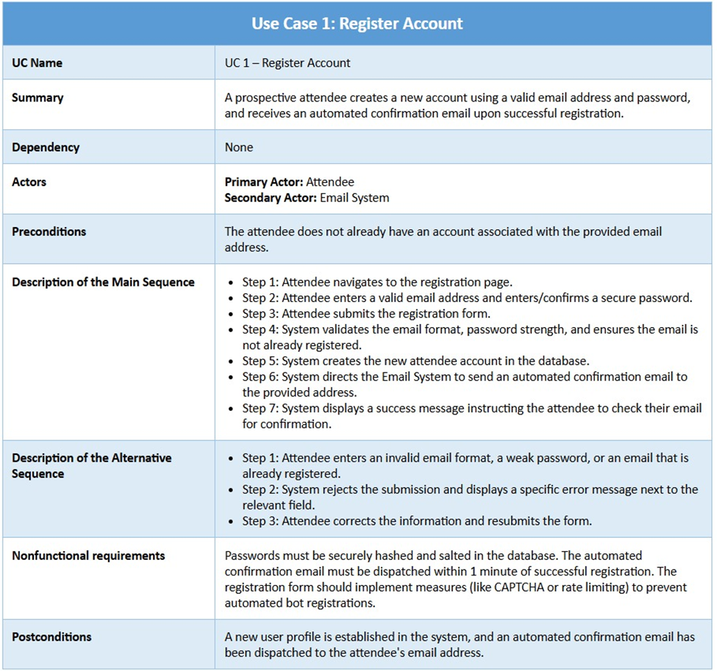
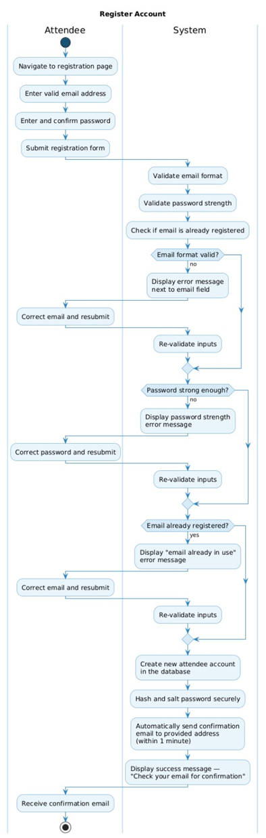

FR_2 – Attendee shall log in to the system using their registered credentials
UC Name | UC 2 – Log In
Summary | A registered attendee logs into the system using their email and password.
Dependency | UC 1 – Register Account must be completed.
Actors | Primary Actor: Attendee Secondary Actor: System Administrator
Preconditions | The attendee has a registered and confirmed account. The attendee is not currently logged in.
Description of the Main Sequence | • Step 1: Attendee navigates to the login page.  • Step 2: Attendee enters their registered email and password.  • Step 3: System validates credentials against stored records.  • Step 4: System creates an authenticated session.  • Step 5: Attendee is redirected to the home/dashboard page.
Description of the Alternative Sequence | • Step 1: Attendee enters an incorrect email or password.  • Step 2: System displays an authentication error.  • Step 3: After 5 failed attempts, the account is temporarily locked.  • Step 4: Attendee may request a password reset.
Nonfunctional requirements | Login must be completed within 2 seconds. Failed login attempts must be logged for security auditing. Session tokens must expire after a defined inactivity period.
Postconditions | The attendee has an active, authenticated session and can access protected features of the platform.

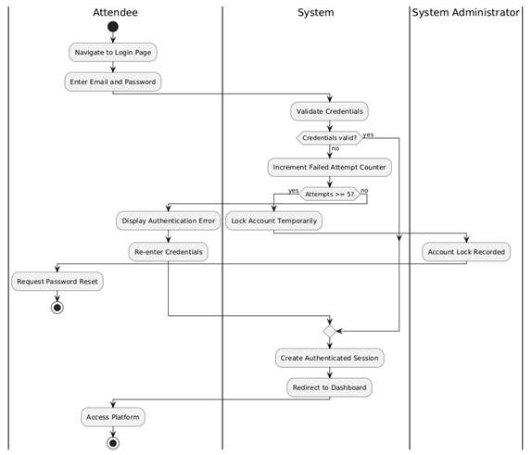

FR_3 – Attendee shall browse the full list of available events on the platform
UC Name | UC 3 – Browse Events
Summary | A logged-in attendee views the full list of available events on the platform.
Dependency | UC 2 – Log In
Actors | Primary Actor: Attendee Secondary Actor: Event Organizer
Preconditions | The attendee is logged in. At least one event exists in the system.
Description of the Main Sequence | • Step 1: Attendee navigates to the events listing page.  • Step 2: System retrieves all available events from the database.  • Step 3: System displays events in a paginated or scrollable list.  • Step 4: Attendee scrolls through and views of event summaries (name, date, location).
Description of the Alternative Sequence | • Step 1: No events are currently available in the system.  • Step 2: System displays a 'No events available' message.  • Step 3: Attendee is prompted to check back later.
Nonfunctional requirements | The event list must be loaded within 3 seconds. The list must support pagination or lazy loading for performance. The interface must be responsive across devices.
Postconditions | The attendee has been presented with a complete list of currently available events.

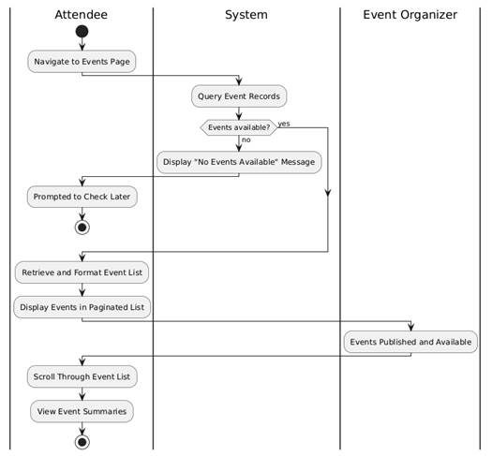

FR_4 – Attendee shall search and filter for events by name, date, location, or category
UC Name | UC 4 – Search and Filter Events
Summary | An attendee searches for events using keywords or filters such as name, date, location, or category.
Dependency | UC 3 – Browse Events
Actors | Primary Actor: Attendee Secondary Actor: Event Organizer
Preconditions | The attendee is logged in and, on the events, listing page. At least one event exists in the system.
Description of the Main Sequence | • Step 1: Attendee enters a keyword in the search bar or selects filter criteria (date, location, category).  • Step 2: System processes the search/filter query.  • Step 3: System retrieves matching events from the database.  • Step 4: System displays the filtered list of events to the attendee.  • Step 5: Attendee reviews the results.
Description of the Alternative Sequence | • Step 1: No events match the search or filter criteria.  • Step 2: System displays a 'No results found' message.  • Step 3: Attendee is prompted to adjust their search criteria.
Nonfunctional requirements | Search results must be returned within 2 seconds. The system must support partial text matching. Filters must be combinable (e.g. date + category).
Postconditions | A filtered list of events matching the attendee's criteria is displayed.

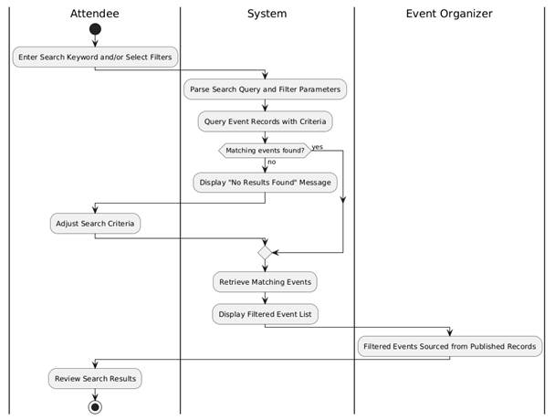

FR_5 – Attendee shall view the complete details of any selected event
UC Name | UC 5 – View Event Details
Summary | An attendee selects an event and views its complete details including description, date, time, location, and available tickets.
Dependency | UC 3 – Browse Events, UC 4 – Search and Filter Events
Actors | Primary Actor: Attendee Secondary Actor: Event Organizer
Preconditions | The attendee is logged in. The selected event exists and is active in the system.
Description of the Main Sequence | • Step 1: Attendee clicks on an event from the list or search results.  • Step 2: System retrieves the full details of the selected event from the database.  • Step 3: System displays the event detail page including name, description, date, time, location, category, organizer, and ticket availability.  • Step 4: Attendee reviews the event details.
Description of the Alternative Sequence | • Step 1: The selected event has been removed or is no longer available.  • Step 2: System displays an 'Event not found' or 'Event no longer available' message.  • Step 3: Attendee is redirected back to the event listing.
Nonfunctional requirements | The event detail page must be loaded within 2 seconds. All displayed information must be accurate and up to date. The page must be accessible and rendered correctly on all screen sizes.
Postconditions | The attendee has viewed the complete and current details of the selected event.

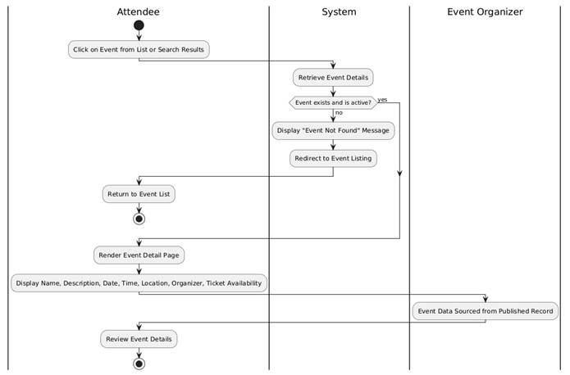

FR_09 Attendee shall manage their personal profile, preferences, and saved payment methods

UC Name | UC_09: Manage Attendee Profile, Preferences, and Payments
Summary | Allows the Attendee to view and update their personal information, communication preferences, and secure payment methods within the system.
Dependency | User must be authenticated (Login Use Case).
Actors | Primary Actor: Attendee  Secondary Actor: Payment Gateway (for card validation), Database
Preconditions | The Attendee is successfully logged into their account.
Description of the Main Sequence | Step 1: Attendee navigates to the "Account Settings" or "Profile" section.  Step 2: System retrieves and displays current profile data, notification preferences, and masked payment methods.  Step 3: Attendee modifies personal details (e.g., Name, Bio, Profile Picture) and saves changes.  Step 4: Attendee updates preferences (e.g., opting in/out of email notifications).  Step 5: Attendee adds a new payment method by entering card/billing details.  Step 6: System validates the data and confirms the update to the Attendee.
Description of the Alternative Sequence | Step 1 (Invalid Input): If the Attendee enters an invalid email format or empty required fields, the system displays a validation error and highlights the specific field.  Step 2 (Payment Validation Failure): If a new payment method fails validation (e.g., expired card), the system displays an error message from the gateway and prompts for a different card.  Step 3 (Delete Payment): Attendee selects "Remove" on an existing card; the system asks for confirmation before deleting the record.
Non functional  requirements | Security: Payment data must be handled via PCI-DSS compliant tokenization (no raw card numbers stored).  Performance: Profile updates should reflect within < 2 seconds.
Postconditions | The Attendee’s profile, preferences, and payment information are updated in the database and persist for future sessions/registrations.

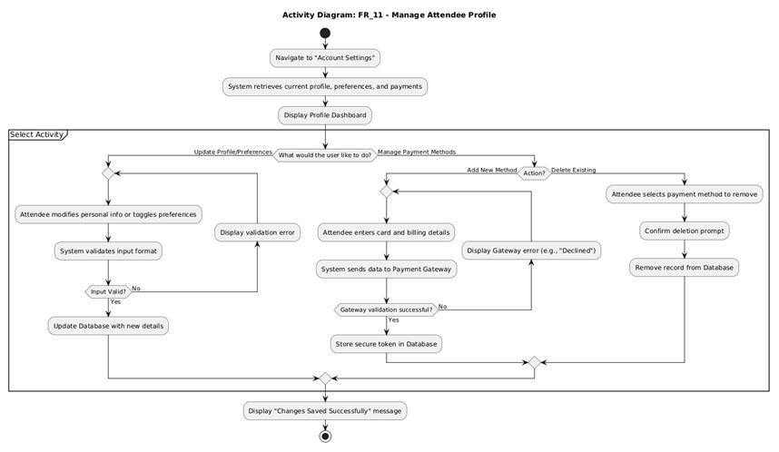

FR_10 Attendee shall join a waitlist when an event has reached its maximum capacity

UC Name | UC_10: Join Event Waitlist
Summary | When an event is at maximum capacity, the Attendee can join a waitlist to be prioritized for a spot if a registered user cancels.
Dependency | User must be logged in; Event must have "Waitlist" enabled by the Organizer.
Actors | Primary Actor: Attendee  Secondary Actor: Database, Notification System
Preconditions | The event has reached its defined max_capacity. The Attendee is not already registered or on the waitlist.
Description of the Main Sequence | Step 1: Attendee navigates to the Event Detail page.  Step 2: System detects that the event is full and displays a "Join Waitlist" button instead of "Register."  Step 3: Attendee clicks "Join Waitlist."  Step 4: System validates the Attendee's eligibility (e.g., no scheduling conflicts).  Step 5: System adds the Attendee to the waitlist in a First-In-First-Out (FIFO) order.  Step 6: System displays a confirmation message with the Attendee's position (optional).
Description of the Alternative Sequence | Step 1 (Waitlist Full): If the waitlist also has a maximum capacity and is full, the system displays "Event and Waitlist Sold Out."  Step 2 (Already on List): If the Attendee is already on the list, the system displays "You are currently #X on the waitlist."  Step 3 (Waitlist Disabled): If the Organizer disabled waitlisting for this specific event, the system simply shows "Sold Out."
Non functional requirements | Reliability: The waitlist order must be strictly preserved (Atomic operations).  Performance: Joining the waitlist should be processed in < 500ms.
Postconditions | The Attendee is recorded in the waitlist table linked to the specific event ID.

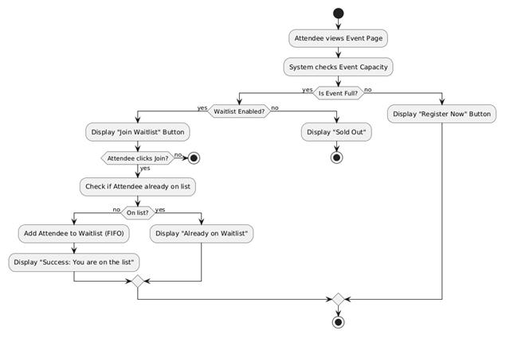

FR_11 Event Organizer shall create a new event with title, date, time, location, and description

UC Name | UC_11: Create New Event
Summary | Enables the Event Organizer to set up a new event by  providing essential details such as title, date, time, location, and a description.
Dependency | User must be authenticated with "Organizer" or "Admin" privileges.
Actors | Primary Actor: Event Organizer  Secondary Actor: Database
Preconditions | The Organizer is logged into the management dashboard.
Description of the Main Sequence | Step 1: Organizer selects "Create New Event" from the dashboard.  Step 2: System presents a form with fields for Title, Date, Time, Location, and Description.  Step 3: Organizer enters the event details.  Step 4: Organizer clicks the "Save" or "Publish" button.  Step 5: System validates that all mandatory fields are completed and formatted correctly.  Step 6: System saves the event to the database and generates a unique Event ID.  Step 7: System displays a success message and redirects to the Event Preview page.
Description of the Alternative Sequence | Step 1 (Missing Information): If any required field (e.g., Date or Title) is left blank, the system highlights the missing fields and prevents submission.  Step 2 (Invalid Date/Time): If the Organizer selects a date in the past, the system displays an error message: "Event date must be in the future."  Step 3 (Draft Save): If the Organizer chooses "Save as Draft," the system saves the progress without making the event visible to Attendees.
Non functional requirements | Usability: The form should be navigable via keyboard (Tab index).  Availability: The event creation service must be available 99.9% of the time.
Postconditions | A new event record exists in the database with the state set to "Published" or "Draft."

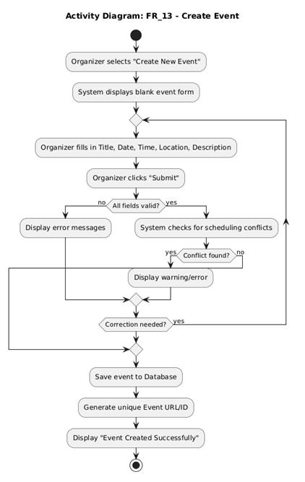

FR_12 Event Organizer shall edit the details of an existing published event

UC Name | UC_12: Edit Published Event Details
Summary | Allows the Event Organizer to modify the information of an event that is already visible to the public and potentially has registered attendees.
Dependency | UC_11 (Event must be created/published); Organizer must have edit permissions.
Actors | Primary Actor: Event Organizer  Secondary Actor: Database, Notification Service (to alert registered attendees)
Preconditions | The event exists in the database with a "Published" status.
Description of the Main Sequence | Step 1: Organizer selects the published event from their management list.  Step 2: System retrieves and displays the current event data in an editable form.  Step 3: Organizer modifies the necessary fields (e.g., changing the venue or start time).  Step 4: Organizer clicks "Update Event."  Step 5: System validates the new data for logic errors (e.g., date in the past).  Step 6: System updates the database record.  Step 7: System identifies critical changes (Time/Location) and triggers notifications to already registered attendees.  Step 8: System displays a confirmation message.
Description of the Alternative Sequence | Step 1 (Read-Only Fields): If the event has already started or ended, the system disables the "Edit" button or makes specific fields (like Date) non-editable.  Step 2 (Discard Changes): If the Organizer exits without saving, the system prompts: "Unsaved changes will be lost. Proceed?"  Step 3 (Validation Failure): If the new location is invalid, the system prevents saving and highlights the error.
Non functional requirements | Integrity: The system must ensure no data loss during the update process.  Audit: All edits should be logged (who changed what and when).
Postconditions | The event details are updated in the system, and any registered attendees are notified of significant changes.

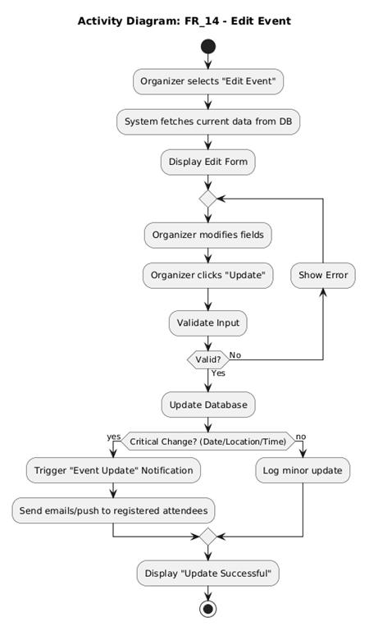

FR_13 Event Organizer shall cancel an event and trigger automated notifications to all registered attendees

UC Name | UC_13: Cancel Event and Notify Attendees
Summary | Allows the Event Organizer to officially cancel an event. The system then automatically changes the event status and alerts all registered participants.
Dependency | UC_12 (Event must exist).
Actors | Primary Actor: Event Organizer  Secondary Actor: Notification System (Email/Push), Database
Preconditions | The event is currently in a "Published" or "Draft" state and has not yet concluded.
Description of the Main Sequence | Step 1: Organizer navigates to the Event Management dashboard.  Step 2: Organizer selects the specific event and clicks "Cancel Event."  Step 3: System prompts for a cancellation reason (e.g., "Inclement weather") and a final confirmation.  Step 4: Organizer provides the reason and confirms.  Step 5: System updates the Event status to "Cancelled" in the database.  Step 6: System fetches the list of all registered attendees.  Step 7: System triggers automated notifications containing the cancellation reason to all attendees.  Step 8: System displays a confirmation that the event is cancelled and alerts have been sent.
Description of the Alternative Sequence | Step 1 (Event Already Cancelled): If the event is already cancelled, the button is disabled.  Step 2 (Cancellation Aborted): If the Organizer clicks "Cancel" on the confirmation prompt, the system returns to the dashboard without changes.  Step 3 (Notification Failure): If the email server is down, the system logs the failure and puts the notifications in a retry queue.
Non-Fuctional Requirements | Reliability: 100% of registered attendees must receive a notification (via at least one channel).  Audit: The timestamp and reason for cancellation must be permanently stored.
Postconditions | The event status is "Cancelled," and all registered attendees have been notified.

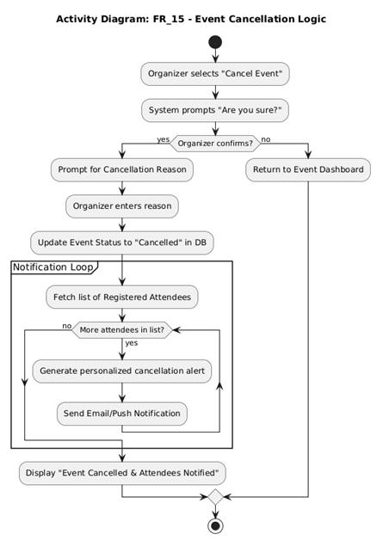

UC-14 Event Organizer shall set ticket price, ticket type tiers, and maximum venue capacity
UML Table
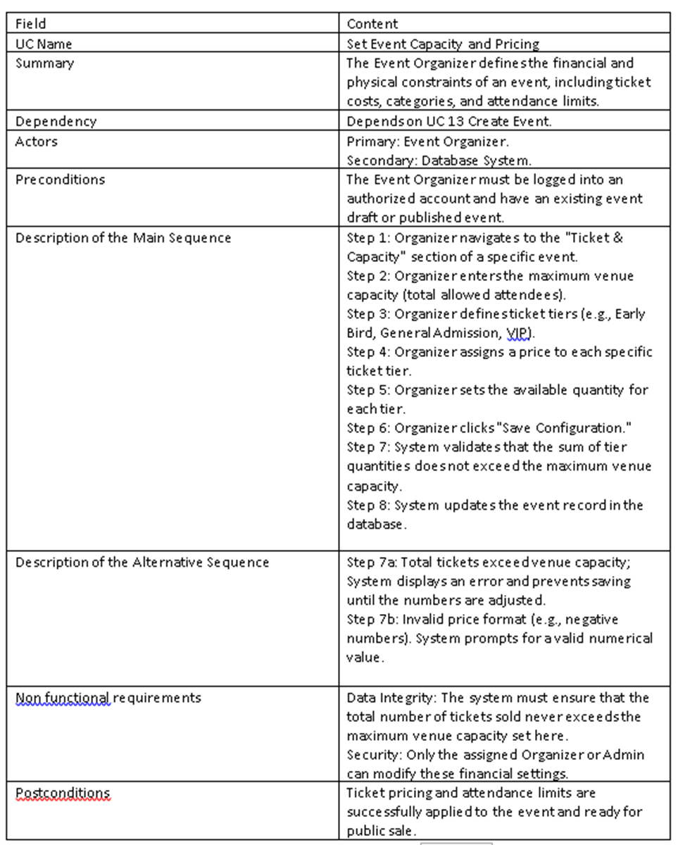
SWIMLANE DIAGRAM

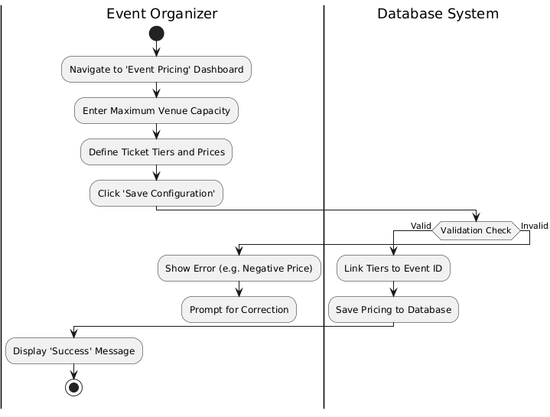

UC -15 Event Organizer shall assign tasks and roles to staff members and service providers
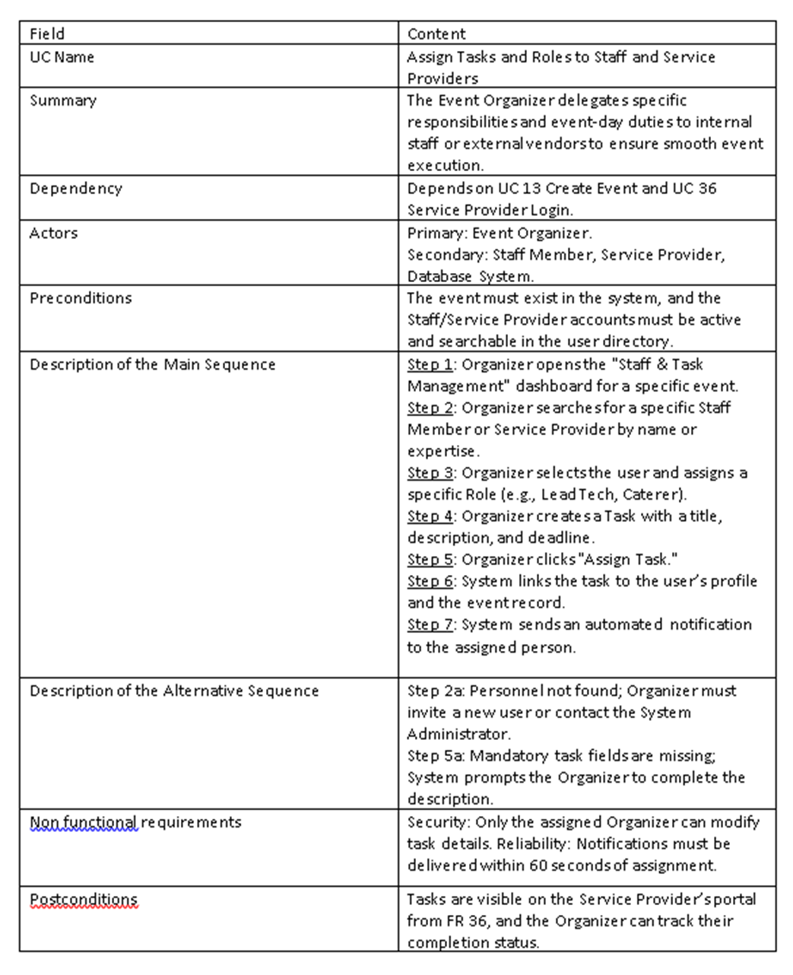
UML Table

SWIMLANE DIAGRAM

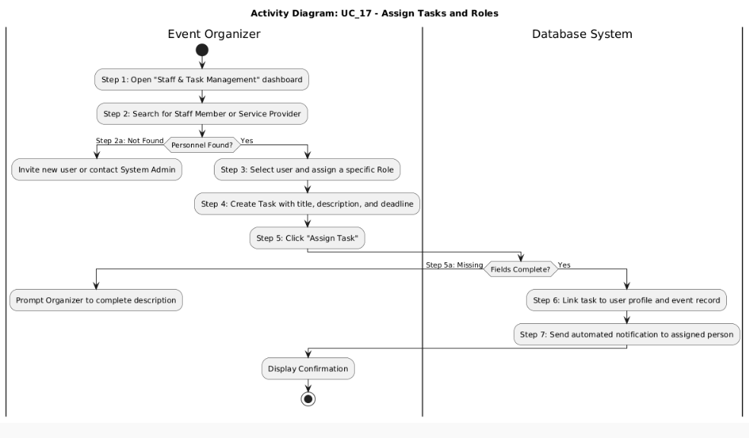

UC-16 Event Organizer shall view and export the full list of registered attendees
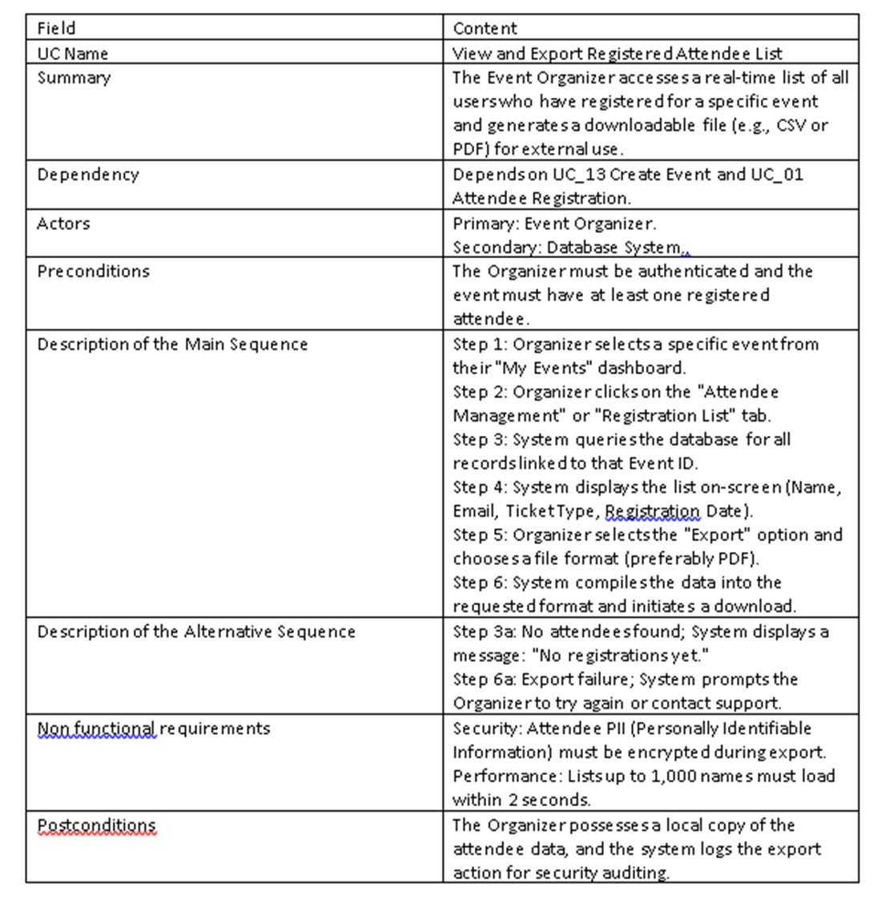
UML Table

SWIMLANE DIAGRAM

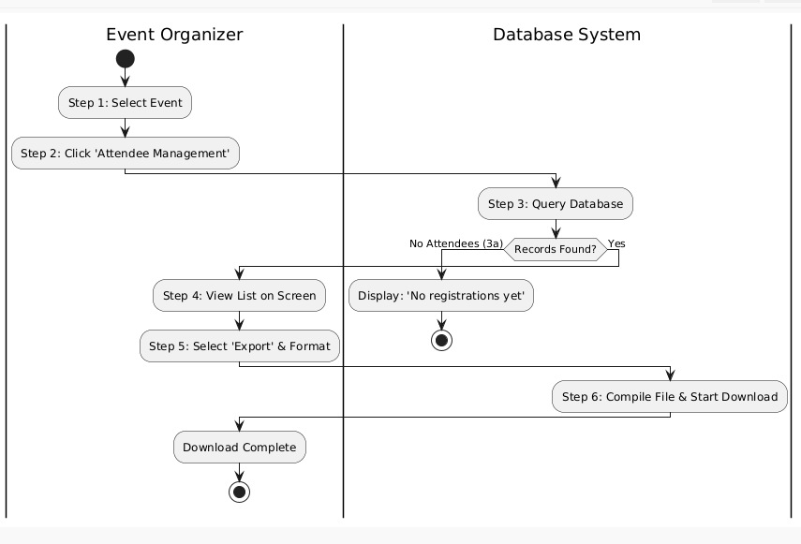

UC-17 Event Organizer shall generate a detailed report on attendance, revenue, and feedback
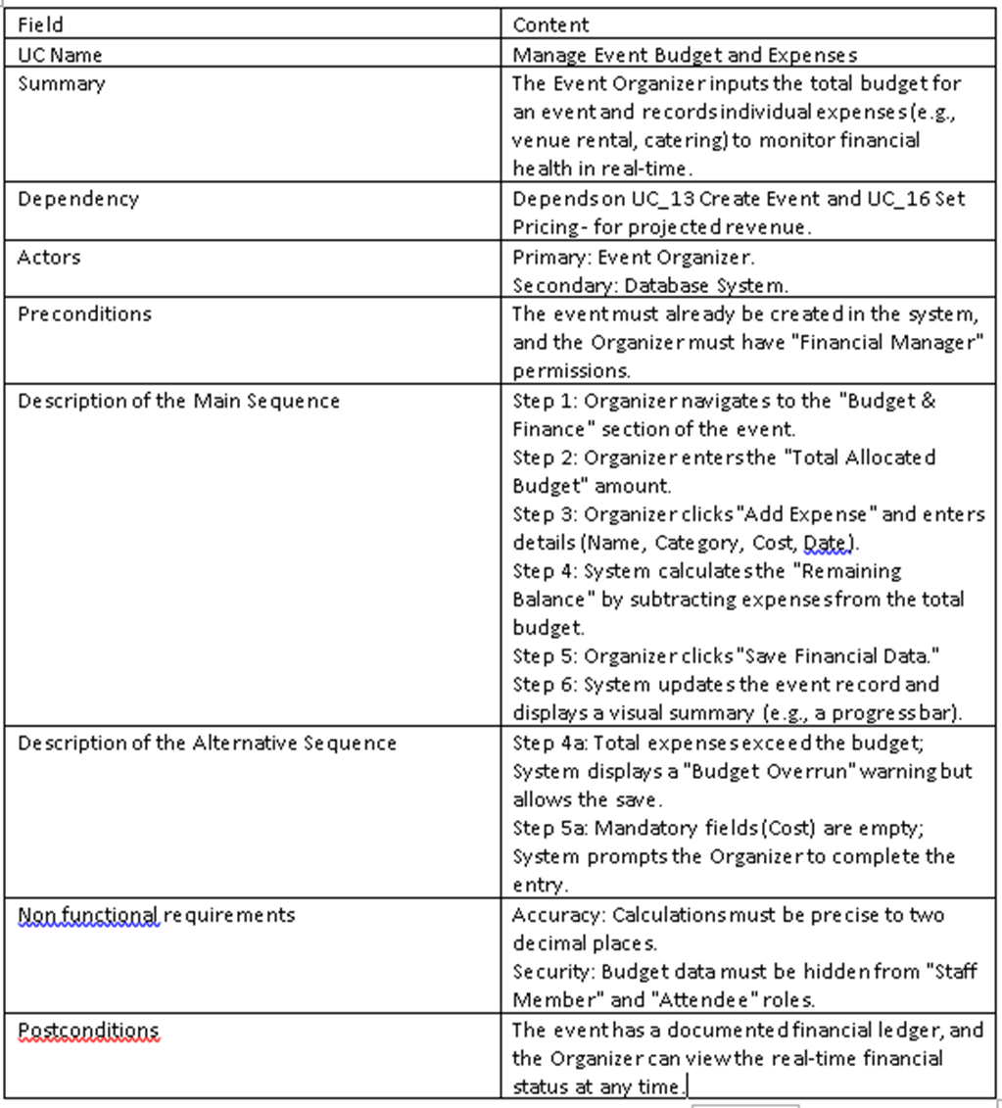
UML Table

SWIMLANE DIAGRAM

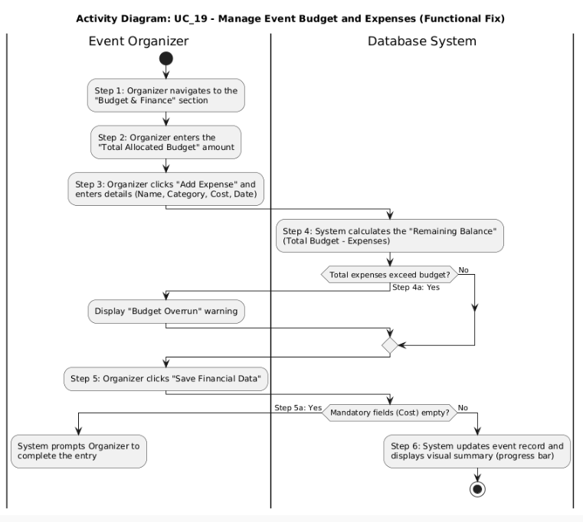

UC-18 Event Organizer shall manage the schedule of sessions and sub-events within a larger event
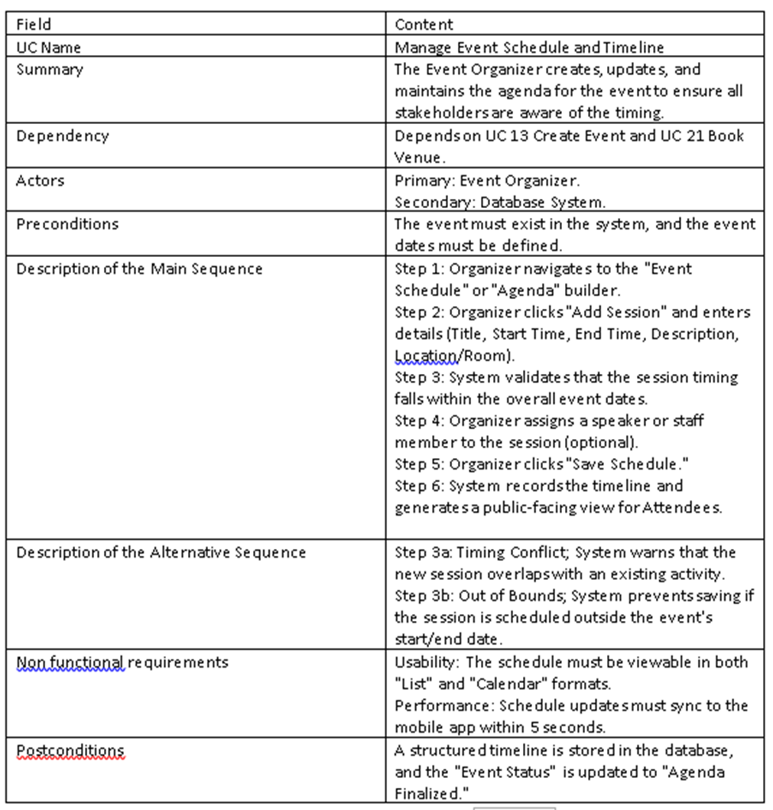
UML Table

SWIMLANE DIAGRAM
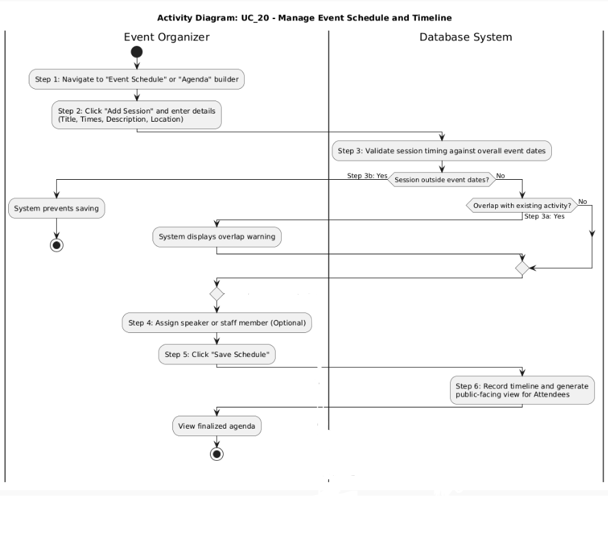

FR_19 Event Organizer shall book a venue for an event based on availability shown by the Venue Manager
Swimlane:
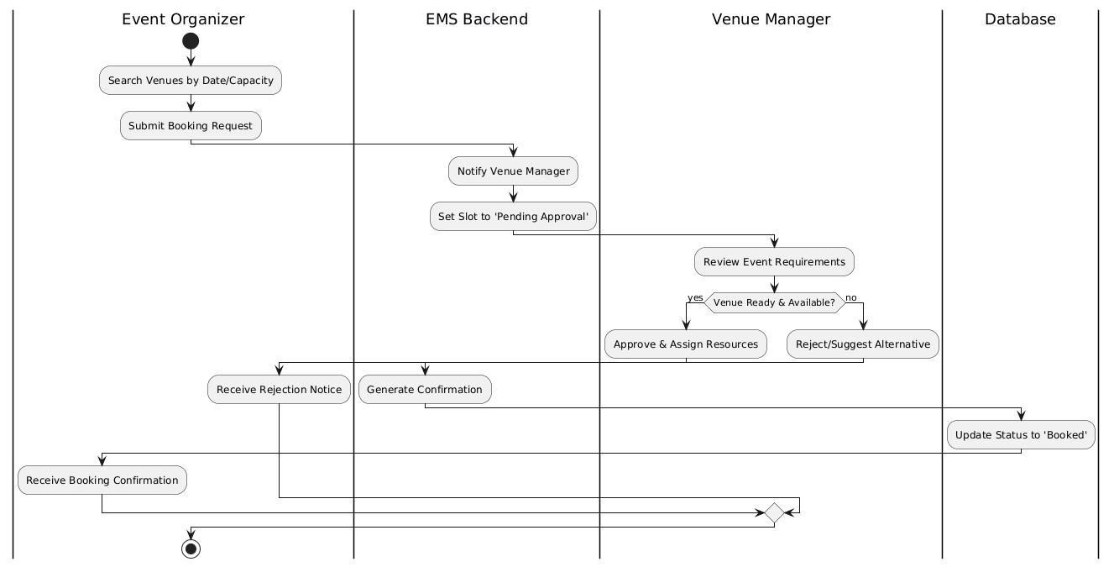
Field | Description
UC Name | Book Venue
Summary | Event Organizer selects and secures a venue based on real-time availability.
Dependency | None
Actors | Primary: Event Organizer; Secondary: Venue Manager
Preconditions | Organizer is logged in; Venue Manager has updated the availability calendar.
Description of the Main Sequence | • Step 1: Organizer searches for available dates.  • Step 2: System displays available slots from Venue Manager.  • Step 3: Organizer selects a specific slot and venue.  • Step 4: System sends a booking request to the Venue Manager.  • Step 5: System confirms the booking and updates the calendar.
Description of the Alternative Sequence | • Step 1: Requested date is unavailable.  • Step 2: System suggests alternative venues or dates.  • Step 3: Organizer chooses a new date or exits.
Non-functional requirements | Security: Only authorized Organizers can book; Performance: Updates within 2s.
Postconditions | Venue is marked as "Reserved"; Organizer receives a confirmation notice.

FR_20 Event Organizer shall monitor the real-time budget and expenses of an event

Swimlane:
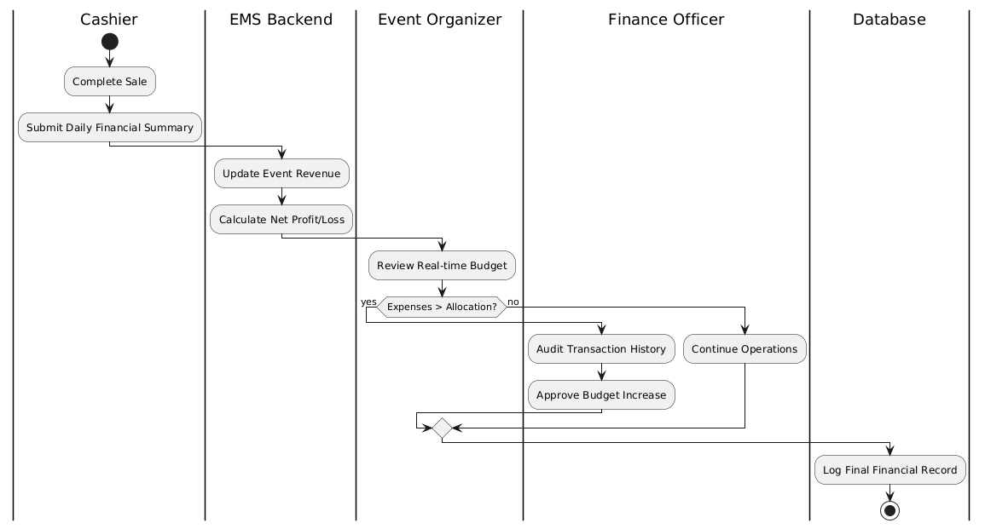

Field | Description
UC Name | Monitor Real-time Budget and Expenses
Summary | Event Organizer tracks the financial status of an event as expenses occur.
Dependency | None
Actors | Primary: Event Organizer
Preconditions | An initial event budget has been set and the system has access to expense logs.
Description of Main Sequence | • Step 1: Organizer opens the Budget Dashboard.  • Step 2: System pulls real-time data from internal expense records.  • Step 3: System calculates the difference between budget and actual spend.  • Step 4: Organizer views the visual financial report.
Description of Alt. Sequence | • Step 1: Expenses exceed the budget.  • Step 2: System flags the discrepancy with a red alert.  • Step 3: Organizer reviews over-budget items.
Non-functional reqs. | Accuracy: Calculations must be 100% accurate; Usability: Dashboard must be mobile-friendly.
Postconditions | The Organizer has an up-to-date view of the event's financial health.
FR_21 Event Organizer shall create and manage promotional discount codes for ticket sales
Swimlane:
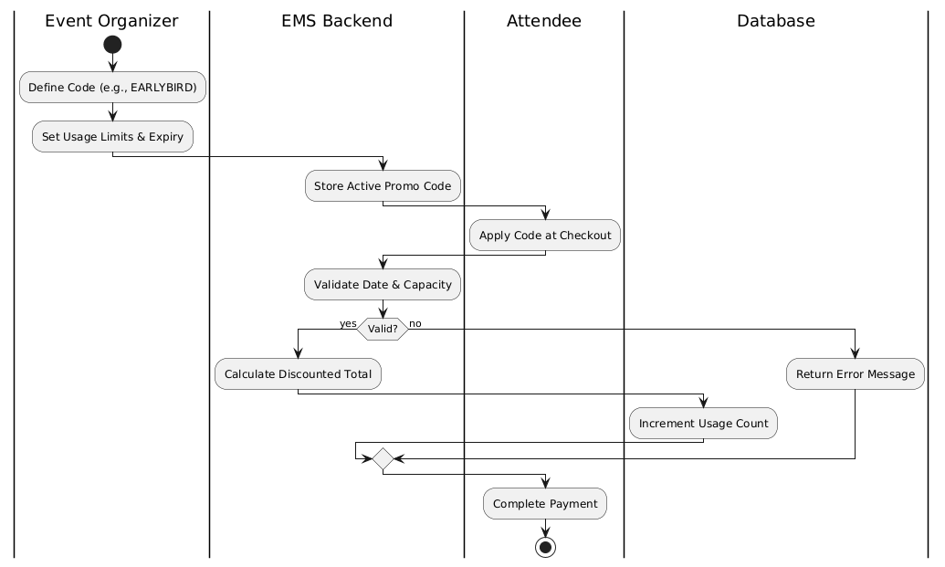
Field | Description
UC Name | Manage Promotional Discount Codes
Summary | Event Organizer creates, updates, or deletes codes used for ticket price reductions.
Dependency | None
Actors | Primary: Event Organizer
Preconditions | The system’s payment module is active.
Description of Main Sequence | • Step 1: Organizer enters the "Promotions" section.  • Step 2: Organizer enters a code string (e.g., "EARLYBIRD") and a discount value.  • Step 3: Organizer sets usage limits and expiration dates.  • Step 4: System saves and activates the code.
Description of Alt. Sequence | • Step 1: Organizer attempts to create a duplicate code name.  • Step 2: System prevents entry and requests a unique code string.
Non-functional reqs. | Reliability: Codes must apply immediately upon activation.
Postconditions | A new or updated discount code is available for use during checkout.

FR_22 Cashier shall process ticket payments on behalf of walk-in attendees at the venue
Swimlane:
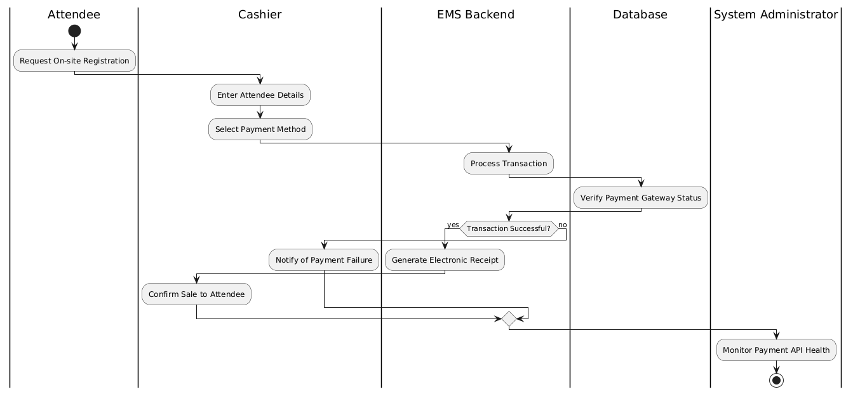

Field | Description
UC Name | Process Walk-in Payments
Summary | Cashier processes manual payments for attendees purchasing tickets at the venue.
Dependency | Manage Promotional Discount Codes (if discount codes are applied)
Actors | Primary: Cashier; Secondary: Attendee
Preconditions | POS (Point of Sale) system is online and ticket inventory is available.
Description of Main Sequence | • Step 1: Cashier selects ticket type and quantity.  • Step 2: Cashier inputs attendee payment details (Cash/Card).  • Step 3: System validates payment with the bank/processor.  • Step 4: System records the sale and updates inventory.
Description of Alt. Sequence | • Step 1: Payment is declined.  • Step 2: System notifies the Cashier.  • Step 3: Cashier asks for a different payment method or cancels the sale.
Non-functional reqs. | Performance: Payment processing must complete within 10 seconds.
Postconditions | Payment is confirmed, and the transaction is added to the daily sales report.

FR_23 Cashier shall issue and print physical tickets for attendees at the point of sale
Swimlane:
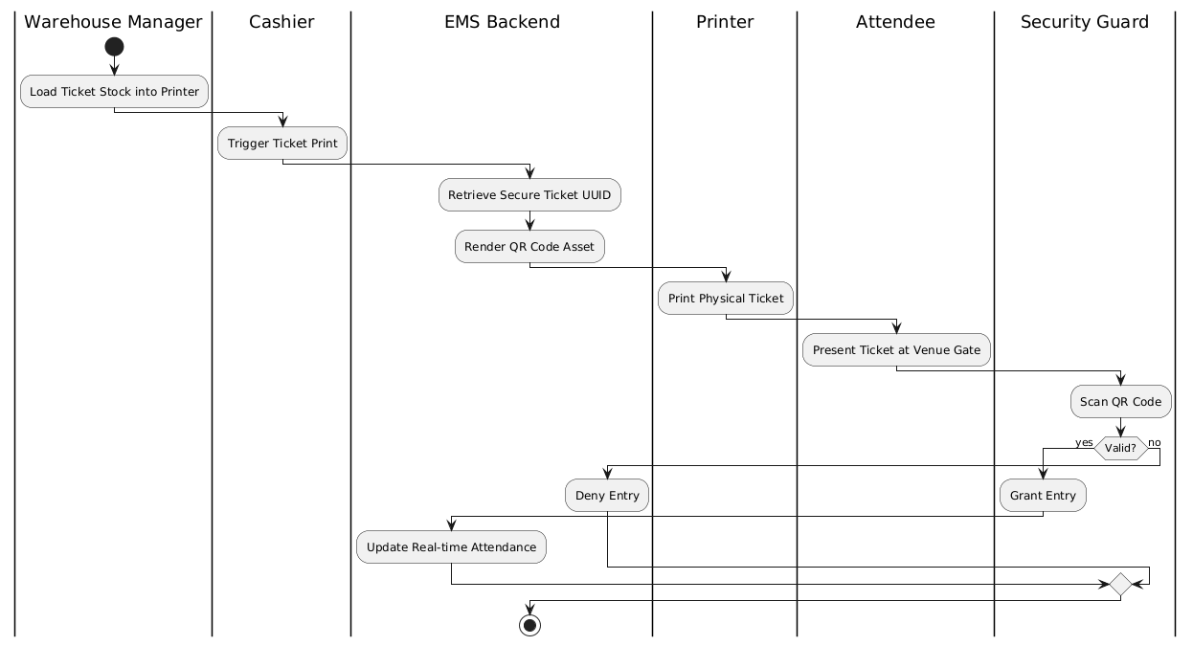
Field | Description
UC Name | Issue and Print Physical Tickets
Summary | Cashier generates and prints a physical ticket for an attendee after a successful sale.
Dependency | Process Walk-in Payments (Requires a successful payment)
Actors | Primary: Cashier
Preconditions | Payment has been verified (UC-04) and printer is connected.
Description of Main Sequence | • Step 1: System generates a unique QR code for the transaction.  • Step 2: System formats the ticket layout (Event name, Date, Seat).  • Step 3: Cashier triggers the "Print" command.  • Step 4: Printer produces the physical ticket.
Description of Alt. Sequence | • Step 1: Printer is out of paper or disconnected.  • Step 2: System displays a hardware error alert.  • Step 3: Cashier resolves the hardware issue and selects "Reprint."
Non-functional reqs. | Security: Each ticket must have a unique encrypted ID to prevent fraud.
Postconditions | Attendee receives a physical ticket that is valid for event entry.

UC Name | UC 24 – Refund
Summary | FR_24: Cashier shall process full or partial refund requests in accordance with the event refund policy
Dependency | UC 23- Ticket must be issued.
Actors | Primary Actor: Cashier Secondary Actor: Attendee
Preconditions | The attendee must have a valid ticket .
Description of the Main Sequence | • Step 1: Cashier views the ticket given by the attendee.  • Step 2: Cashier verifies the tickets are valid.  • Step 3: System validates the purchase price and date.  • Step 4: System calculates possible refund.  • Step 5:Cashier refunds the ticket and invalidates it.
Description of the Alternative Sequence | • Step 1: Attendee has invalid ticket.  • Step 2: System displays an authentication error.  • Step 3: Cashier informs attendee.
Nonfunctional requirements | System lookup must make sure the same ticket isn't refunded twice.
Postconditions | Refund is confirmed and its added to the daily finance report

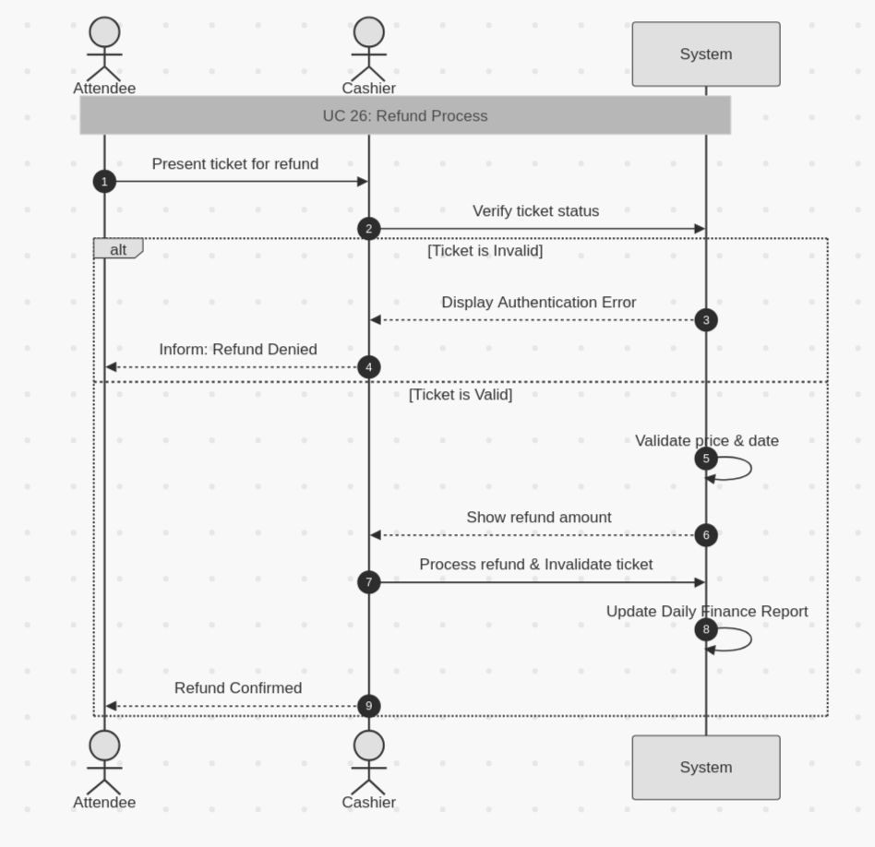

UC Name | UC 25 - Daily finance report
Summary | FR_25: Cashier shall generate a daily financial summary report of all transactions for the day
Dependency | UC 24- Transactions must have occurred.
Actors | Primary Actor: Cashier
Preconditions | The system must have been active.
Description of the Main Sequence | • Step 1: Cashier views all transactions for the day.  • Step 2: Cashier validates each one.  • Step 3: System validates date.  • Step 4: System creates a spreadsheet including all issued tickets and refunds.  • Step 5: System uploads spreadsheet
Description of the Alternative Sequence | • Step 1: Mistakenly a transaction is either added or deleted.  • Step 2:Cashier checks transaction history.  • Step 3: Cashier rolls back change.
Nonfunctional requirements | Cashier must be attentive while validating.
Postconditions | Spreadsheet is made public for all to see
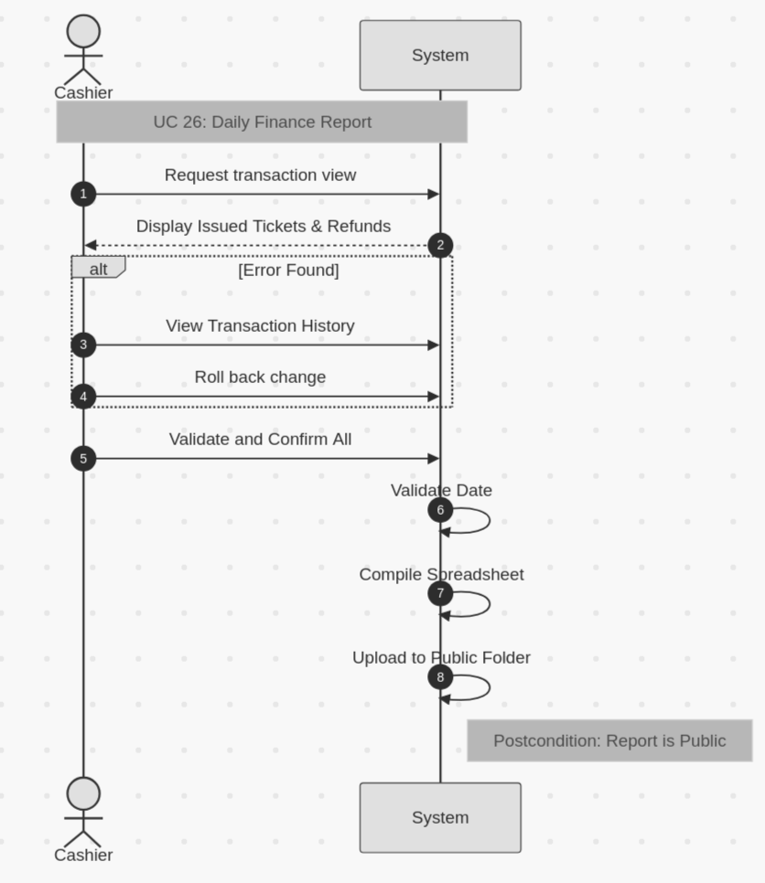

UC Name | UC 26 – Availability update
Summary | FR_26: Venue Manager shall update availability status of a venue for specific dates
Dependency | UC 11- Event must be created.
Actors | Primary Actor: Venue manager
Preconditions | Venue must be a real place and added into the system.
Description of the Main Sequence | • Step 1: Venue manager is logged into the system.  • Step 2: Venue manager locates the desired event.  • Step 3: Venue manager validates event status.  • Step 4: Venue manager makes change to status.  • Step 5: Status is saved to the database by the system.
Description of the Alternative Sequence | • Step 1: Event is non existent .  • Step 2: System cannot locate it.  • Step 3: Venue manager request event creation.
Nonfunctional requirements | Venue manager must approve before changes are saved by the system
Postconditions | Updated status is made public for all.
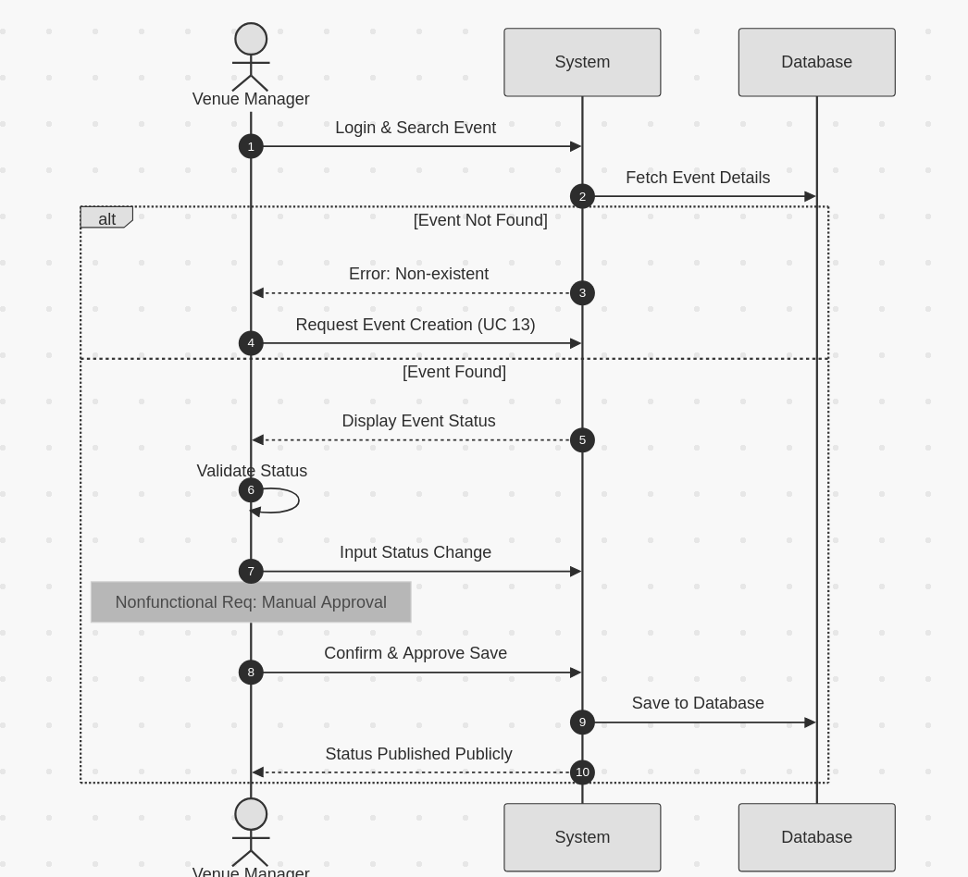

UC Name | UC 27 - Set maximum capacity
Summary | FR_27: Venue Manager shall set and enforce the maximum attendee capacity for each venue
Dependency | UC 11 - Event must exist.
Actors | Primary Actor: Venue manager
Preconditions | Venue must be a real place and added into the system.
Description of the Main Sequence | • Step 1: Venue manager is logged into the system.  • Step 2: Venue manager locates the desired event.  • Step 3: Venue manager validates event capacity.  • Step 4: Venue manager makes change to capacity.  • Step 5: Status is saved to the database by the system.
Description of the Alternative Sequence | • Step 1: Event is non existent .  • Step 2: System cannot locate it.  • Step 3: Venue manager requests event creation.
Nonfunctional requirements | Venue manager must approve before changes are saved by the system
Postconditions | Updated capacity is made public for all.
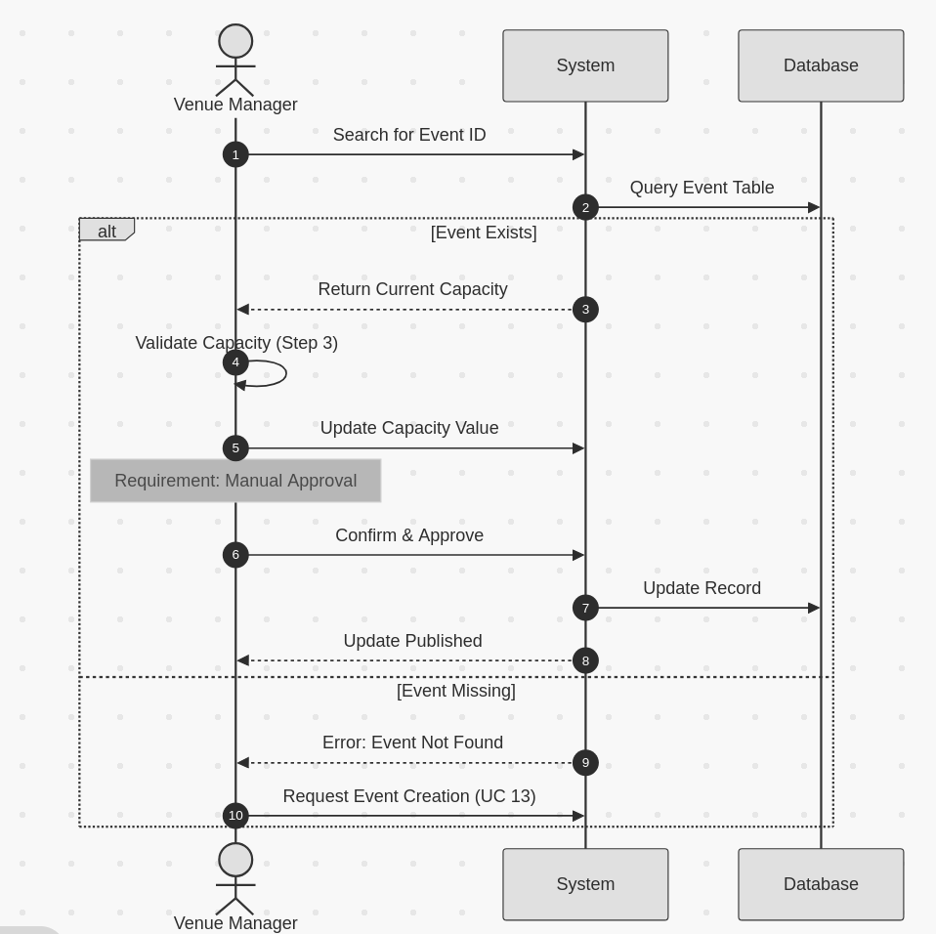

UC Name | UC 28 - Equipment allocation
Summary | FR_28: Venue Manager shall allocate equipment and physical resources to assigned events
Dependency | UC 11 - Event must exist.
Actors | Primary Actor: Venue manager
Preconditions | Venue must be a real place and added into the system.
Description of the Main Sequence | • Step 1: Venue manager is logged into the system.  • Step 2: Venue manager locates the desired event.  • Step 3: Venue manager decides on the necessary equipment.  • Step 4: Venue manager adds it to the venue requirements.  • Step 5: Status is saved to the database by the system.
Description of the Alternative Sequence | • Step 1: Event is non existent .  • Step 2: System cannot locate it.  • Step 3: Venue manager requests event creation.
Nonfunctional requirements | Venue manager must approve before changes are saved by the system
Postconditions | Updated requirements are made public for all users.
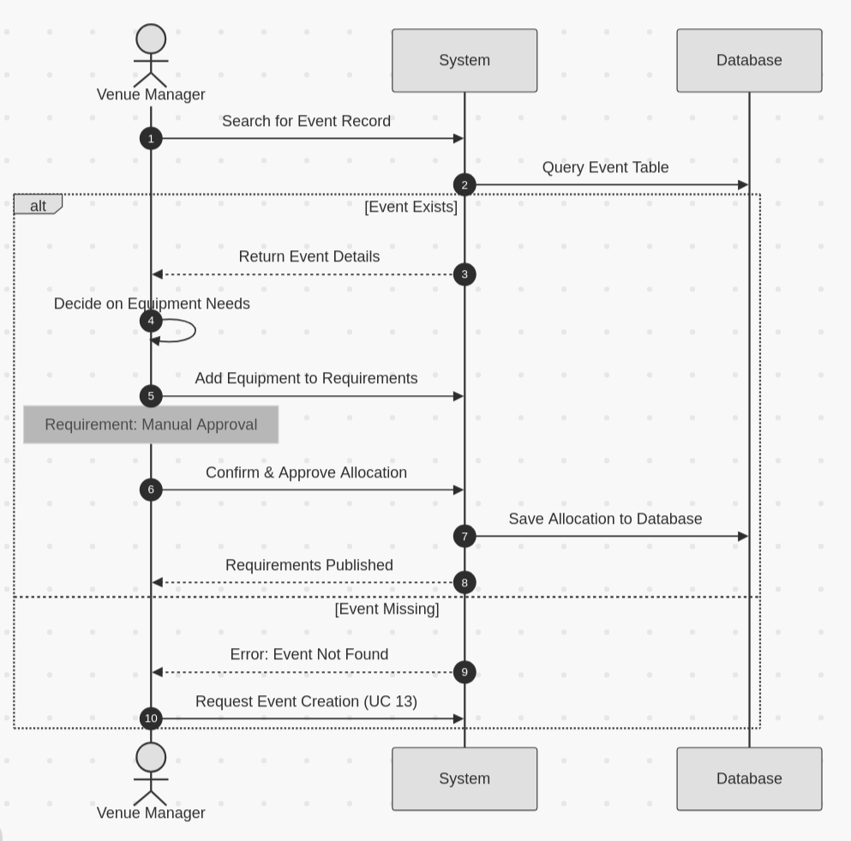

FR_29 Venue Manager shall view the full schedule of events assigned to their venue

Field | Description
UC Name | View Venue Event Schedule
Summary | Allows the Venue Manager to view a chronological list of all events booked and assigned to their managed venue.
Dependency | Organizer must have completed a venue booking (UC_21).
Actors | Primary: Venue Manager · Secondary: Database
Preconditions | Venue Manager is logged in. At least one event is assigned to their venue.
Description of Main Sequence | Step 1: Venue Manager navigates to "My Venue Schedule."  Step 2: System queries the database for all events linked to that venue.  Step 3: System displays a calendar/list view with event name, date, time, organizer, and capacity.  Step 4: Venue Manager can filter by date range or event status.  Step 5: System updates the view based on the applied filter.
Description of Alternative Sequence | Step 1 (No Events): If no events are scheduled, system displays "No events currently assigned to this venue."  Step 2 (Filter Returns Empty): System displays "No events match the selected filter
Non-functional reqs. | Performance: Schedule must load in under 2 seconds. Availability: Must be accessible 99.9% of the time.
Postconditions | Venue Manager has a current, accurate view of all scheduled events at their venue.

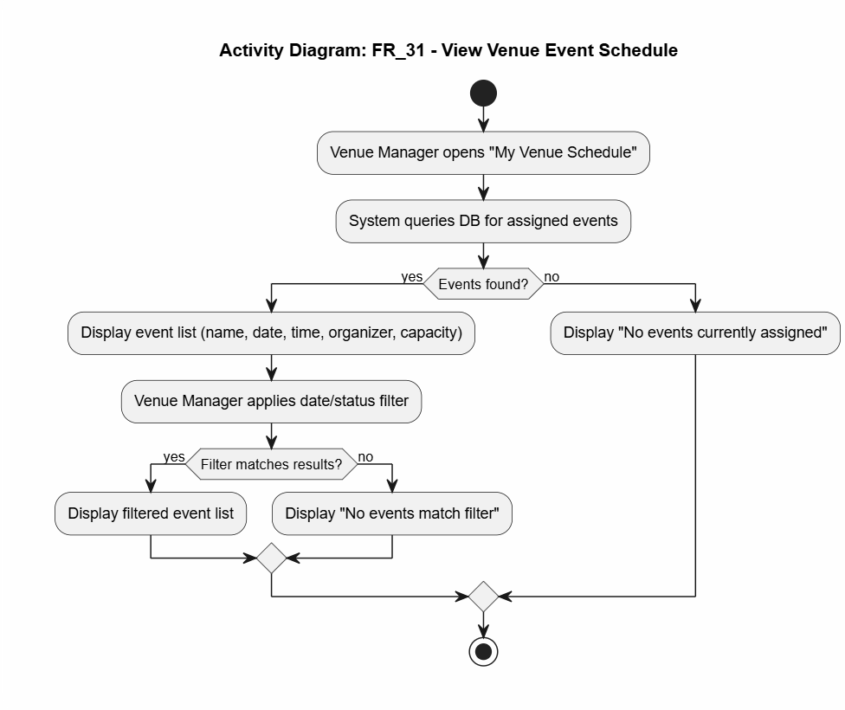

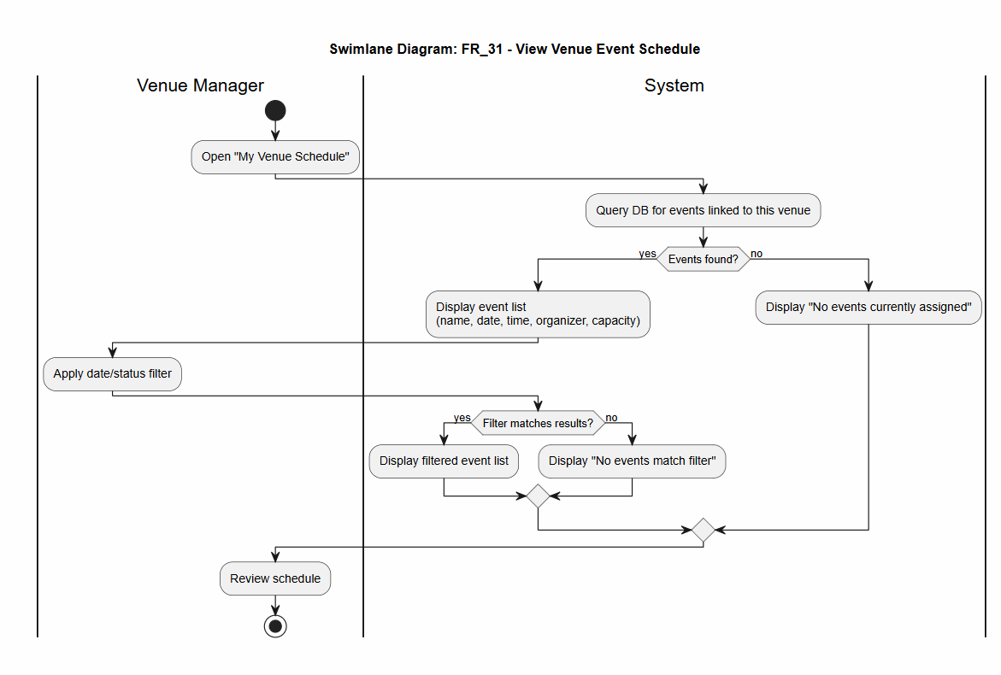

FR_30 Security Guard shall scan the QR code on an attendee ticket using a mobile device at entry and validate or reject entry based on the QR code scan result

UC Table

Field | Description
UC Name | UC_30: Validate Attendee Entry via QR Scan
Summary | A Security Guard uses a mobile device to scan an attendee’s QR code. The system verifies the ticket’s authenticity, event matching, and scan status to permit or deny entry.
Dependency | FR_02 (Login), FR_06 (Ticket Generation)
Actors | Primary Actor: Security Guard  Secondary Actor: Ticket Database, EMS Backend
Preconditions | 1. Security Guard is logged into the mobile scanning interface.  2. The mobile device has an active camera/scanner.  3. The attendee has presented a digital or printed QR code.
Main Sequence | Step 1: Security Guard activates the QR scanner within the app.  Step 2: Guard scans the attendee’s QR code.  Step 3: System decodes the QR data and queries the Ticket Database.  Step 4: System verifies the ticket is for the correct event and date.  Step 5: System checks that the ticket status is "Unused."  Step 6: System displays a "Valid - Access Granted" visual (Green) and audio cue.  Step 7: System updates ticket status to "Checked-In" with a timestamp.
Alternative Sequence | A1: Invalid QR Code: If the code cannot be read or doesn't exist in the DB, the system displays "Invalid Ticket" (Red).  A2: Duplicate Scan: If the ticket was already scanned, the system displays "Already Used" with the time of the first scan.  A3: Wrong Event: If the ticket is valid but for a different event, the system displays "Wrong Venue/Event."
Non-Functional Reqs | Performance: QR processing and DB lookup must occur in < 1.5 seconds to prevent entry bottlenecks.  Reliability: App must handle low-light scanning via the device's flash.
Postconditions | The attendee is marked as present in the database, and the real-time attendance count (FR_32) is updated.

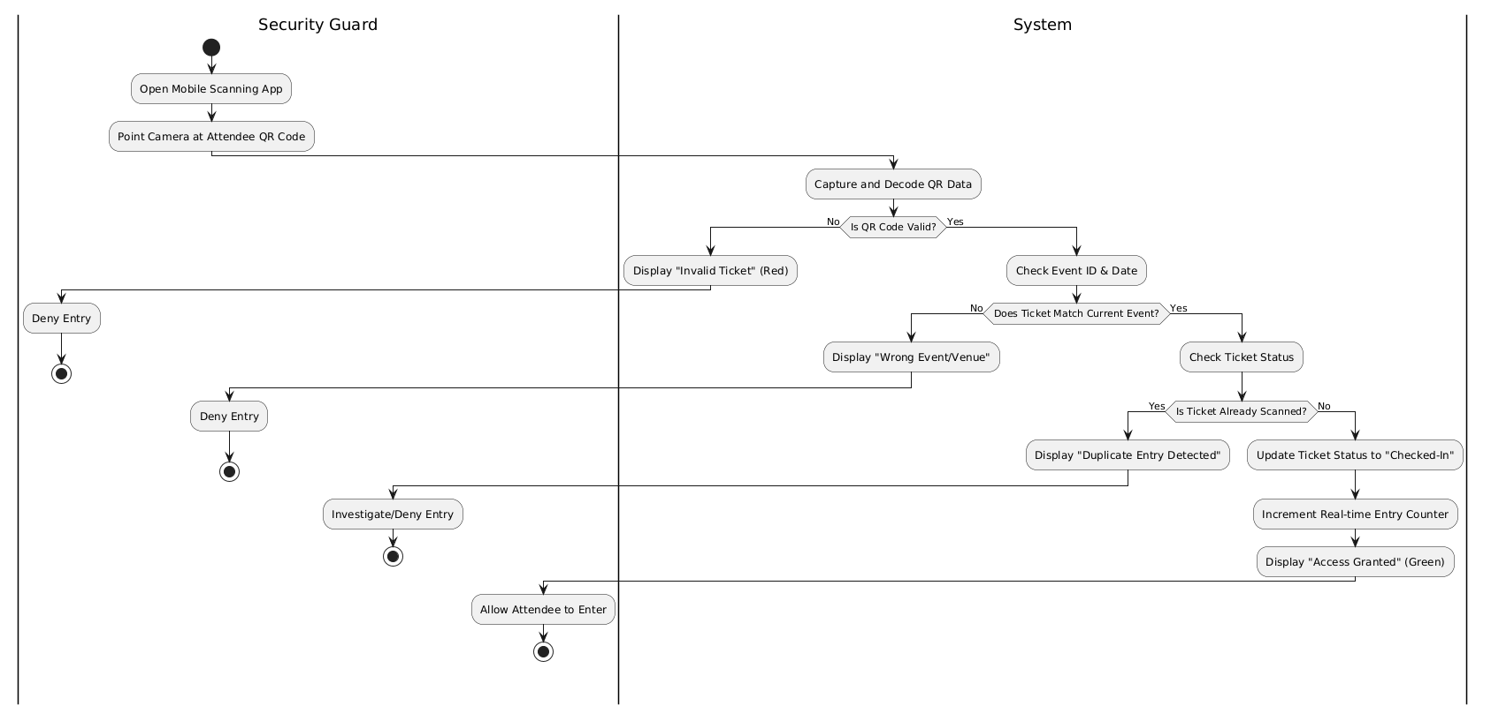

FR_31 Security Guard shall control and restrict access to designated restricted areas of the event

UC Table
Field | Description
UC Name | UC_31: Control Access to Restricted Areas
Summary | Security Guard enforces zone-based access control at the event, preventing unauthorized individuals from entering designated restricted areas such as backstage, VIP lounges, or staff-only zones.
Dependency | Event organizer must have defined restricted zones in the event setup.
Actors | Primary: Security Guard · Secondary: Event Organizer, Database
Preconditions | Restricted zones are configured in the system. Security Guard is assigned to a specific access point.
Main Sequence | Step 1: Security Guard selects their assigned zone on the mobile app. Step 2: System loads the access control rules for that zone (e.g., VIP-only). Step 3: Attendee presents ticket at restricted entry. Step 4: Security Guard scans ticket. Step 5: System checks if the ticket tier grants access to this zone. Step 6: System displays Access Granted or Denied based on zone rules.
Alternative Sequence | Step 1 (No Zone Permission): Ticket is valid but tier does not permit zone access — system displays "Zone Access Denied — VIP Only." Step 2 (Zone Config Missing): If the organizer has not defined zone rules, system defaults to "Scan and Allow" and logs a warning.
Non-Functional Reqs | Security: Zone access rules must be enforced server-side, not client-side only. Performance: Zone check must return in under 1 second.
Postconditions | Attendee is granted or denied zone-specific access. All access attempts are logged per zone.
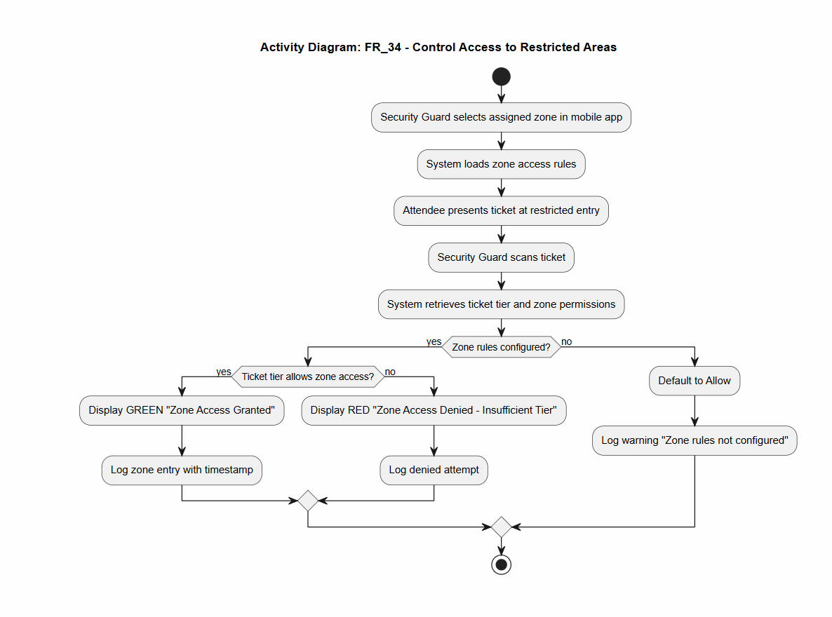

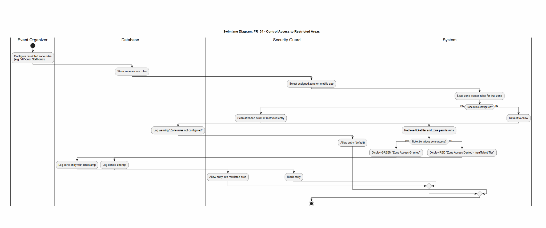

FR_32 Security Guard shall monitor real-time entry and exit counts to ensure venue safety compliance

UC Table
Field | Description
UC Name | UC_32: Monitor Real-Time Attendance Counts
Summary | Security Guard monitors a live dashboard showing current entry and exit counts to ensure the venue does not exceed its legal safety capacity.
Dependency | UC_30, UC_31 (entry counts are fed by the scan/validation pipeline).
Actors | Primary: Security Guard · Secondary: System, Venue Manager
Preconditions | Event is currently active. QR scan module is operational and logging entries/exits.
Main Sequence | Step 1: Security Guard opens the "Live Attendance" panel on the mobile app. Step 2: System displays current occupancy count, total entries, total exits, and % of max capacity. Step 3: Counts update automatically in real time as scans occur. Step 4: Security Guard monitors the display throughout the event.
Alternative Sequence | Step 1 (Capacity Threshold Reached): When occupancy reaches 90% of max capacity, system displays a yellow alert. Step 2 (Capacity Exceeded): If occupancy reaches 100%, system displays a red alert and sends a push notification to the Security Guard and Venue Manager. Step 3 (Connection Lost): System displays last known count with a "Live data unavailable" warning.
Non-Functional Reqs | Performance: Dashboard must refresh in real time (≤ 2 second delay). Reliability: Count data must be consistent across all guard devices.
Postconditions | Security Guard has an accurate, up-to-date view of venue occupancy for safety enforcement.
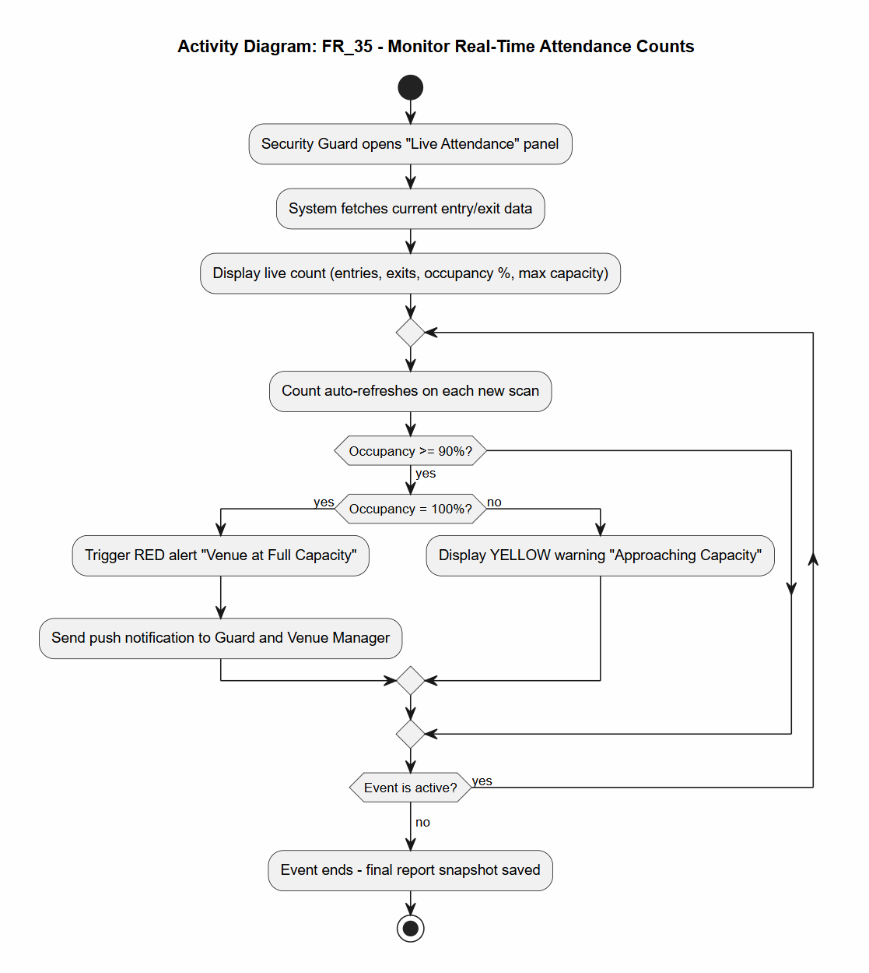

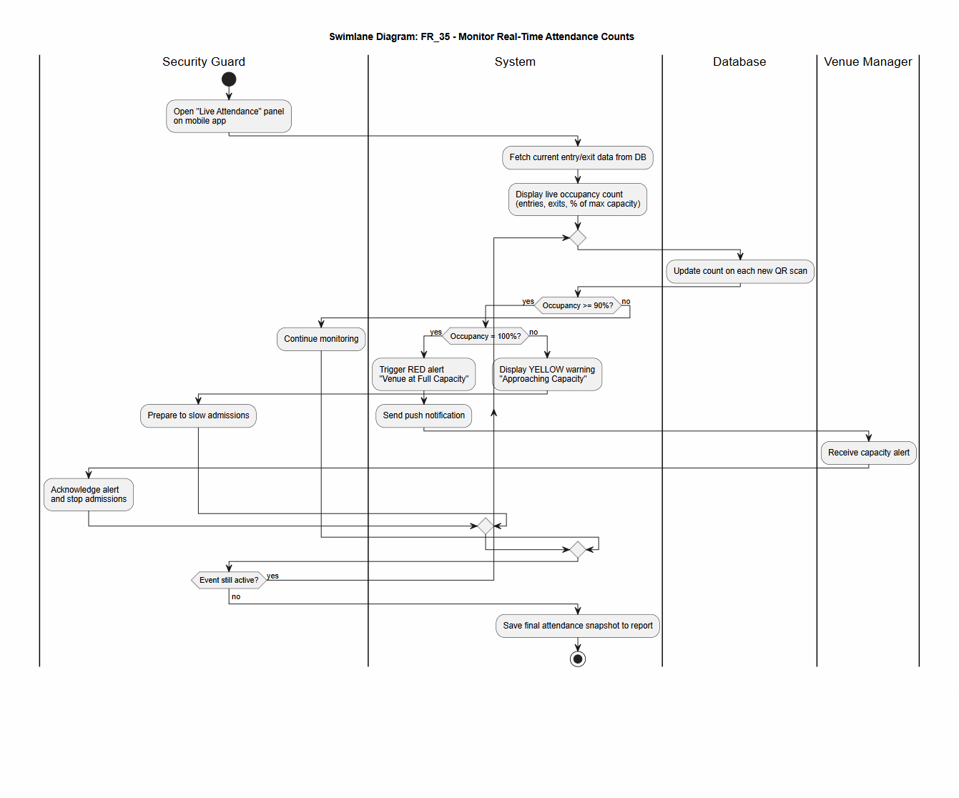

FR_33 Service Provider shall log in and view their assigned tasks and event-day schedules and update the completion status of each assigned task in real time
Field | Description
UC Name | UC_33: Service Provider Task & Schedule Management
Summary | Service Provider (caterer, decorator, etc.) logs into a dedicated vendor portal, views their assigned tasks and event-day schedule, and marks tasks as complete in real time.
Dependency | Event Organizer must have assigned tasks to the Service Provider (FR_17).
Actors | Primary: Service Provider · Secondary: Event Organizer, Database, Notification System
Preconditions | Service Provider account exists and is active. Tasks have been assigned by an Event Organizer.
Main Sequence | Step 1: Service Provider logs into the vendor portal with their credentials. Step 2: System displays the personal task list and event-day schedule. Step 3: Service Provider reviews assigned tasks (name, deadline, requirements, location). Step 4: Service Provider selects a task and clicks "Mark as Complete." Step 5: System updates the task status to "Completed" with a timestamp. Step 6: System notifies the Event Organizer of the status update.
Alternative Sequence | Step 1 (No Tasks Assigned): System displays "No tasks currently assigned to you." Step 2 (Task Already Completed): If a task is already marked complete, system shows completion timestamp and disables re-submission. Step 3 (Login Failure): Invalid credentials — system displays error and locks account after 5 failed attempts.
Non-Functional Reqs | Usability: Vendor portal must be fully functional on mobile. Performance: Task status update must reflect to organizer in under 3 seconds.
Postconditions | Task status is updated in the database. Event Organizer receives a real-time notification of progress.
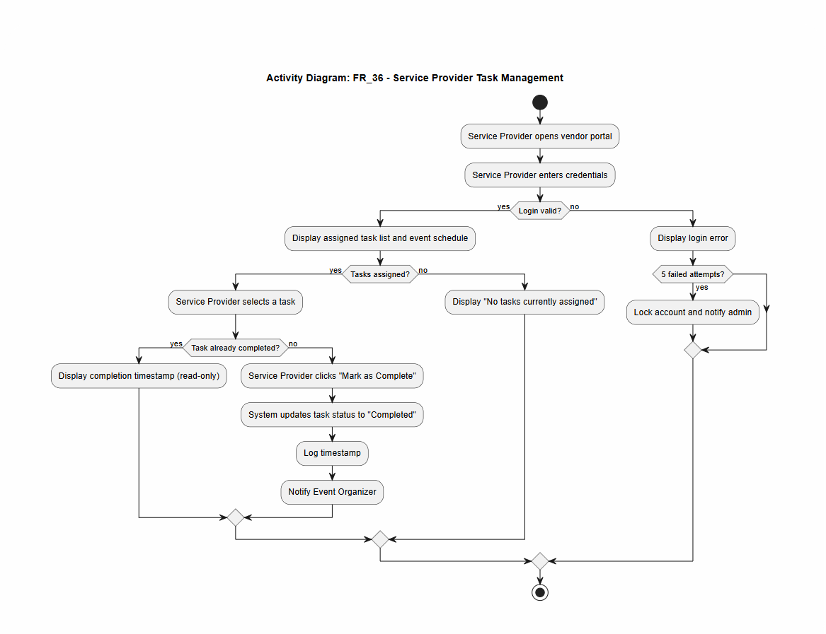

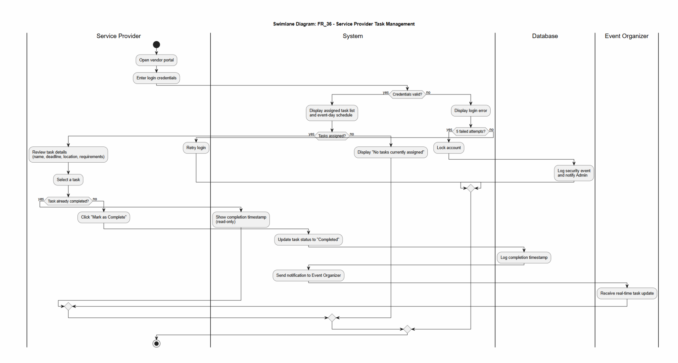

FR_34 Service Provider shall view event-specific requirements and logistical details via the vendor portal

Field | Details
UC Name | UC_34 View Event Logistics and Requirements
Summary | The Service Provider accesses the vendor portal to review specific logistical details, requirements, and deadlines for an event they are assigned to.
Dependency | Depends on FR_36 (Service Provider Login) and FR_17 (Event Organizer assigning tasks).
Actors | Primary Actor: Service Provider  Secondary Actor: Event Organizer (responsible for setting requirements).
Preconditions | 1. The Service Provider must be registered and logged into the system.  2. The Event Organizer must have already assigned the Service Provider to a specific event or task.
Description of the Main Sequence | Step 1: The Service Provider logs into the dedicated vendor portal.  Step 2: The Service Provider selects a specific event from their personal dashboard.  Step 3: The system retrieves and displays the event-specific requirements and logistical details.  Step 4: The Service Provider reviews the assigned tasks, deadlines, and event-day schedules.
Description of the Alternative Sequence | Step 1: If no logistical details have been uploaded by the Organizer, the system displays a "No details available" message.  Step 2: If the Service Provider is not assigned to any events, the dashboard remains empty.
Non-functional requirements | Usability: The portal must follow a consistent, intuitive design pattern (NF_03).  Performance: The logistics page should load in under 2 seconds (NF_06).  Security: The system must enforce role-based access to ensure vendors only see their own assigned logistics (NF_20).
Postconditions | The Service Provider is fully informed of their logistical responsibilities and event-day requirements for the selected event

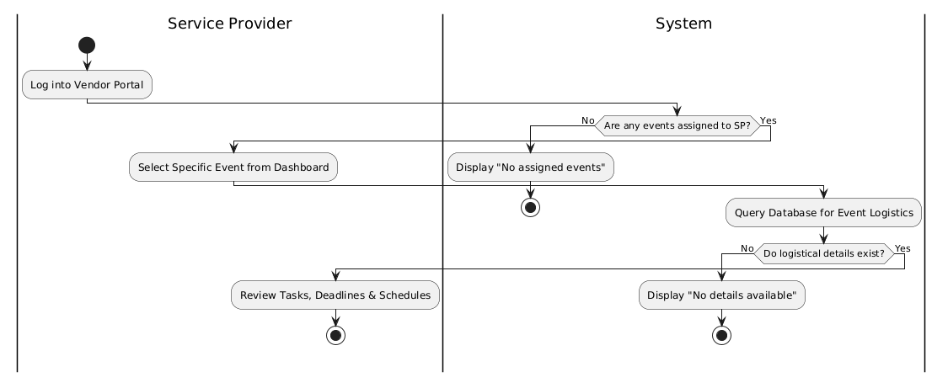

FR_35 System Administrator shall create, edit, and deactivate user accounts across all roles

Field | Details
UC Name | UC_35 Manage User Accounts
Summary | The System Administrator creates, edits, or deactivates user accounts across all system roles to ensure proper access control and platform integrity.
Dependency | Depends on User Authentication and Access Control modules.
Actors | Primary Actor: System Administrator.  Secondary Actor: The targeted User (recipient of account changes).
Preconditions | 1. The System Administrator must be logged into the system with verified administrative credentials.  2. The system's role-based access control must be active to allow administrative overrides.
Description of the Main Sequence | Step 1: The System Administrator navigates to the administrative dashboard and selects the "User Management" module .  Step 2: The Admin chooses to create a new account, edit an existing one, or deactivate a user .  Step 3: The Admin enters or modifies user data, including name, email address, and assigned role .  Step 4: The Admin submits the changes, and the system validates the data against registration rules .  Step 5: The system updates the database and logs the administrative action for auditing purposes.
Description of the Alternative Sequence | Step 1: If the Admin enters an email address that is already registered, the system displays a descriptive error message .  Step 2: If the Admin attempts to deactivate their own account, the system rejects the action to prevent a total lockout.
Non-functional requirements | Security: The system must enforce strict role-based access to ensure only the Admin can access this module (NF_20) .  Usability: The management interface must follow a consistent and intuitive design pattern (NF_03) .  Maintainability: All account changes and administrative overrides must be logged with timestamps for auditing (NF_25).
Postconditions | The user account status or details are successfully updated in the system, and the change is reflected in the user's ability to log in or access specific modules.

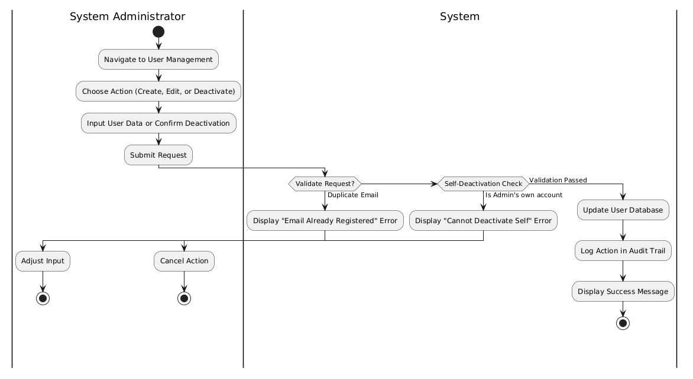

FR_36 System Administrator shall configure system-wide settings and security parameters

Field | Details
UC Name | UC_36 Configure System-wide Settings and Security Parameters
Summary | The System Administrator accesses the administrative dashboard to adjust global platform settings, manage API integrations, and define security parameters for the entire system.
Dependency | Depends on User Authentication and Access Control and FR_35 (Manage User Accounts).
Actors | Primary Actor: System Administrator.  Secondary Actor: None.
Preconditions | 1. The System Administrator must be logged into the system with verified credentials.  2. The system's role-based access control must be active to permit access to the configuration module.
Description of the Main Sequence | Step 1: The System Administrator navigates to the "System Settings" or "Security Parameters" module in the admin dashboard.  Step 2: The Admin selects the specific global parameter to modify (e.g., session timeouts, email/SMS provider keys, or password complexity requirements).  Step 3: The Admin enters the new configuration values and submits the changes.  Step 4: The system validates the new settings against system integrity rules.  Step 5: The system updates the global configuration and logs the change with a timestamp for the audit trail.
Description of the Alternative Sequence | Step 1: If the Admin performs an invalid action or enters data in an incorrect format, the system displays a clear and descriptive error message.  Step 2: The system rejects the change and reverts to the previous stable configuration to maintain system uptime.
Non-functional requirements | Security: The system must enforce strict role-based access control to prevent unauthorized access to these settings.  Usability: All configuration pages must follow a consistent and intuitive design pattern.  Maintainability: All changes and system errors must be logged with timestamps for debugging and auditing.
Postconditions | The system-wide settings and security parameters are successfully updated and applied globally across the platform.

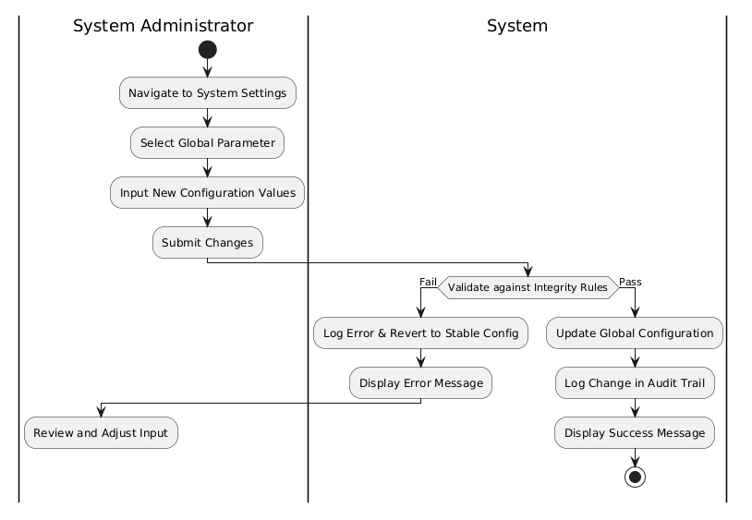

FR_37 System Administrator shall generate and export system-wide reports in CSV or PDF format

Field | Details
UC Name | UC_37 Generate and Export System-Wide Reports
Summary | The System Administrator generates high-level reports encompassing system-wide metrics—such as total attendance, aggregate revenue, and overall feedback scores—and exports them in CSV or PDF format.
Dependency | Depends on the Reporting Module, which requires live data from the attendance, payment, and feedback modules.
Actors | Primary Actor: System Administrator.  Secondary Actor: None.
Preconditions | 1. The System Administrator must be logged into the administrative dashboard with verified credentials.  2. There must be existing data (e.g., transactions, registrations) within the system to populate the reports.
Description of the Main Sequence | Step 1: The System Administrator navigates to the "Reporting & Analytics" section of the admin dashboard .  Step 2: The Admin selects the specific report type (e.g., Global Revenue, System-wide Attendance, or Resource Usage) .  Step 3: The Admin applies any necessary filters, such as date ranges or event categories.  Step 4: The Admin selects the desired export format: CSV or PDF .  Step 5: The system processes the request and generates the file for download.
Description of the Alternative Sequence | Step 1: If the selected filters return no data, the system displays a "No data available for the selected criteria" message.  Step 2: If a system error occurs during generation, the system logs the exception with a timestamp for debugging and notifies the Admin.
Non-functional requirements | Performance: Generating reports must not degrade system performance for concurrent users.  Usability: The reporting interface must follow a consistent, intuitive design pattern.  Maintainability: All report generation attempts and errors must be logged in the system audit trail.
Postconditions | A document in the selected format (CSV or PDF) is successfully downloaded to the Administrator's device.

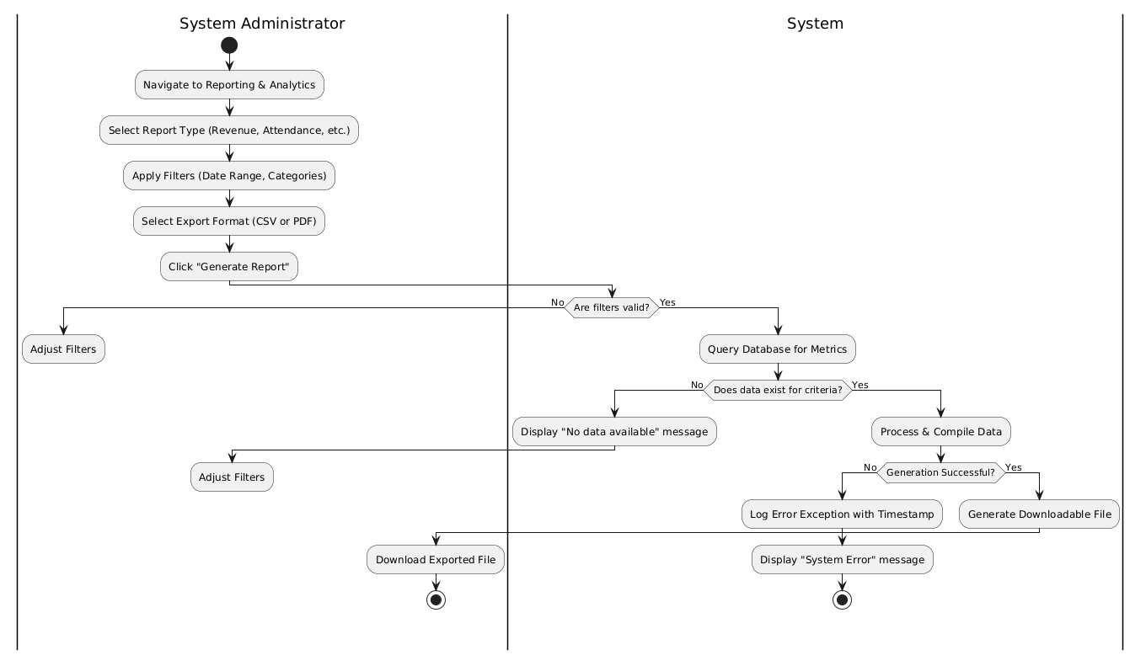

FR_38 System Administrator shall override or reset any user data in the event of an error or dispute

Field | Details
UC Name | UC_38 Override or Reset User Data
Summary | The System Administrator manually intervenes to modify, correct, or reset specific user data or account information to resolve technical errors or formal disputes.
Dependency | Depends on FR_35 (Manage User Accounts) and the core User Authentication and Access Control module.
Actors | Primary Actor: System Administrator  Secondary Actor: The affected User (Attendee, Organizer, etc.).
Preconditions | 1. The System Administrator must be logged into the administrative dashboard with verified credentials.  2. An error or dispute must be identified that requires administrative override.
Description of the Main Sequence | Step 1: The System Administrator searches for the specific user record or transaction associated with the dispute.  Step 2: The Admin selects the "Override" or "Reset" option for the specific data field.  Step 3: The Admin enters the corrected information or triggers a password/profile reset.  Step 4: The Admin provides a reason for the override in the system comments for the audit trail.  Step 5: The system updates the record and logs the administrative intervention with a timestamp.
Description of the Alternative Sequence | Step 1: If the Admin attempts to override data with an invalid format, the system displays a descriptive error message.  Step 2: If the data being overridden is currently being processed (e.g., an active payment), the system locks the record and prevents the override until the process concludes.
Non-functional requirements | Security: Only the System Administrator, who has "full override access across the entire platform," can perform this action.  Maintainability: All overrides must be logged with timestamps for future auditing.  Usability: The interface must follow a consistent and intuitive design pattern.
Postconditions | The disputed or erroneous user data is updated, and a record of the change is stored in the system's audit trail.

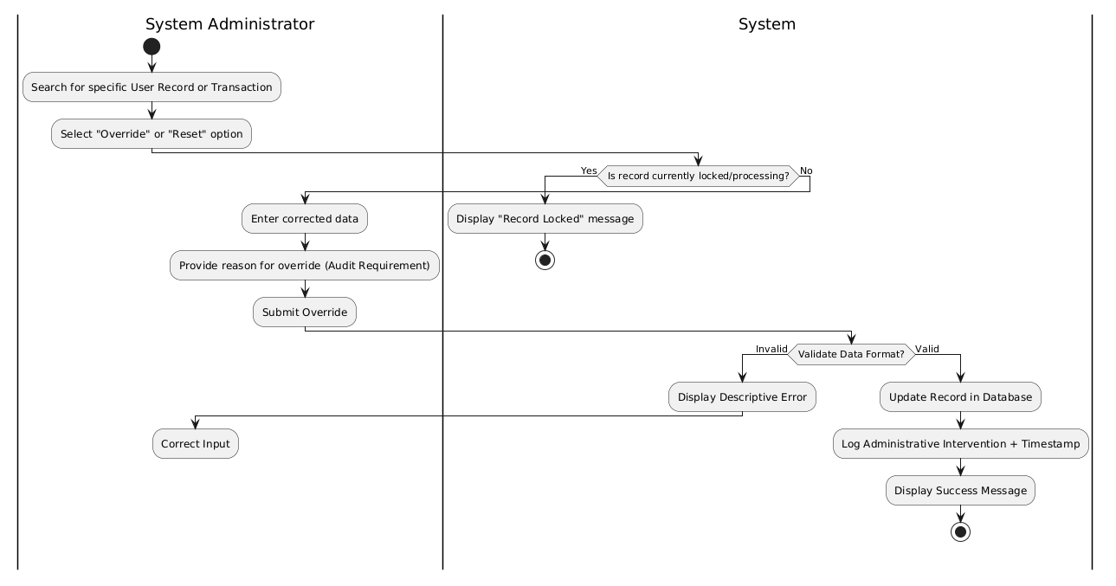

FR_39 System Administrator shall review and manage system error logs and audit trails

Field | Details
UC Name | UC_39 Review and Manage System Error Logs and Audit Trails
Summary | The System Administrator accesses the administrative dashboard to monitor system health, investigate application errors, and review audit trails of user actions to ensure platform integrity.
Dependency | Depends on the Logging Module and FR_35 (System Administrator Login/Account Management).
Actors | Primary Actor: System Administrator.  Secondary Actor: None.
Preconditions | 1. The System Administrator must be logged into the administrative dashboard with verified credentials.  2. The system must have active logging enabled for application errors and security events.
Description of the Main Sequence | Step 1: The System Administrator navigates to the "System Logs" or "Audit Trail" section of the administrative dashboard.  Step 2: The Admin applies filters to narrow down the logs by date range, error severity, or specific User ID.  Step 3: The system retrieves and displays the requested log entries, including timestamps and detailed error descriptions.  Step 4: The Admin reviews the logs to identify potential security threats or technical bugs.  Step 5: The Admin performs management actions, such as archiving old logs or flagging specific entries for developer attention.
Description of the Alternative Sequence | Step 1: If no log entries match the selected filters, the system displays a "No matching logs found" message.  Step 2: If the logging database is temporarily unavailable, the system notifies the Admin and attempts to reconnect to the failover log server.
Non-functional requirements | Security: Only the System Administrator can access audit trails and error logs to prevent unauthorized tampering.  Maintainability: All application errors must be logged with accurate timestamps for effective debugging.  Reliability: Log data must be included in the automated daily backups.
Postconditions | The System Administrator has successfully reviewed the system's operational health and security state, and any necessary log management actions have been recorded.

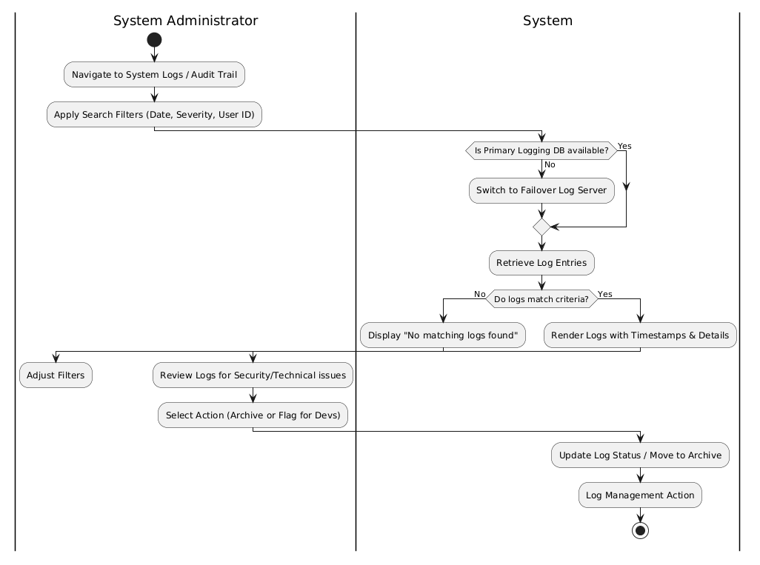

4.2 User Case Diagram
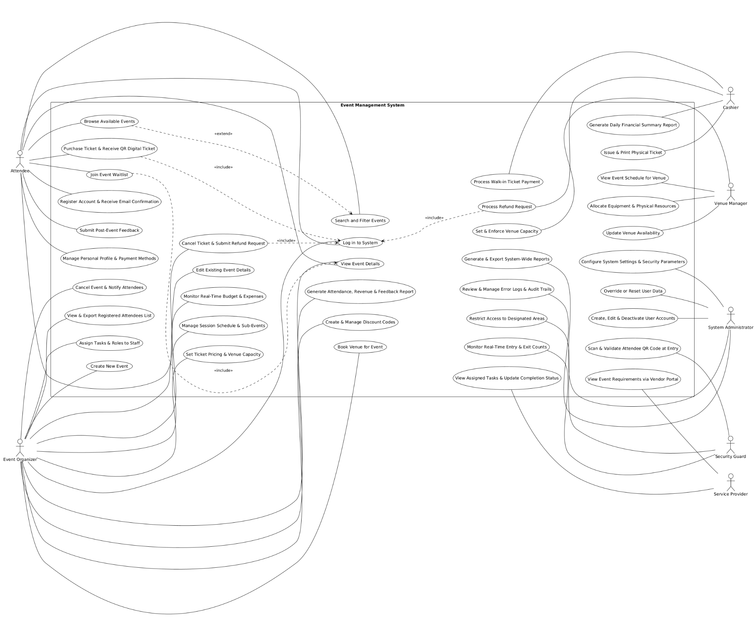

4.3 ER Diagram
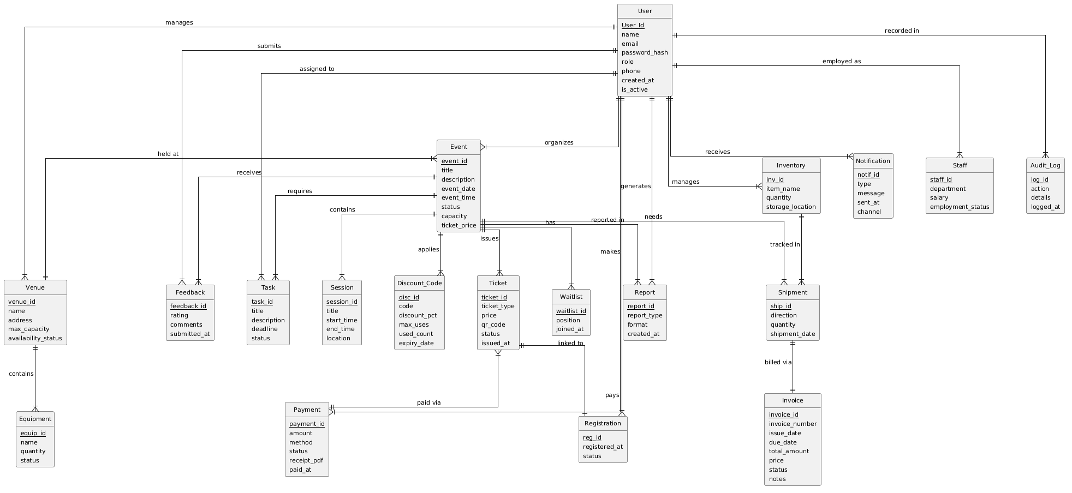

4.4 State Diagrams

State Diagram: Event Organizer

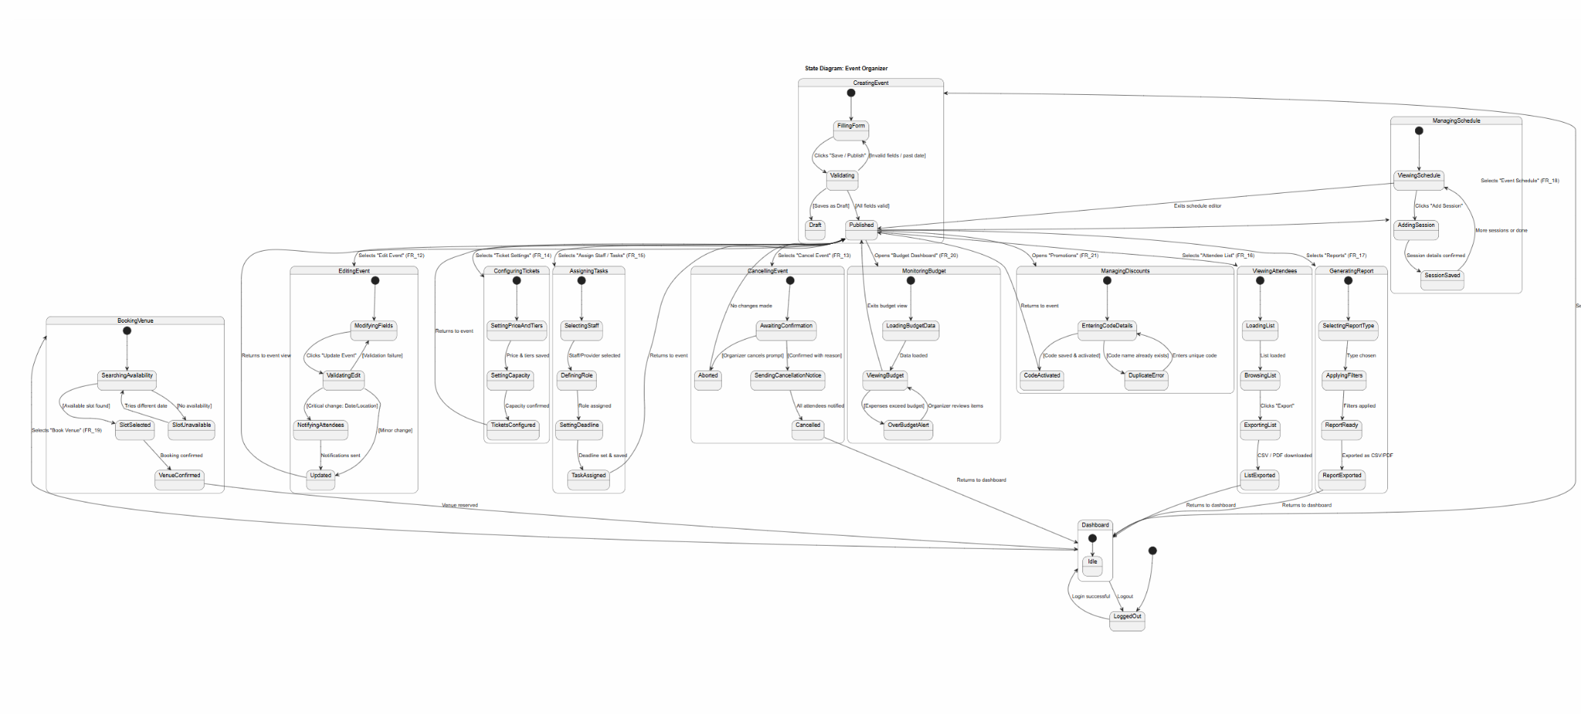

Attendee State Diagram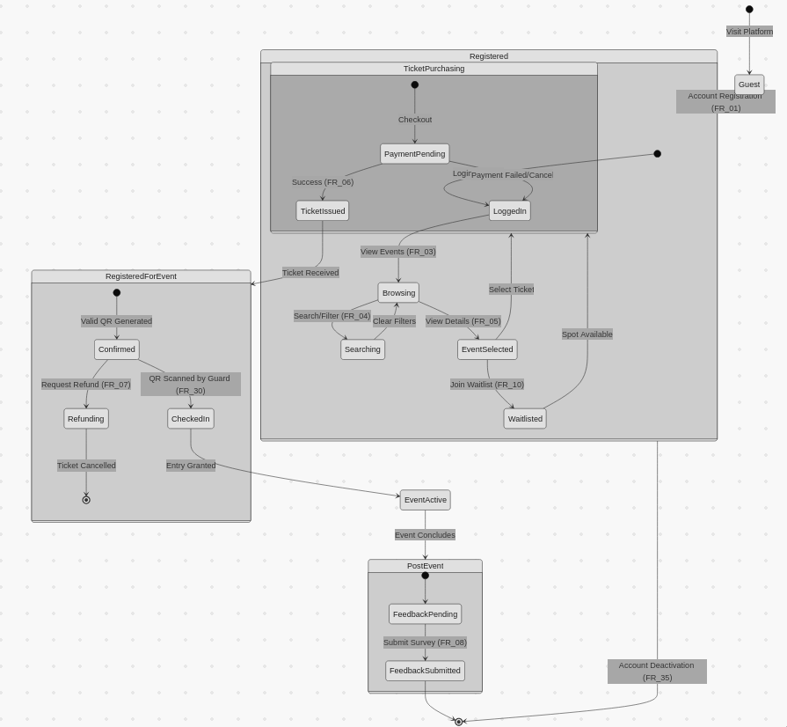

System Administrator
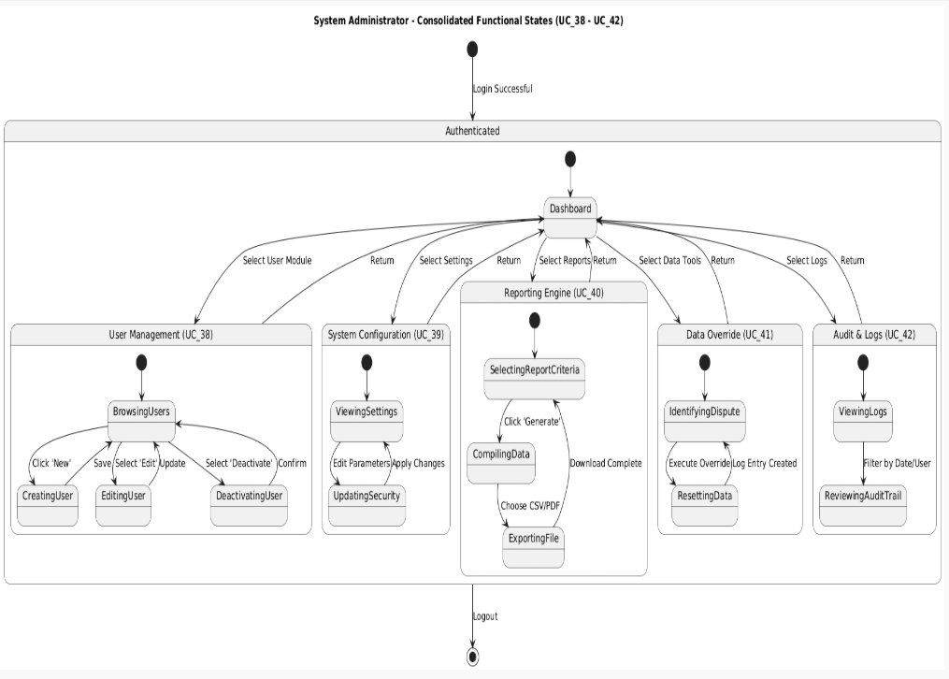

Security Guard State Diagram
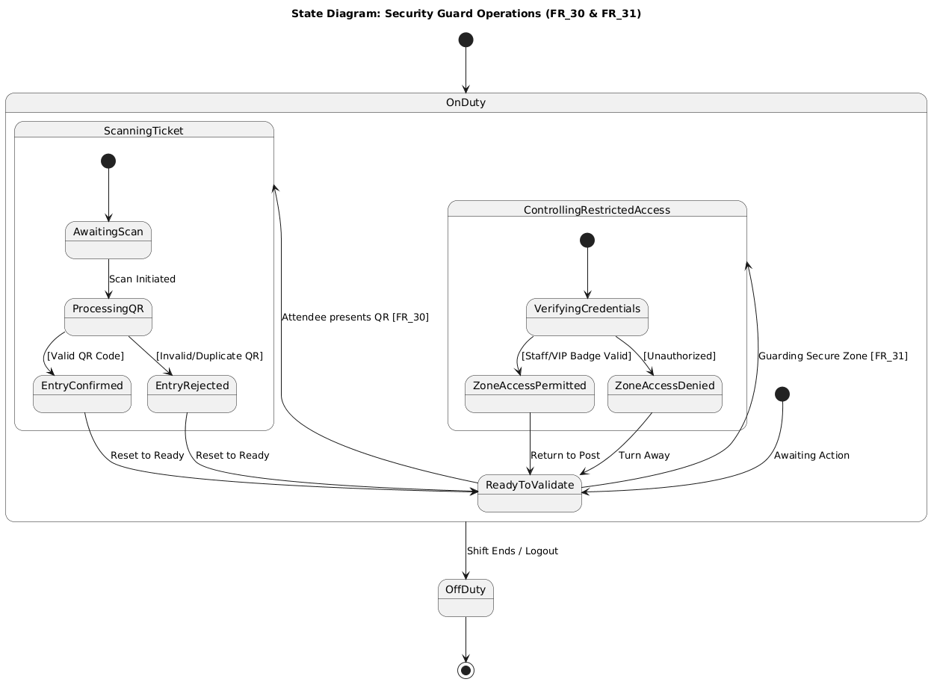

Venue Manager State Diagram
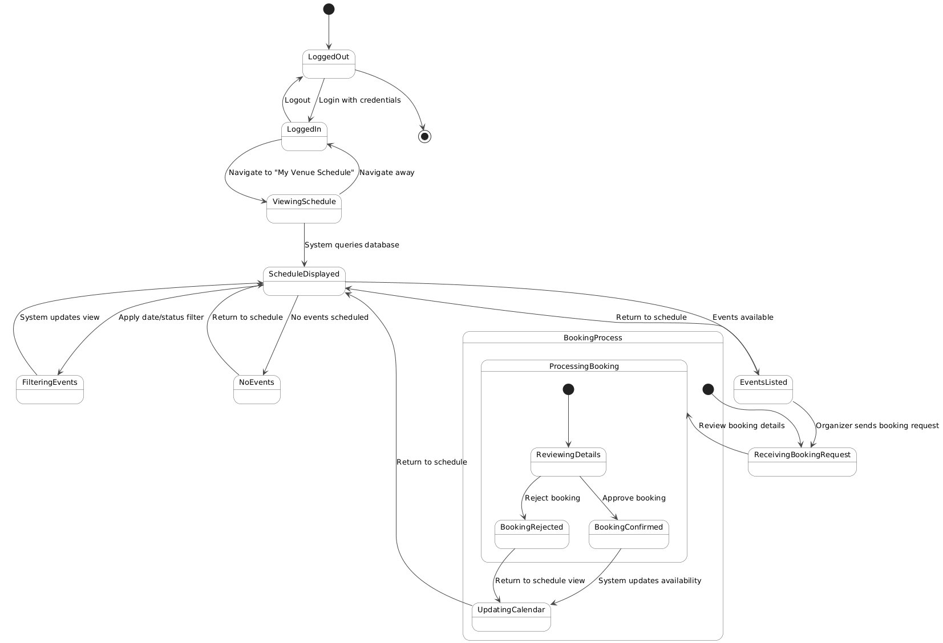

Service Provider State Diagram

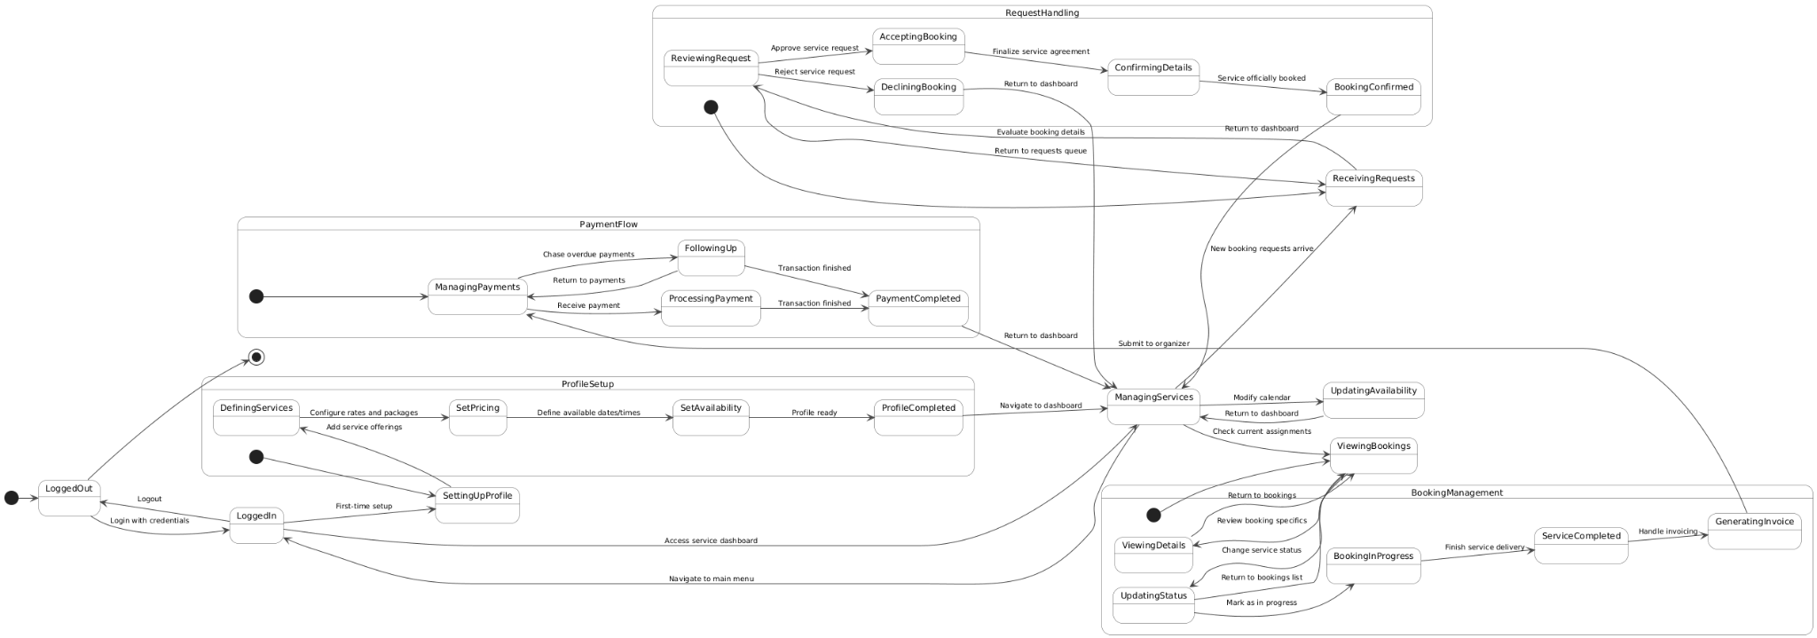

4.4 Class Diagrams

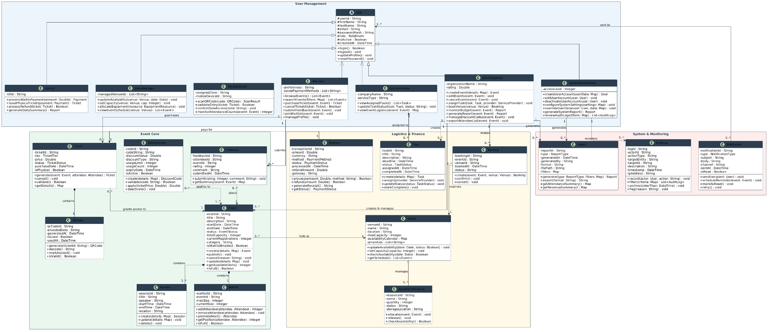

4.5 Sequence Diagrams
UC_01 - Attendee shall register an account using a valid email address and password and shall receive an automated email confirmation after completing registration
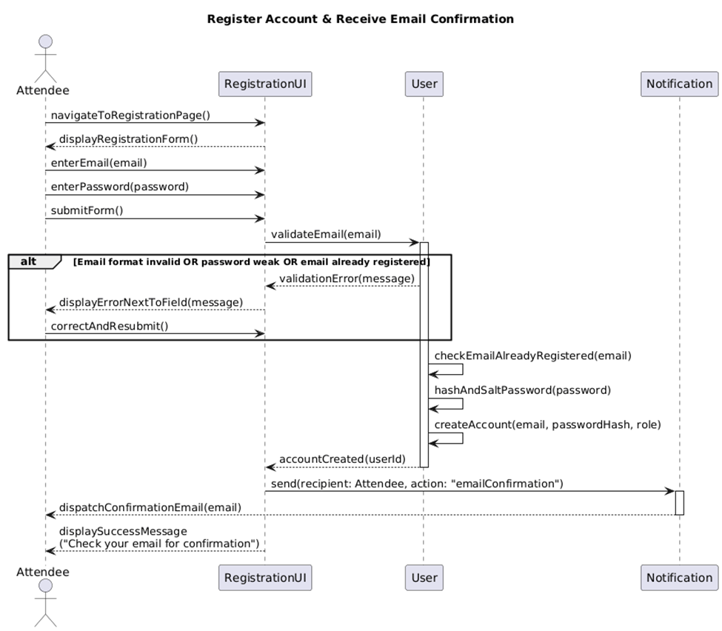

UC_02 - Attendee shall log in to the system using their registered credentials

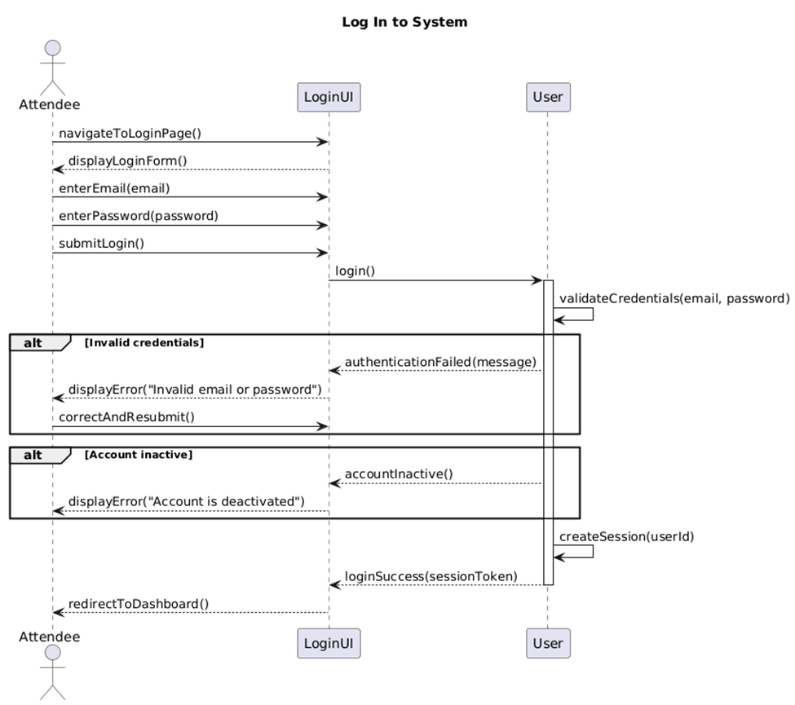

UC_03 - Attendee shall browse the full list of available events on the platform

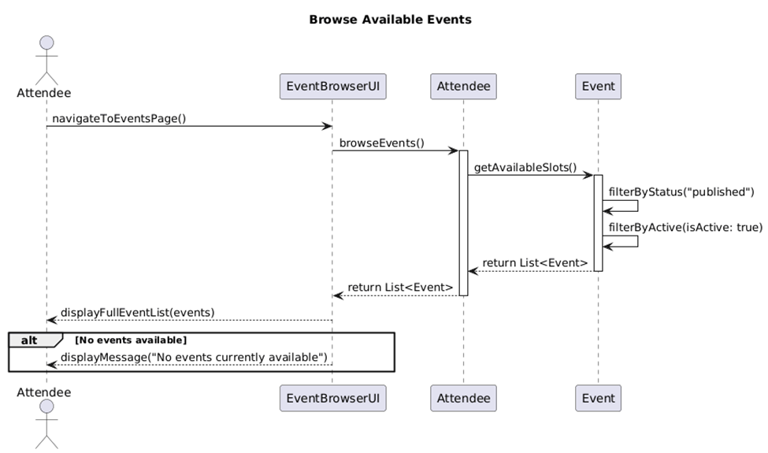

UC_04 - Attendee shall search and filter for events by name, date, location, or category
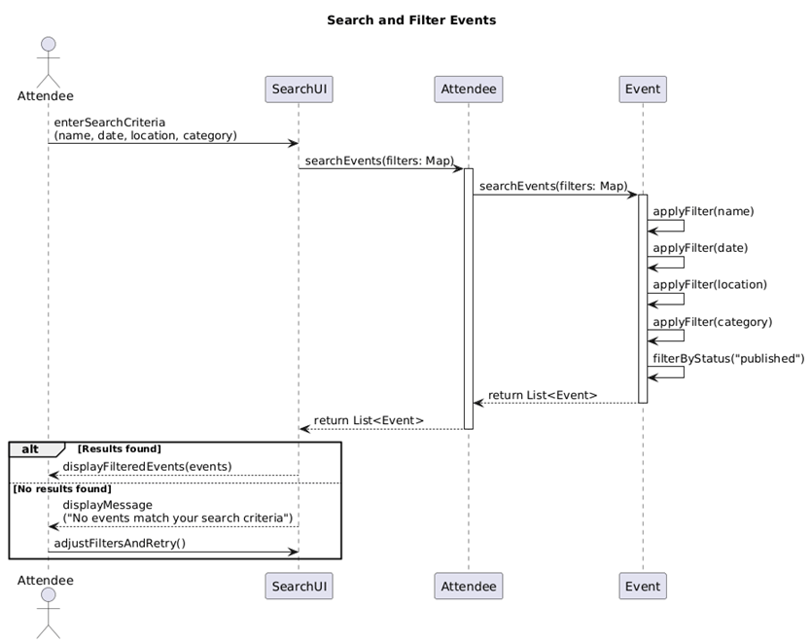

UC_05 - Attendee shall view the complete details of any selected event
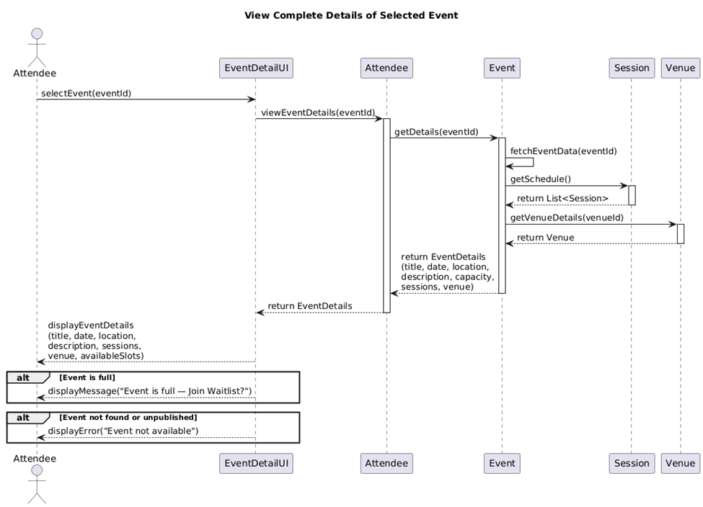

UC_11 - Event Organizer shall create a new event with title, date, time, location, and description
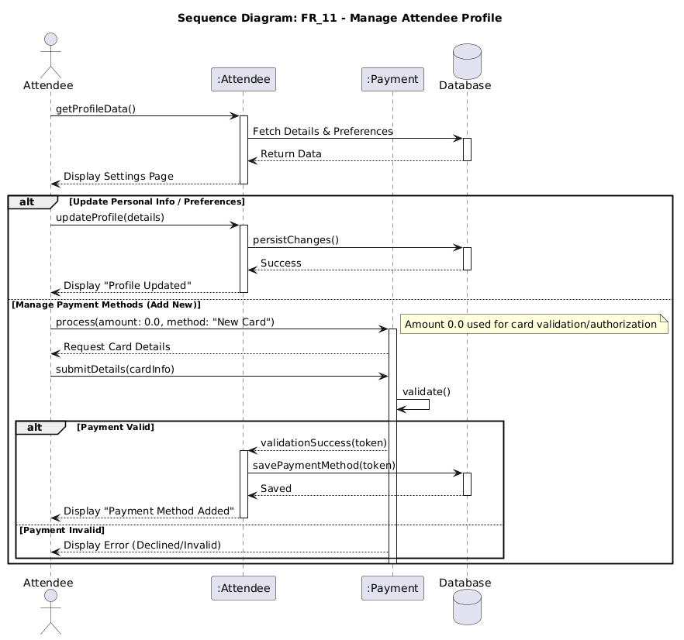

UC_12 Event Organizer shall edit the details of an existing published event
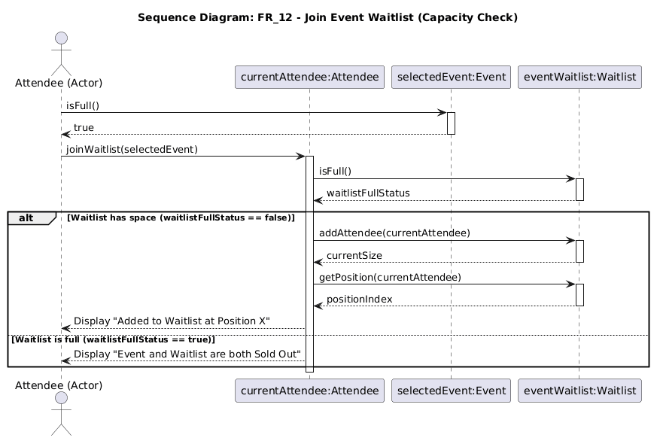

UC_13 Event Organizer shall cancel an event and trigger automated notifications to all registered attendees
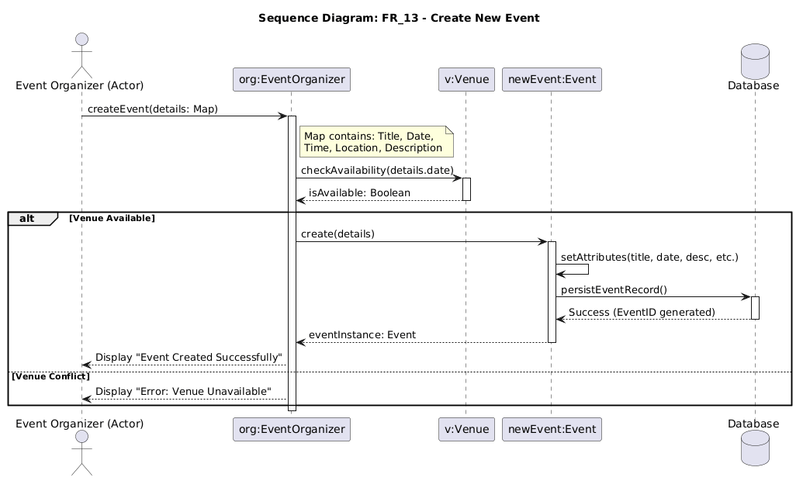

UC_14 Event Organizer shall set ticket price, ticket type tiers, and maximum venue capacity
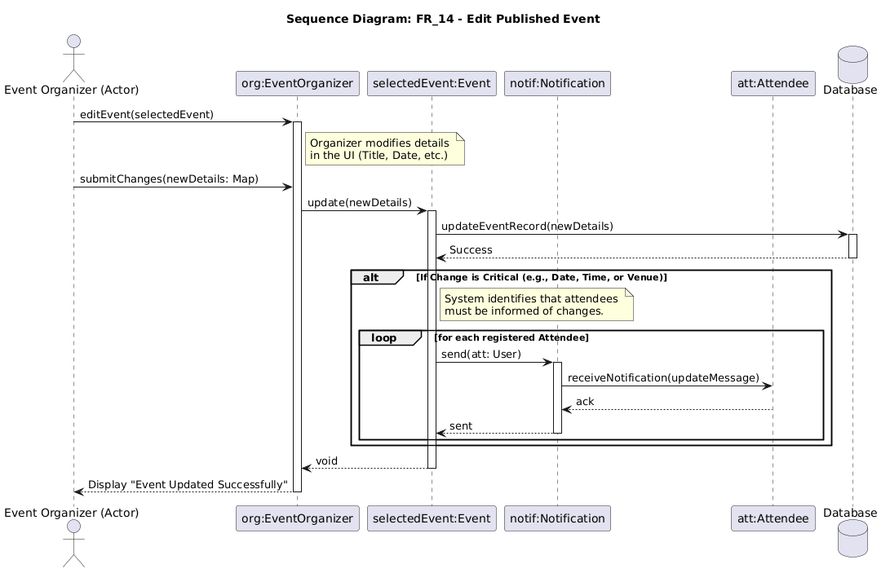

UC-15 Event Organizer shall assign tasks and roles to staff members and service providers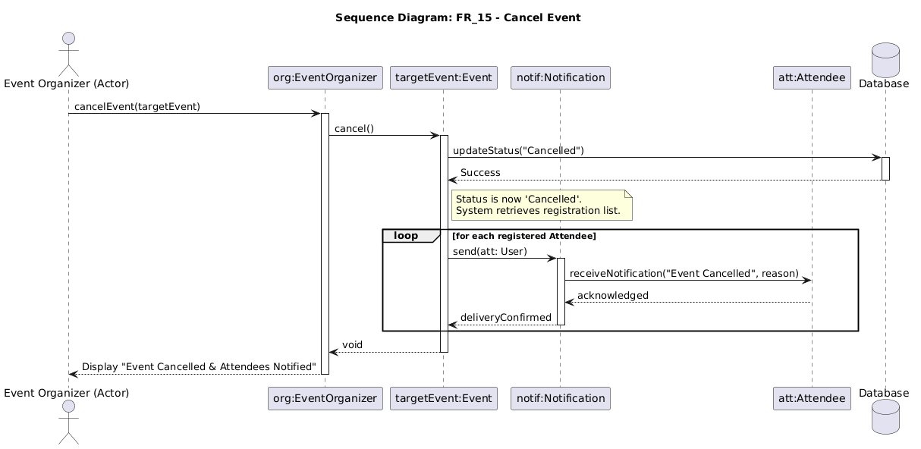

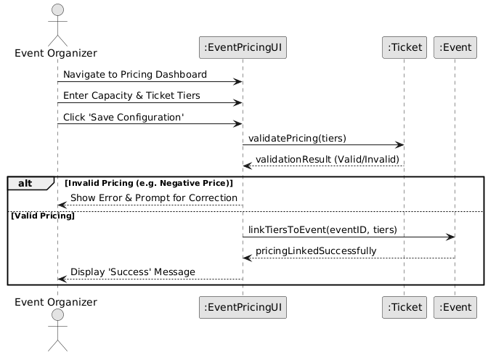
UC-16 Event Organizer shall view and export the full list of registered attendees

UC-17 Event Organizer shall generate a detailed report on attendance, revenue, and feedback
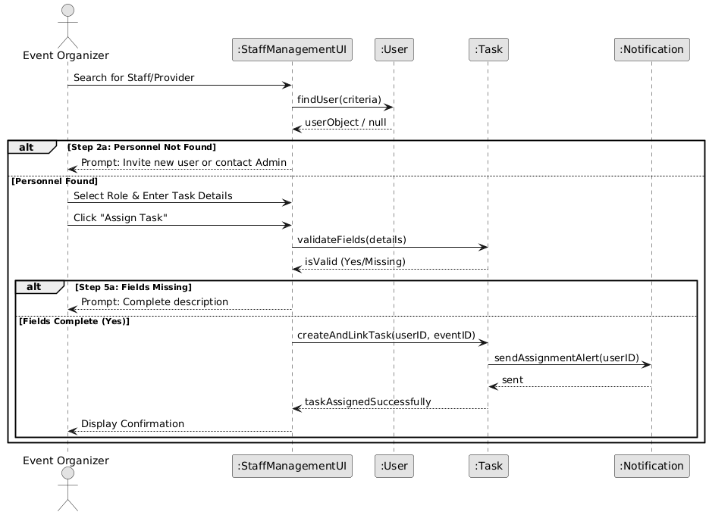

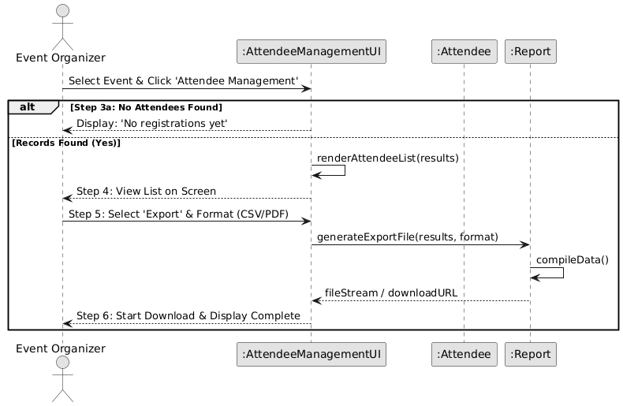
UC-18 Event Organizer shall manage the schedule of sessions and sub-events within a larger event

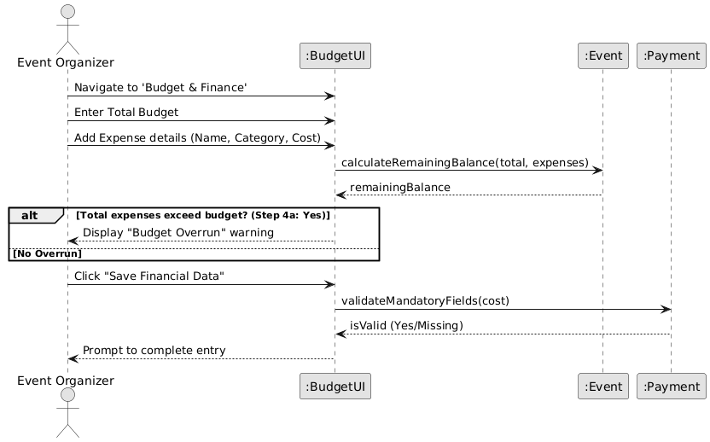
UC-19 Event Organizer shall book a venue for an event based on availability shown by the Venue Manager

UC-20 Event Organizer shall monitor the real-time budget and expenses of an event
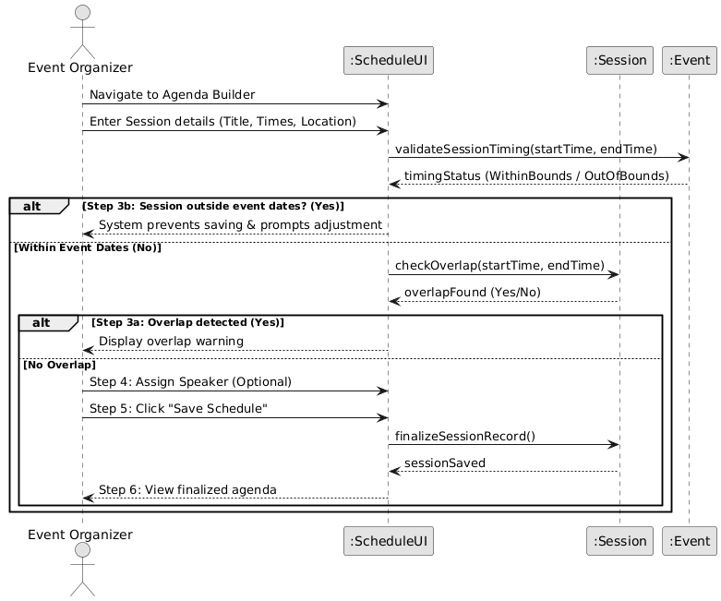

UC21 — The organizer submits a new code, the Discount Service validates and persists it to the database, then returns confirmation. The same flow covers edits and deactivations.
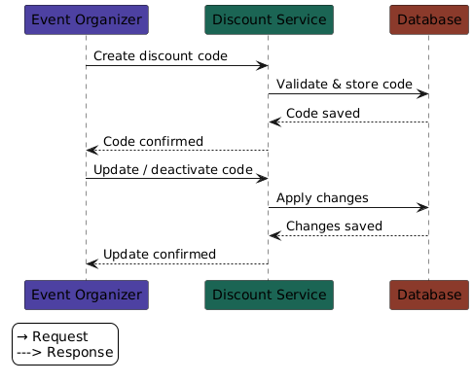
UC22 — The attendee requests tickets, the Cashier mediates between the Payment System (charging) and Ticket System (reserving the seat), then returns the receipt.
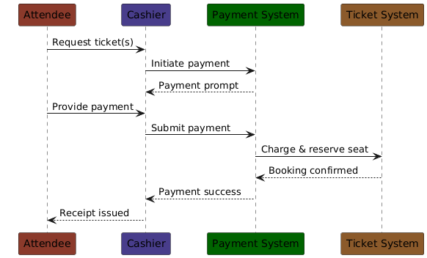

UC23 — Follows on from payment. The Cashier fetches booking details (including barcode), sends a print job, then marks the ticket as printed in the system before handing it to the attendee.
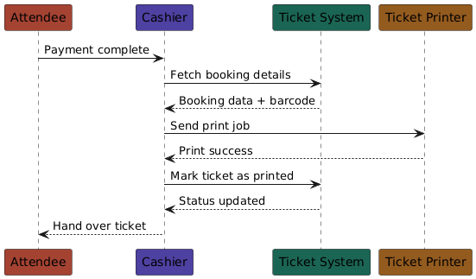

UC24 — The Cashier looks up the booking, checks the event's refund policy, voids (or partially voids) the ticket, then triggers the appropriate refund amount through the Payment System.
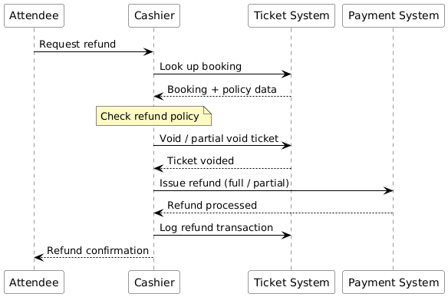

UC25 — : The Cashier triggers a report, the Report Service queries all of today's transactions from the database, aggregates the totals, persists the report record, then returns the summary for viewing or printing
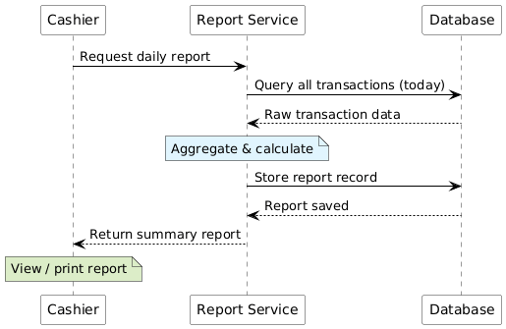

UC_26 Venue Manager shall update the availability status of a venue for specific dates
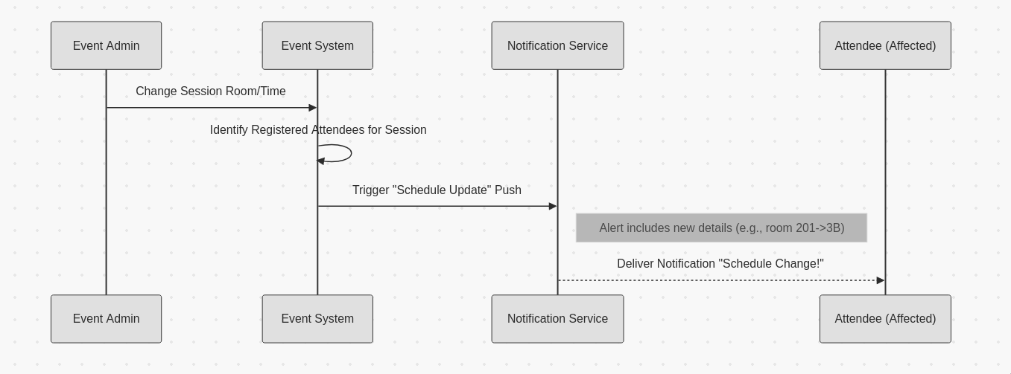
UC_27 Venue Manager shall set and enforce the maximum attendee capacity for each venue
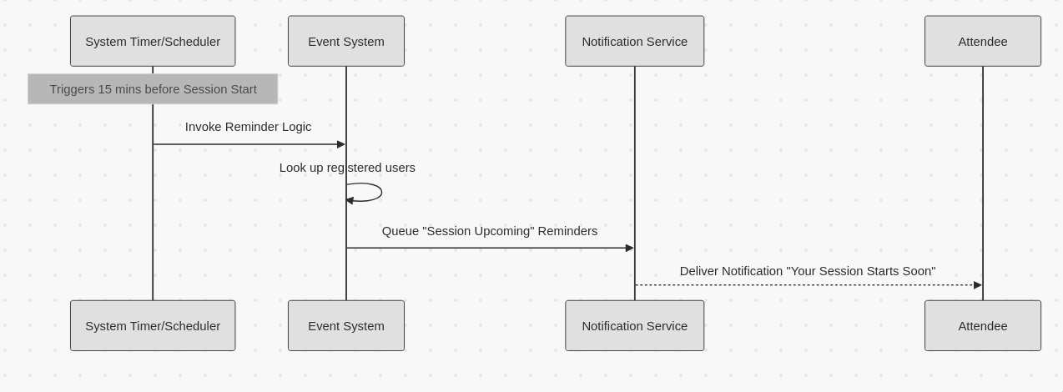
UC_28 Venue Manager shall allocate equipment and physical resources to assigned events
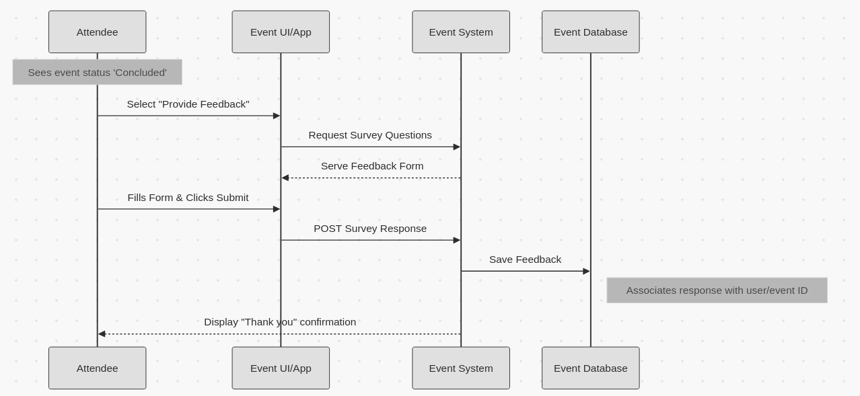
UC_29 Venue Manager shall view the full schedule of events assigned to their venue
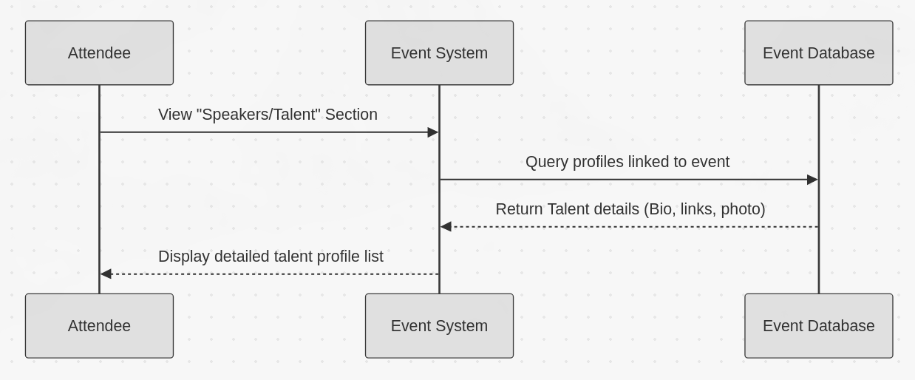

UC_30 Security Guard shall scan the QR code on an attendee ticket using a mobile device at entry and validate or reject entry based on the QR code scan result
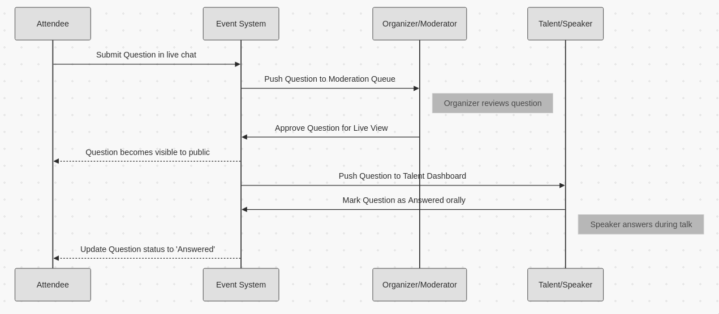

FR_31 Security Guard: Control Restricted Area Access
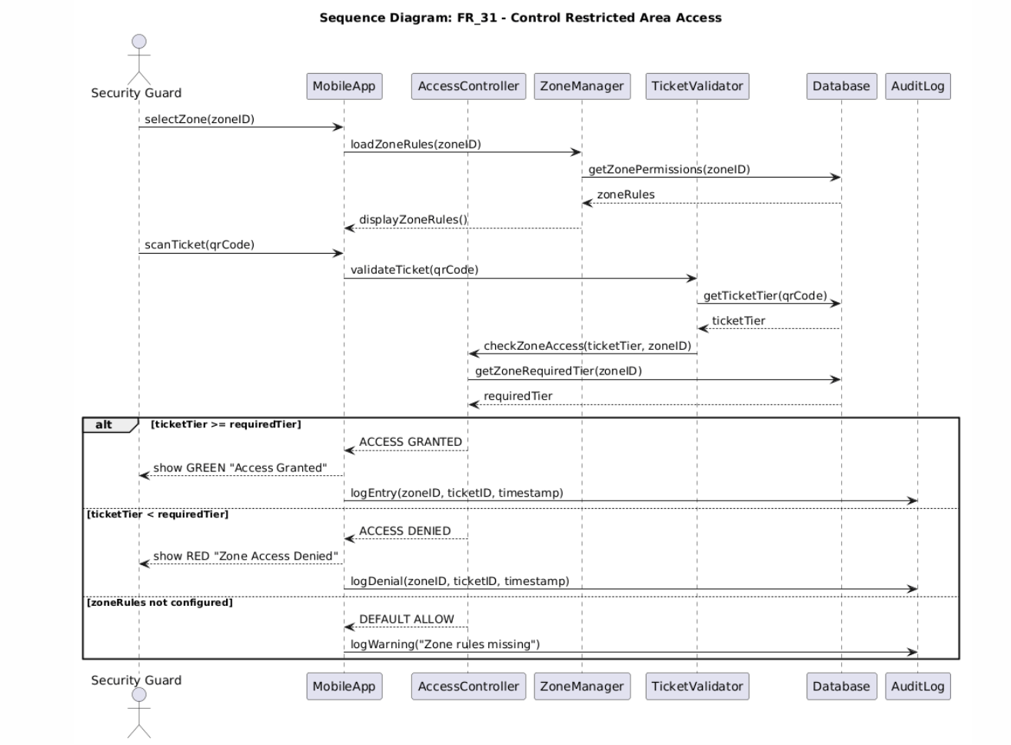

FR_32 Security Guard: Monitor Real-Time Attendance

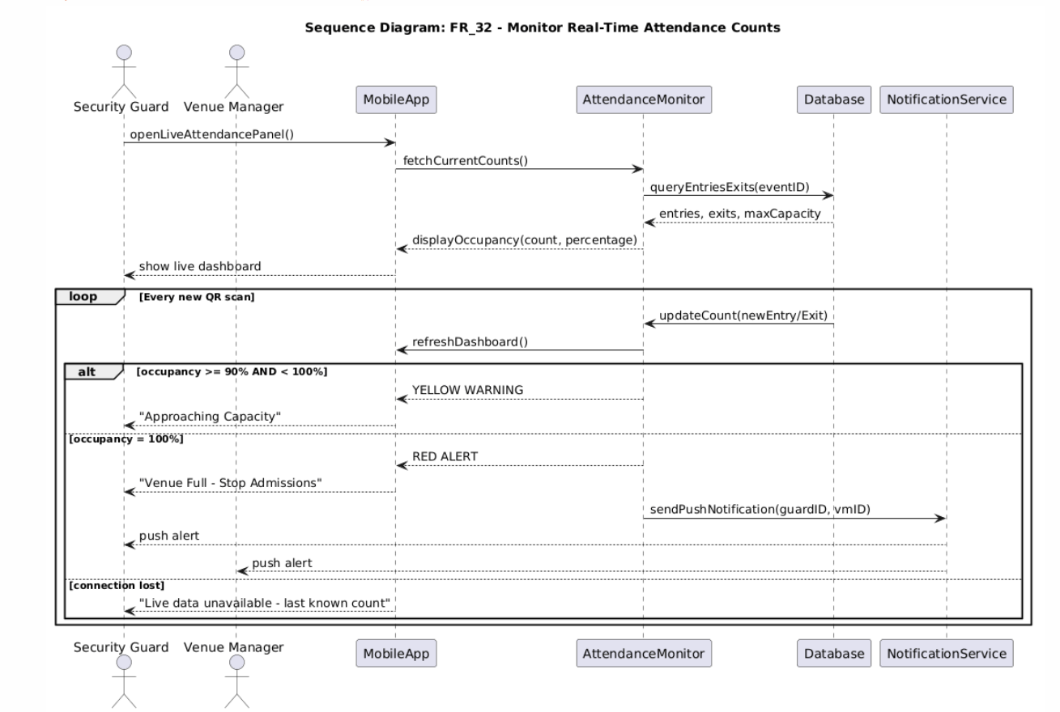

FR_33 Service Provider: View Tasks & Update Status
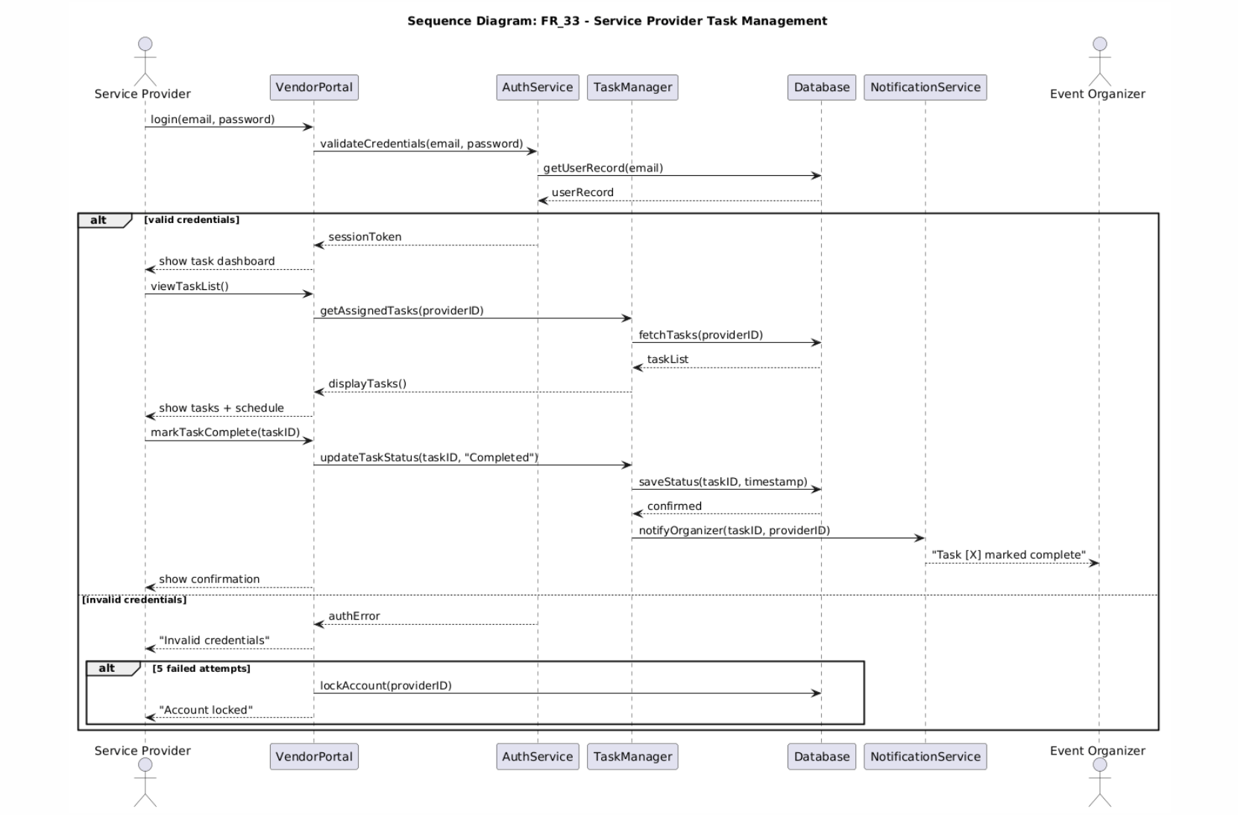

FR_34 Service Provider: View Event Logistics
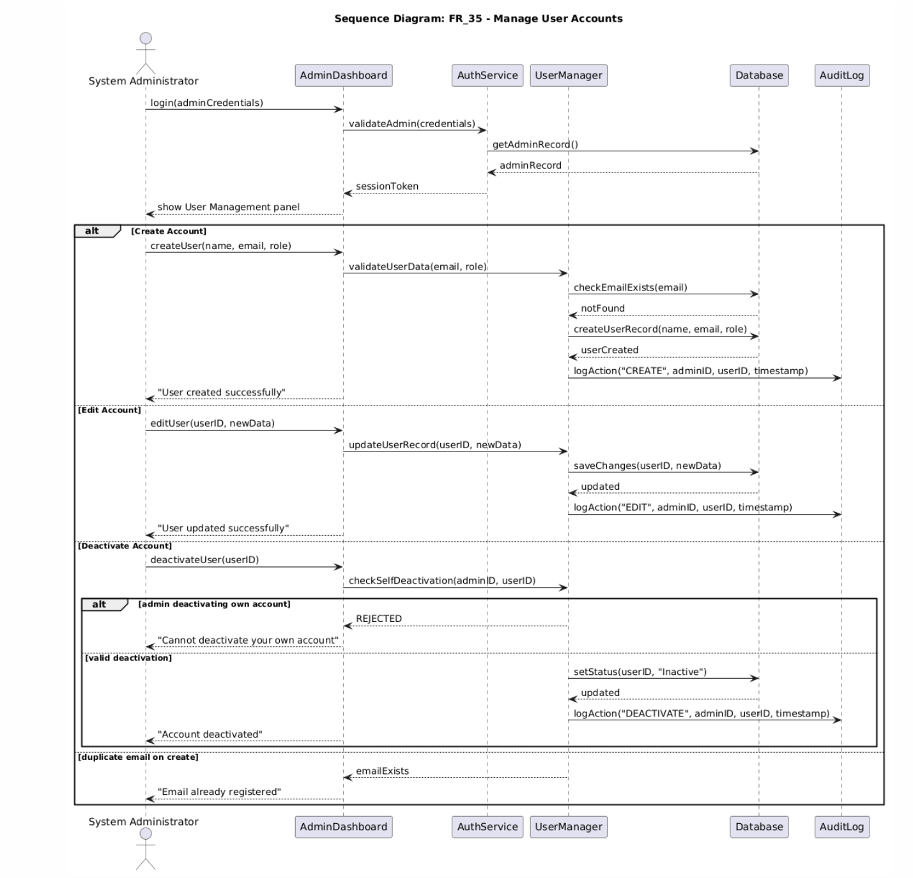

FR_35 System Administrator: Manage User Accounts
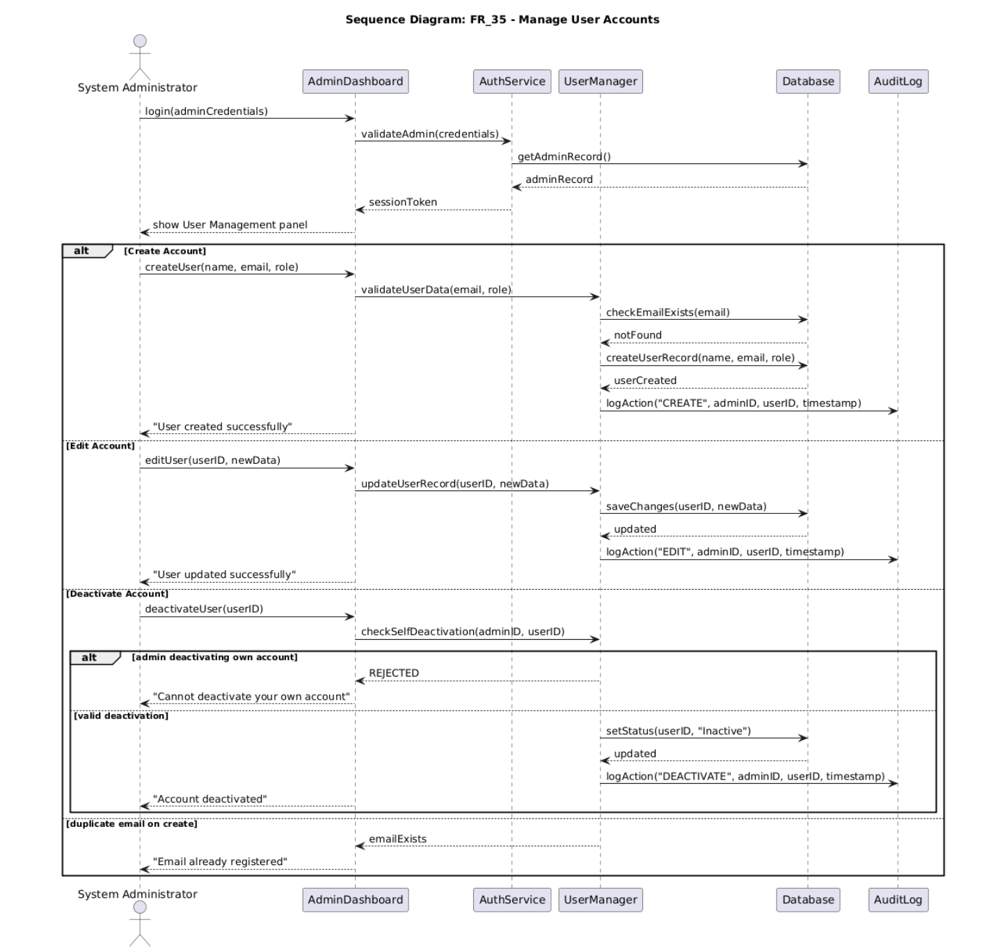

FR_36 System Administrator shall configure system-wide settings and security parameters
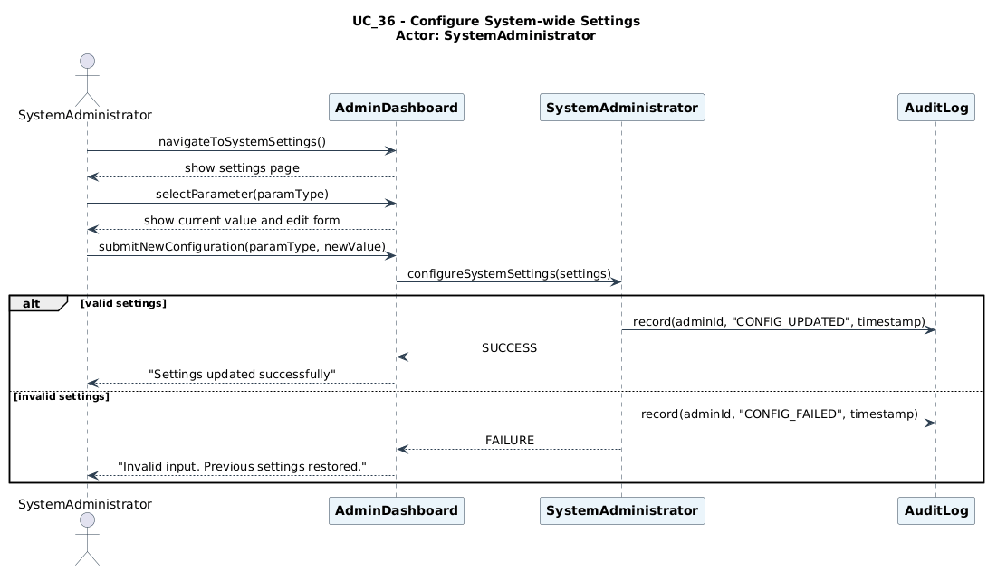

FR_37 System Administrator shall generate and export system-wide reports in CSV or PDF format
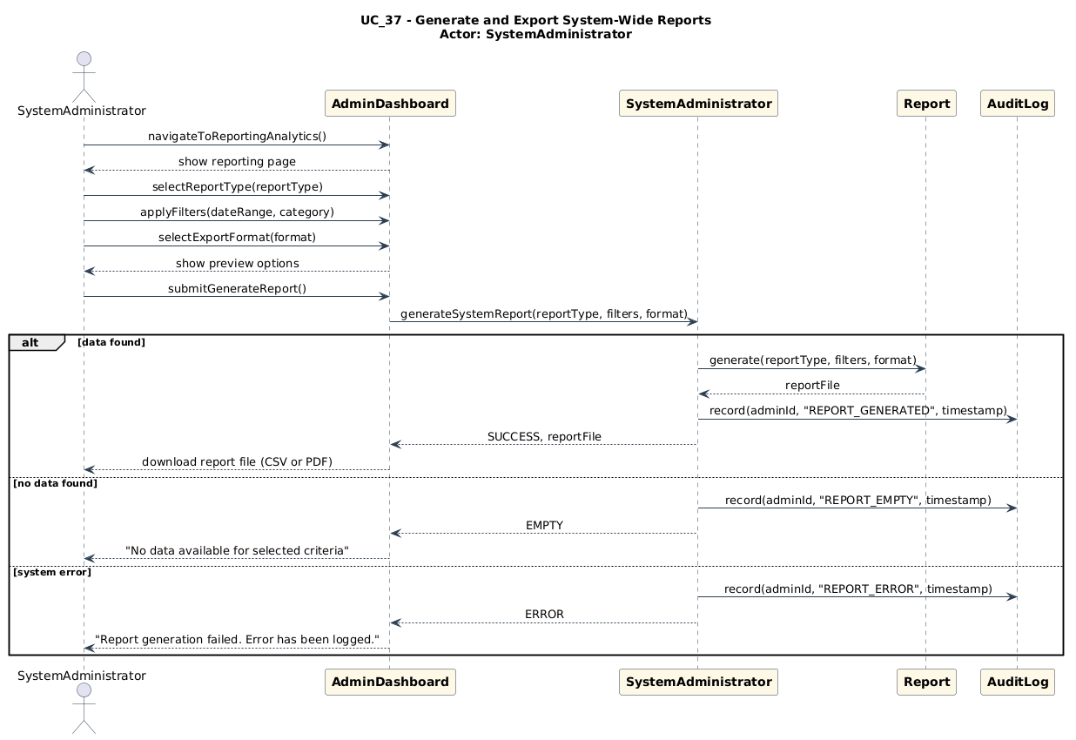

FR_38 System Administrator shall override or reset any user data in the event of an error or dispute
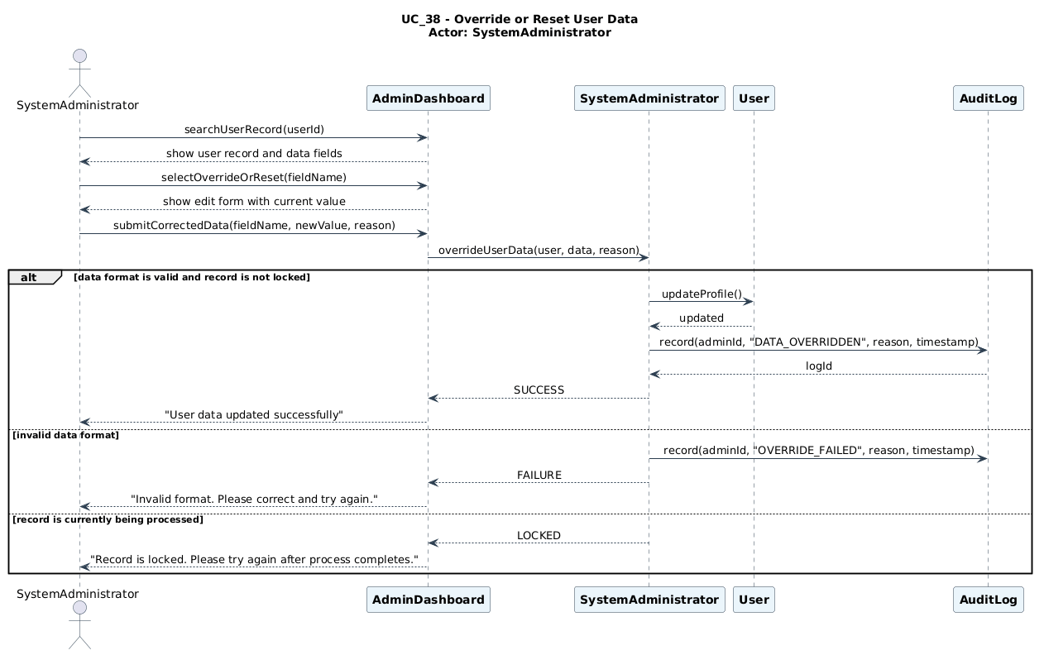

UC_39 System Administrator shall review and manage system error logs and audit trails
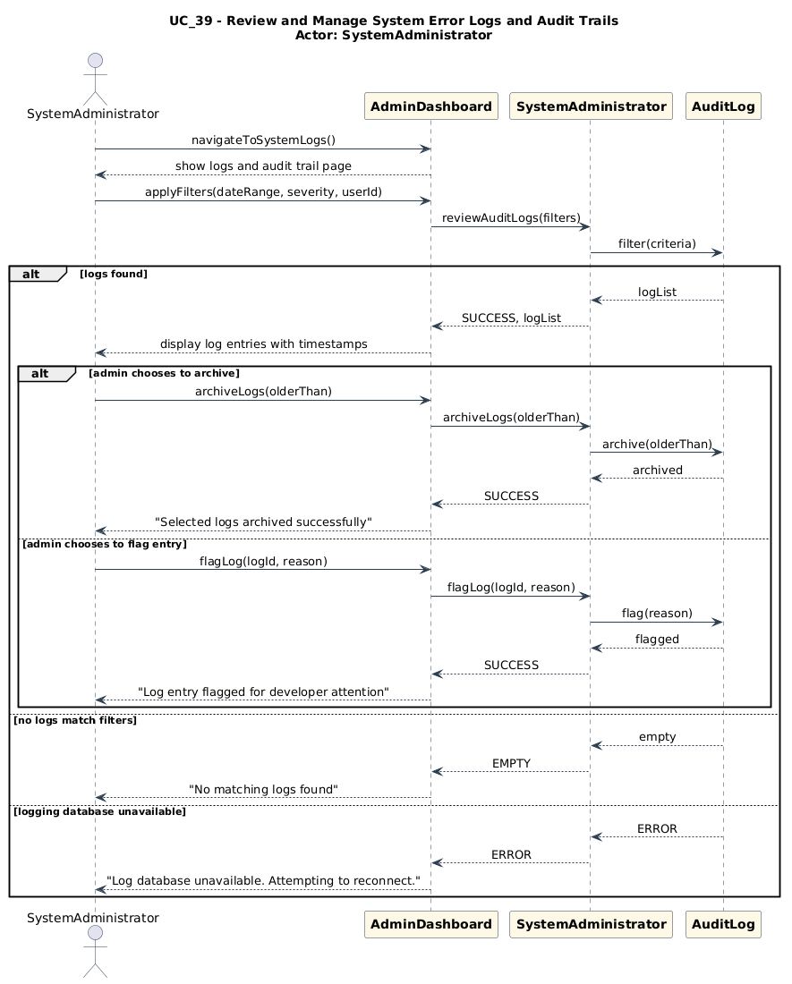

4.6 BPMN Diagrams
BPMN 1 — Event Registration & Ticket Purchase

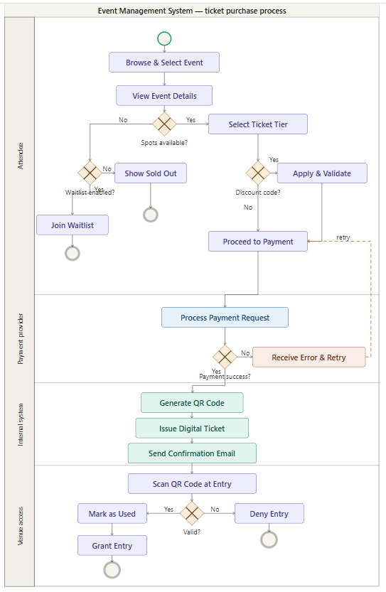

BPMN 2 — Event Creation & Management Process

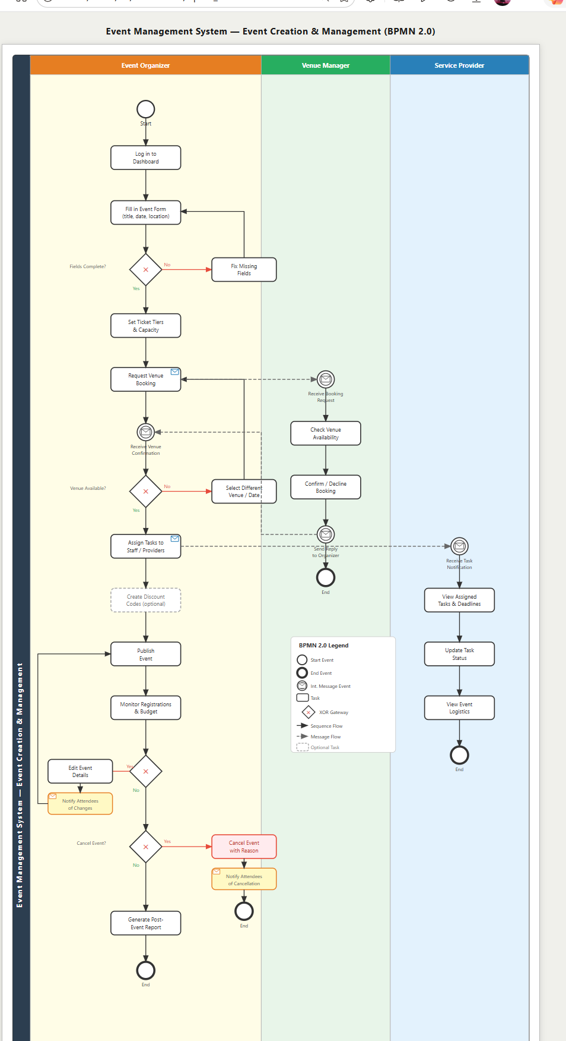

4.7 Collaboration Diagrams

UC_01 -Attendee shall register an account using a valid email address and password and shall receive an automated email confirmation after completing registration
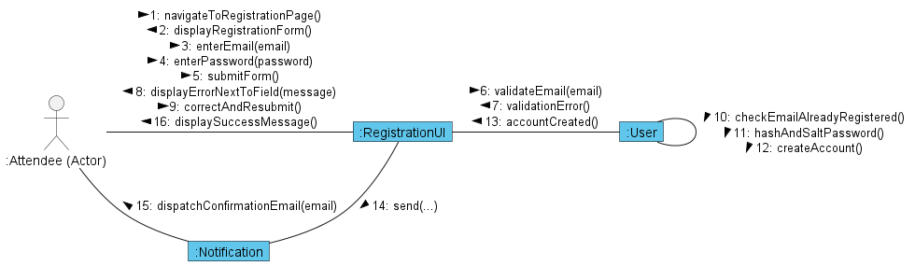

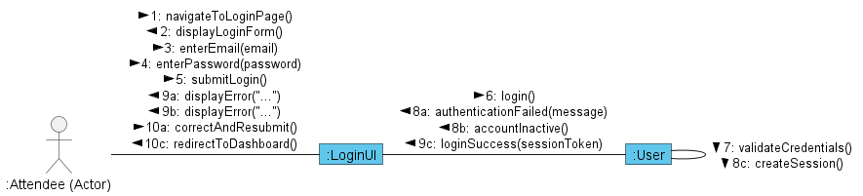
UC_02 -Attendee shall log in to the system using their registered credentials

UC_03 - Attendee shall browse the full list of available events on the platform

UC_04 - Attendee shall search and filter for events by name, date, location, or category
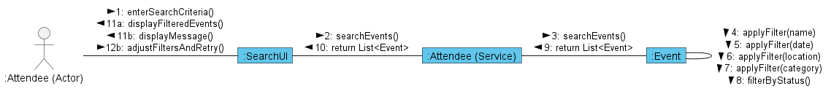

UC_05 - Attendee shall view the complete details of any selected event
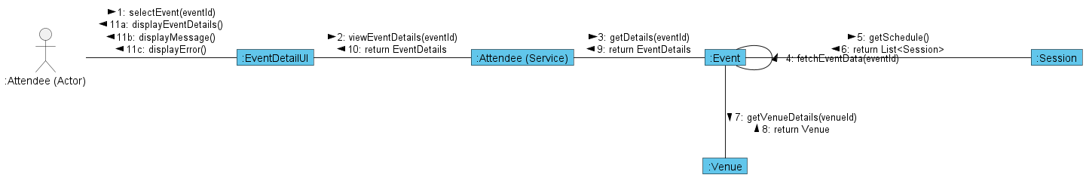

UC_11 - Event Organizer shall create a new event with title, date, time, location, and description
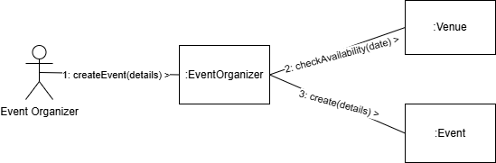

UC_12 Event Organizer shall edit the details of an existing published event
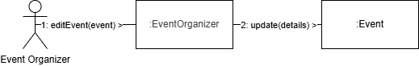
UC_13 Event Organizer shall cancel an event and trigger automated notifications to all registered attendees
UC_14 Event Organizer shall set ticket price, ticket type tiers, and maximum venue capacity
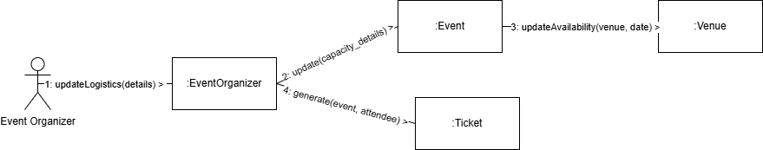
UC-15 Event Organizer shall assign tasks and roles to staff members and service providers
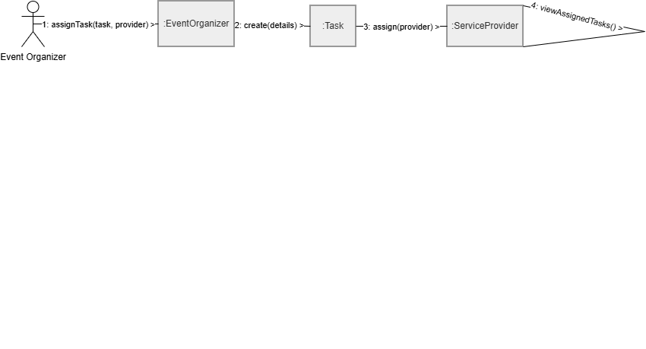

UC-16 Event Organizer shall view and export the full list of registered attendees
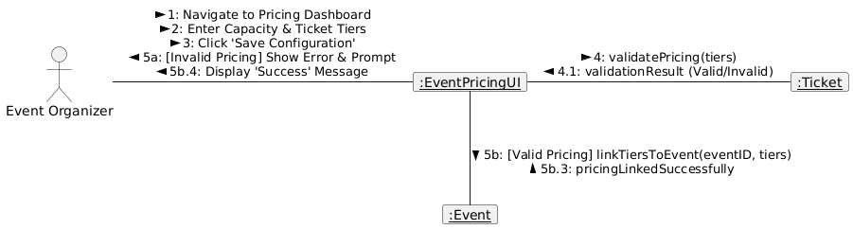

UC-17 Event Organizer shall generate a detailed report on attendance, revenue, and feedback

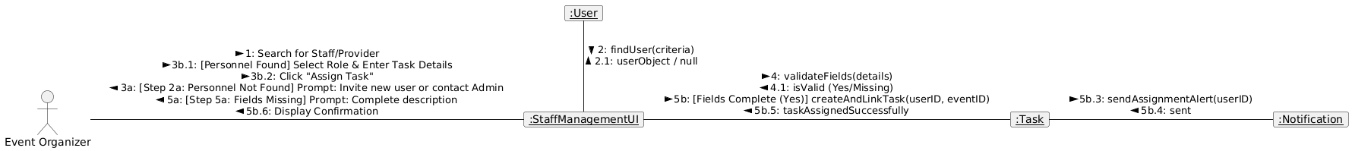

UC-18 Event Organizer shall manage the schedule of sessions and sub-events within a larger event
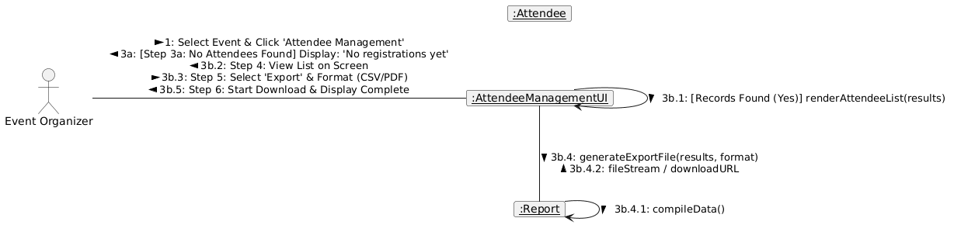

UC-19 Event Organizer shall book a venue for an event based on availability shown by the Venue Manager
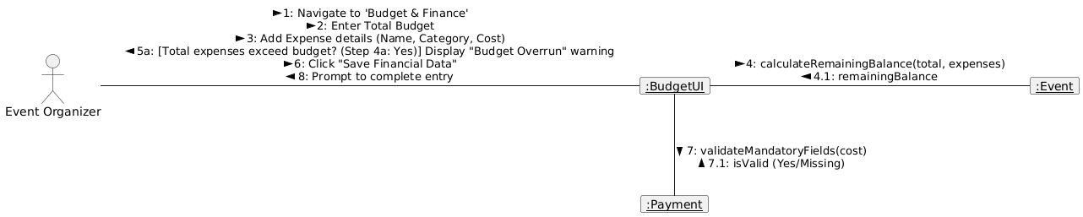

UC-20 Event Organizer shall monitor the real-time budget and expenses of an event
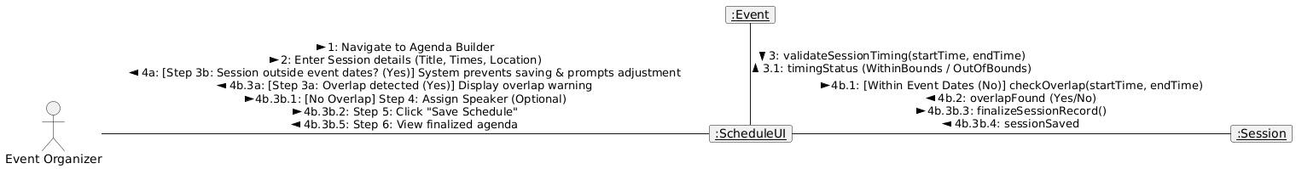

Diagram 21 — Daily Report Generation
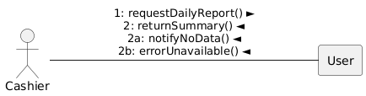
Diagram 22 — Refund Processing
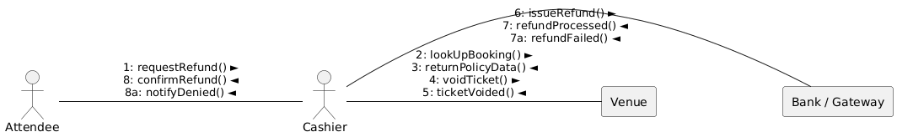
Diagram 23 — Ticket Printing
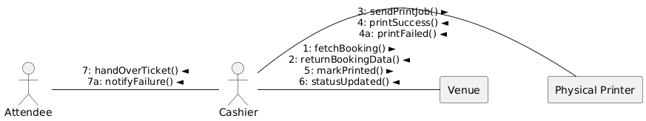
Diagram 24 — Ticket Purchase & Payment
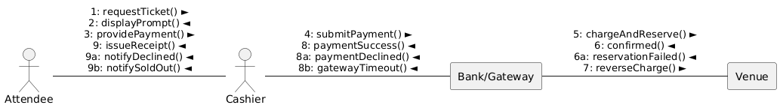
Diagram 25 — Discount Code Management
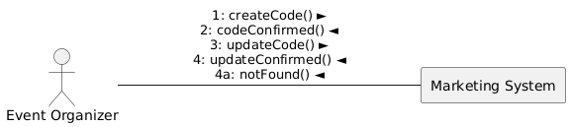
FR 26: The submitRating and createRecord messages ensure data is persisted using your OOP structures.
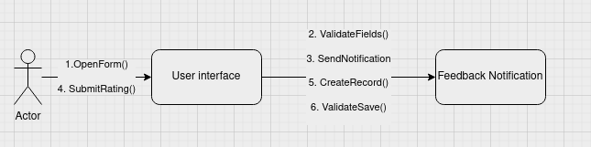

FR 27: Represented by the sendNotification() call which initiates the attendee's awareness.

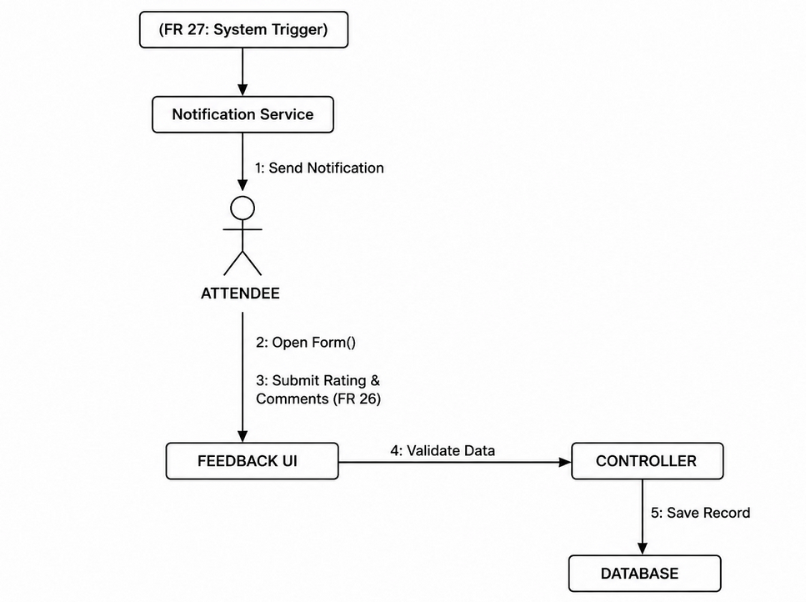
Key Logic:
FR 28: Handled by message 4 & 6 (real-time feedback summation).
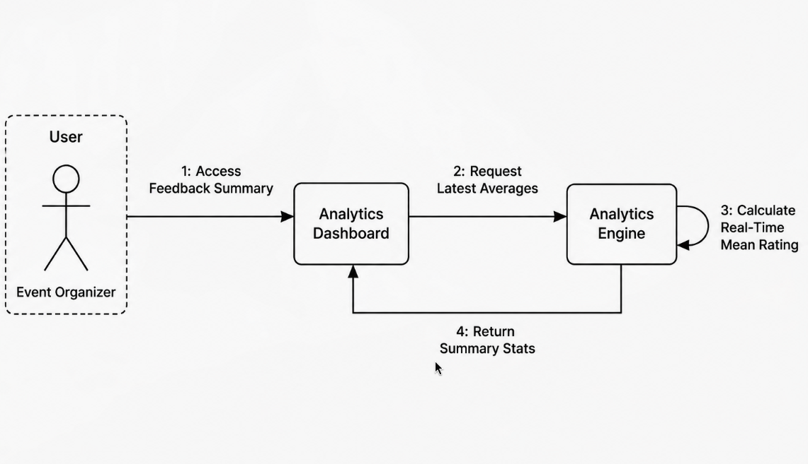

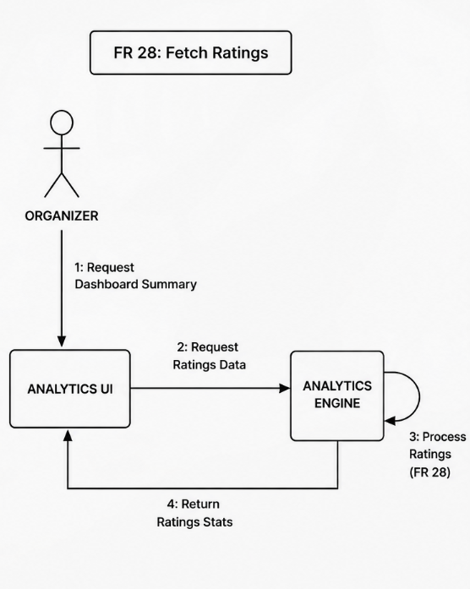

FR 29: Handled by message 5 & 6 (calculating attendance vs. registration percentages).

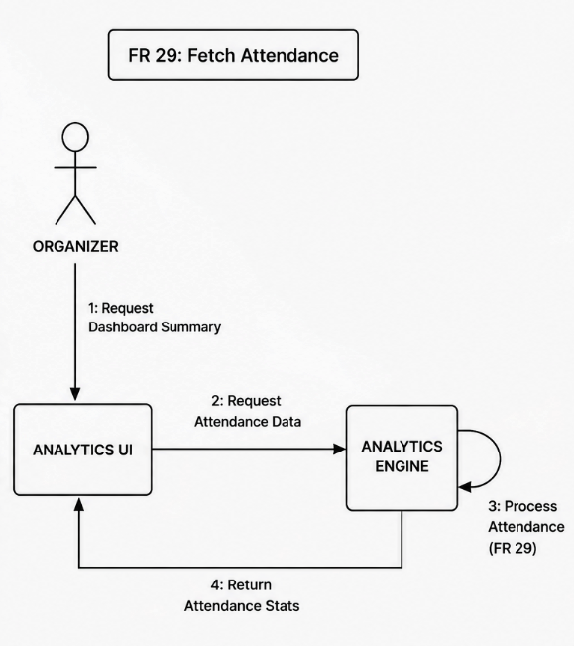

FR 30: The selectExportFormat message triggers the specific implementation (PDF or Excel).

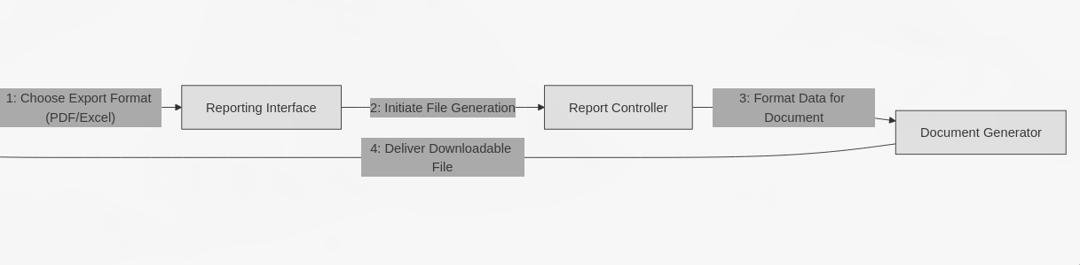

CC_31 Control Restricted Area Access

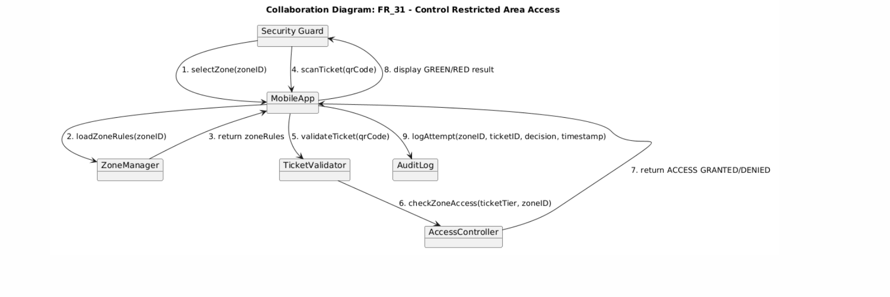

CC_32 Monitor Real-Time Attendance Counts

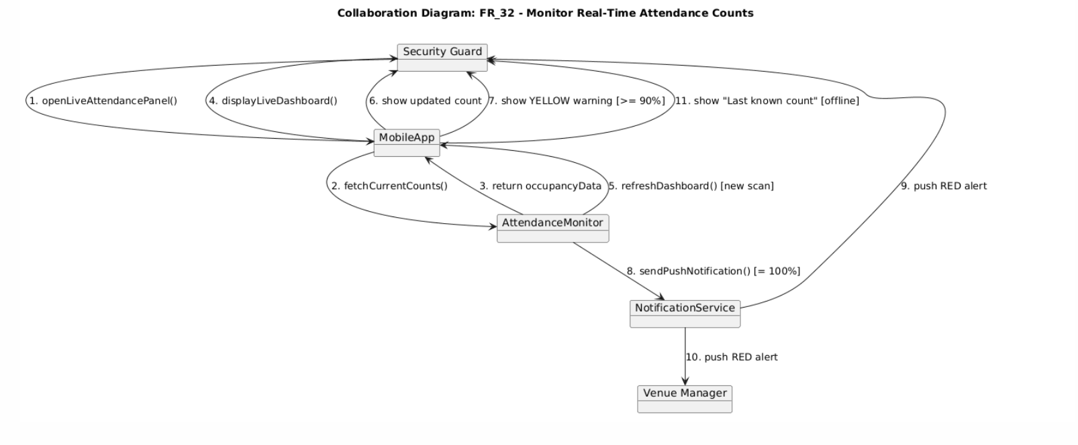

CC_33 Service Provider Task Management

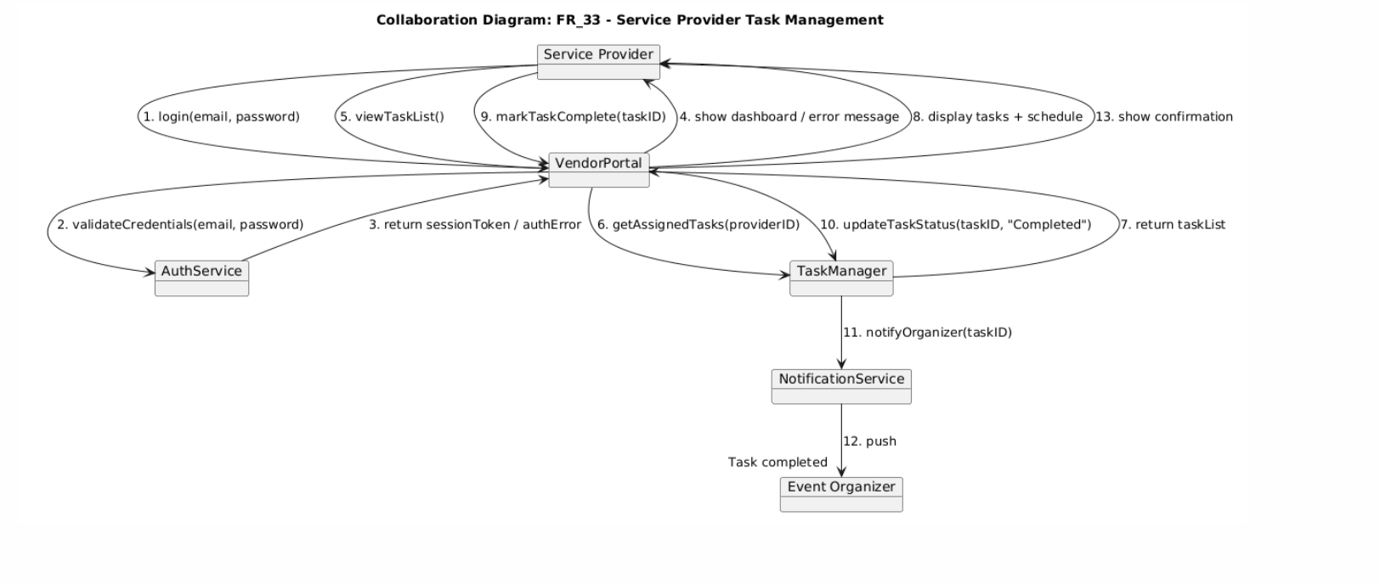

CC_34 Service Provider View Event Logistics

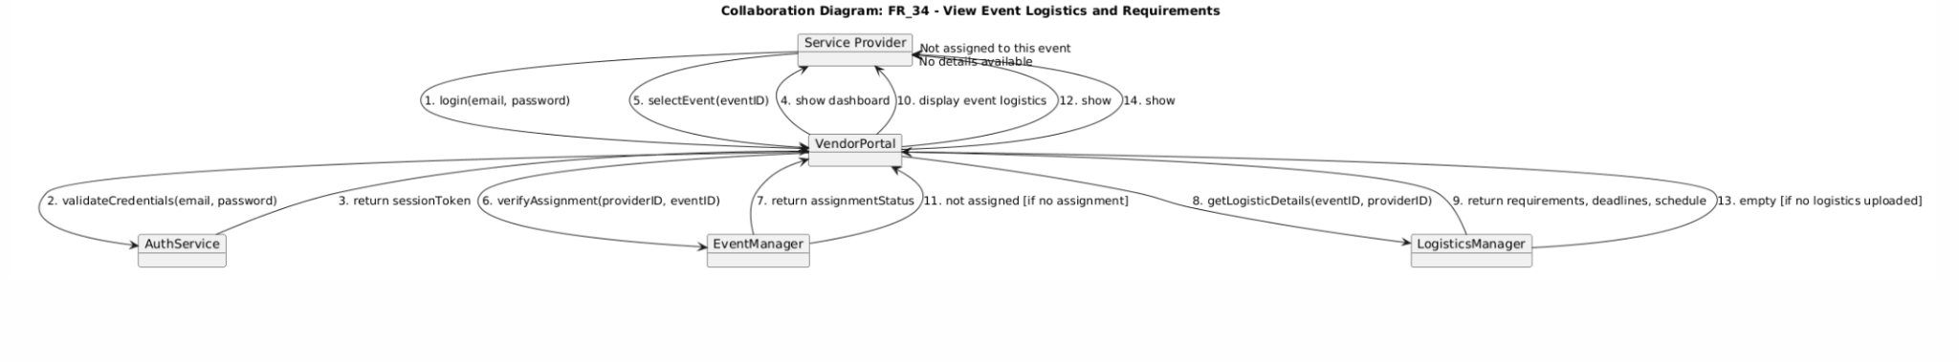

CC_35 System Administrator Manage User Accounts
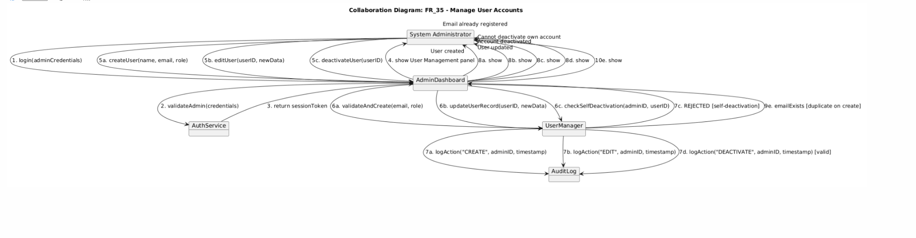

Collaboration Diagram FR_36
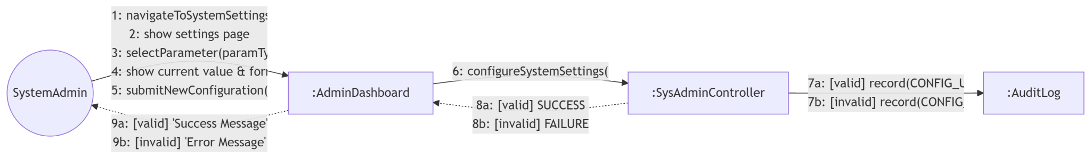

FR_37
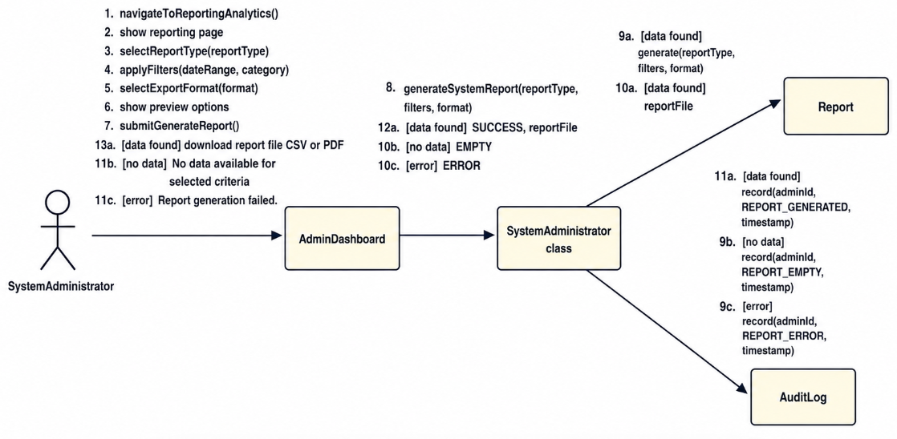

FR_38
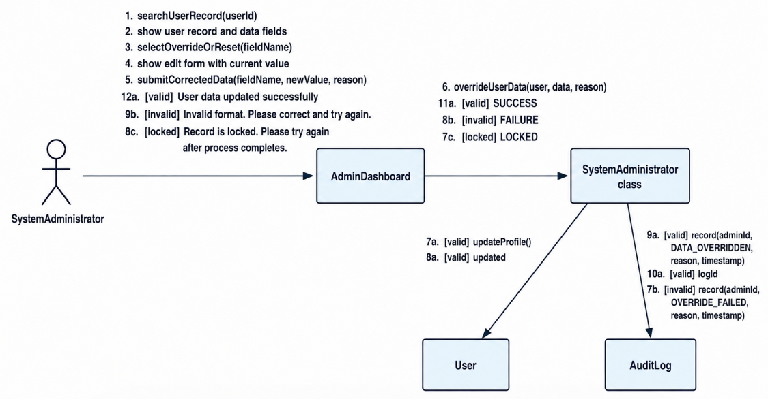
FR_39
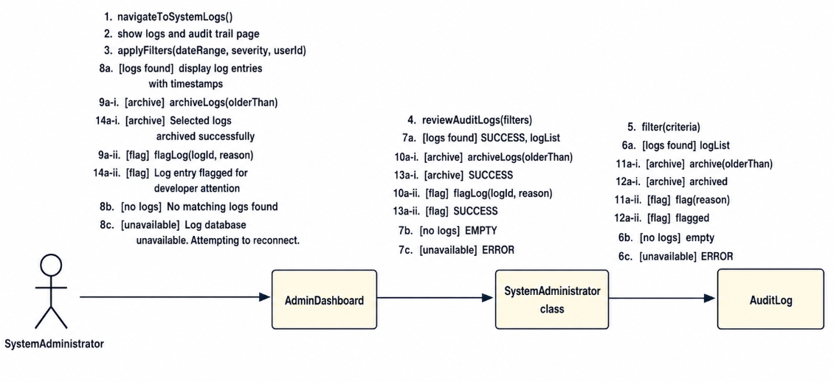

Interaction Overview Diagrams: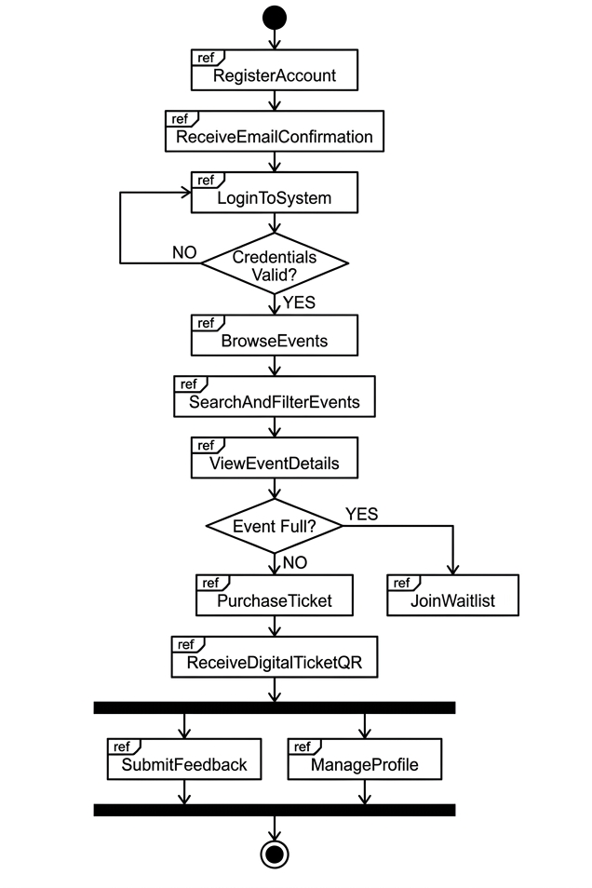
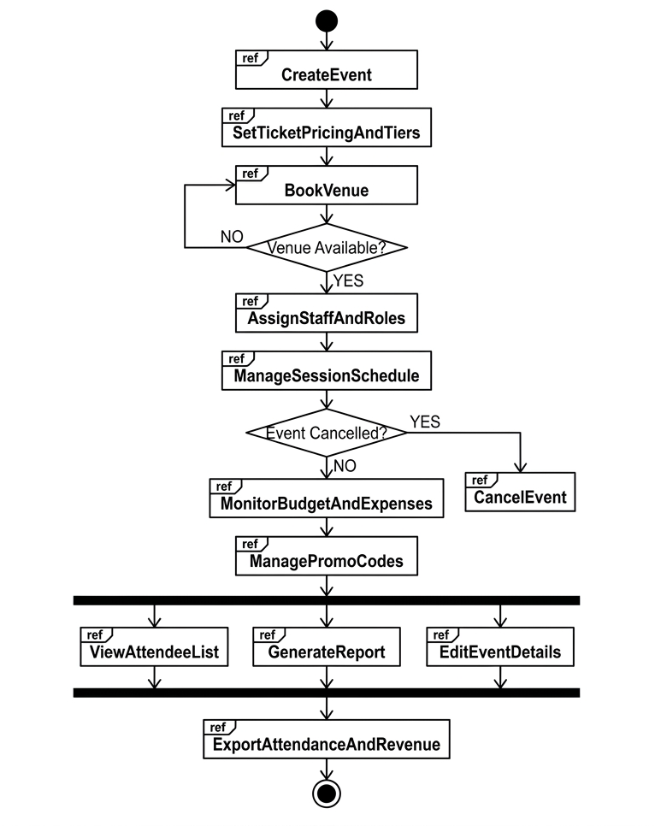

4.8 Class Diagrams (Design Patterns)

1. Observer Pattern
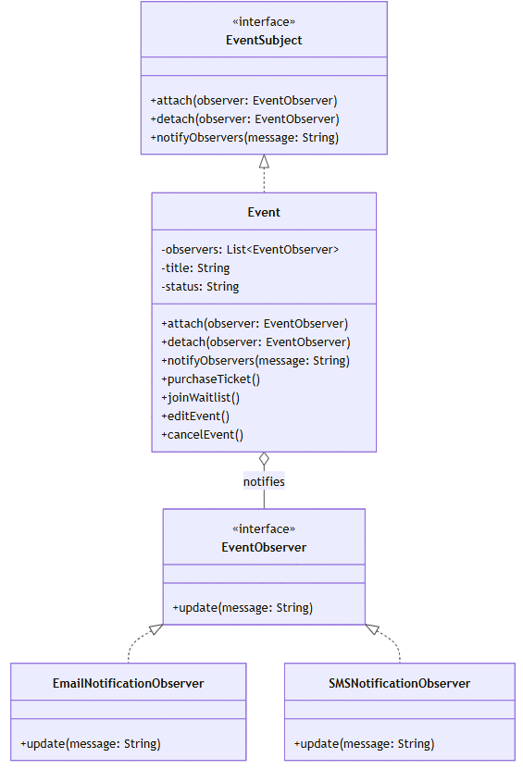
2. Factory Method Pattern
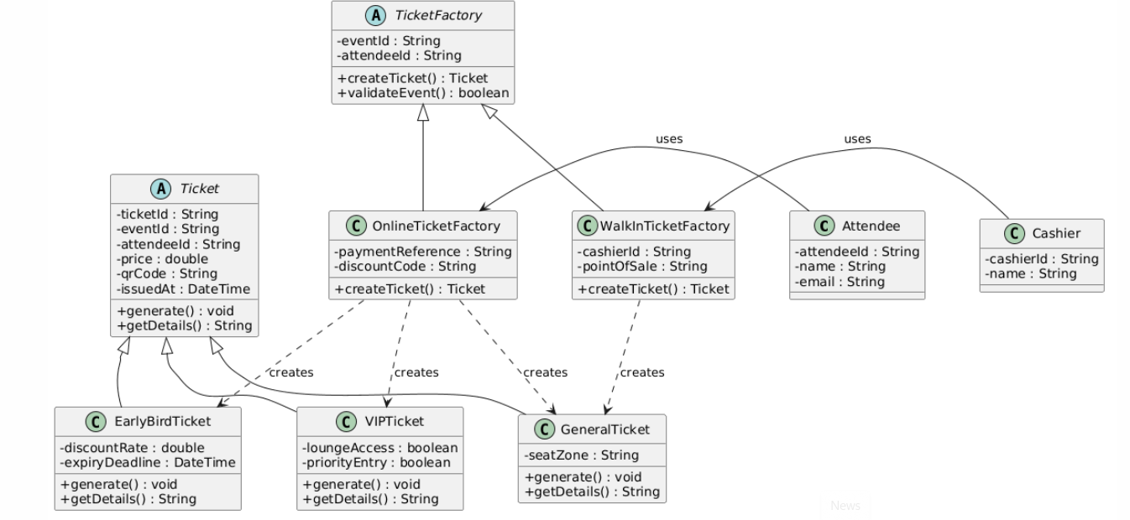
3.Facade Pattern
